Moduldokumentation

Modul Design Patterns (depa)

Simon Wächter

2017

Inhalt

1 Einleitung 8

1.1 Einleitung 8

1.2 Lernziele 8

1.3 Prüfungen 8

2 Woche 1 9

2.1 Core Components of OOP 9

2.2 Collection Frameworks 9

2.2.1 Collection Framework 9

2.2.2 Interfaces 10

2.2.3 Collection 10

2.2.4 Iterator 10

2.2.5 Generic Algorithms 11

2.2.6 Iterator 11

2.2.7 Implementation 12

2.2.8 Abstract Collection 12

2.2.9 Example of a Simple Collection 14

2.2.10 Implementations 14

2.2.11 Collection Framework Overview 15

3 Woche 2 16

3.1 Review of the Exercise 16

3.2 What is a Design Pattern 16

3.3 History of Design Patterns 17

3.4 Why Design Patterns 18

3.5 Properties 18

3.6 Types of Patterns 19

3.7 Types of Software Patterns 19

3.8 Pattern Form: GoF 19

3.9 References 20

3.10 Observer Pattern 20

3.10.1 Overview 20

3.10.2 Motivation 20

3.10.3 Structure 21

3.10.4 Participants 21

3.10.5 Collaboration 21

3.10.6 Consequences 22

3.10.7 Sample Code 22

3.10.8 Known Uses 23

4 Woche 3 24

4.1 Aufgabe 1: java.util.Observer 24

4.2 Aufgabe 2: Observer & Resourcen 26

4.3 Aufgabe 3: Nebeneffekte von Änderungen 27

4.4 Aufgabe 4: Zyklische Abhängigkeit 28

4.5 Aufgabe 5: Kausalität von Änderungen 29

4.6 Aufgabe 6: Was ist das Modell, wie wird es verändert? 30

5 Woche 4 31

5.1 State Pattern 31

5.1.1 Motivation 31

5.1.2 Overview 32

5.1.3 Structure 32

5.1.4 Example 33

5.1.5 Example (Without a State Pattern) 33

5.1.6 Example (With a State Pattern) 34

5.1.7 Issues 35

5.1.8 Example 36

5.1.9 Issues 36

5.1.10 Applicability 37

5.2 Example for parsing a float Value 37

6 Woche 5 40

6.1 Strategy Pattern 40

6.1.1 Overview 40

6.1.2 Structure 40

6.1.3 Motivation 41

6.1.4 Example 41

6.1.5 Preconditions 43

6.1.6 Applicability 44

6.2 Strategy vs. State 44

6.3 Strategy vs. Inheritance Approach 44

6.4 Null Object Pattern 45

6.4.1 Overview 45

6.4.2 NullLayout 45

7 Woche 6 46

7.1 Composite Pattern 46

7.1.1 Motivation 46

7.1.2 Structure 47

7.1.3 Participants 48

7.2 Example Group Figure 49

7.3 Structure of the Composite Pattern 50

7.4 Composite Pattern 50

7.5 Composite Pattern in AWT 50

7.6 Composite Pattern in Swing 51

7.7 Composite Pattern in AWT/Swing 51

7.8 Composite Pattern in JavaFX Scene Graphs 52

8 Woche 7 53

8.1 Prototype Pattern 53

8.1.1 Motivation 53

8.1.2 Problem 53

8.1.3 Structure 53

8.1.4 Implementation 54

8.2 Object.clone 54

8.2.1 Method 54

8.2.2 Harmony Implementation 55

8.2.3 Example Point 55

8.3 Deep vs. Shallow Copy 56

8.3.1 Source Code 56

8.3.2 Normal Object 56

8.3.3 Shallow Copy 57

8.3.4 Deep Copy 57

8.4 Remarks 58

8.5 Clone with Copy Constructor 58

9 Woche 8 59

9.1 Information Hiding 59

9.1.1 Information Hiding 59

9.1.2 Mutable Parameters 60

9.1.3 Example from JDK 1.1 60

9.1.4 Robust Programming Guideline 61

9.1.5 Rectangle Example revisited 61

9.1.6 Robust Programming Guideline 61

9.2 Immutability 62

9.2.1 Immutable Objects 62

9.2.2 Benefits of Immutable Objects 62

9.2.3 Fraction as Example of a mutable Object 63

9.2.4 Persistent & Immutable Data Structures 64

9.3 Summary 64

10 Woche 9 65

11 Woche 10 66

11.1 Vibrating & Skin Phones 66

11.1.1 Problem 66

11.1.2 Implementation with Inheritance 66

11.1.3 Implementation with a Decorator 66

11.2 Decorator Pattern 67

11.2.1 Structure 67

11.2.2 Dynamics 67

11.2.3 Number of Classes 68

11.2.4 Number of Classes (With Inheritance) 68

11.3 Java API Samples of the Decorator Pattern 69

11.3.1 JScrollPane 69

11.3.2 Collection Decorators 69

11.4 Java IO (Streams) 70

11.4.1 OutputStream 70

11.4.2 FilterOutputStream 71

11.4.3 DataOutputStream 71

11.4.4 InputStream 72

11.4.5 FilterInputStream 73

11.4.6 ObjectStream 73

11.4.7 Decorator Classes 73

11.4.8 Whole Picture: InputStream 74

11.4.9 Whole Picture: OutputStream 74

11.5 Demo 75

12 Woche 11 76

12.1 Proxy Pattern 76

12.1.1 Overview 76

12.2 Dynamic Proxy Class 76

12.2.1 Overview 76

12.2.2 Example 78

13 Woche 12 79

13.1 Command Pattern 79

13.1.1 Goal 79

13.1.2 Applications 79

13.2 Undo/Redo 79

13.2.1 Motivation 79

13.2.2 Implementation 80

13.2.3 State Diagram for Commands 81

13.2.4 Implementation via DrawCommandHandler 81

13.3 Command Pattern 82

13.3.1 Definition 82

13.3.2 Participants 82

13.3.3 Sequence Diagram 83

13.4 Problem of Undo/Redo 83

13.5 Command Pattern 83

14 Woche 13 84

14.1 Factory Method Pattern 84

14.1.1 Creational Patterns 84

14.1.2 Factory Patterns 84

14.1.3 Factory Method Pattern 85

14.2 Abstract Factory 88

14.2.1 Abstract Factory Pattern 88

14.2.2 Structure 89

14.2.3 Implementation 90

14.2.4 Motivation and Examples 91

14.2.5 Remarks 91

14.3 Dependency Injection 92

14.3.1 Problem of Coupling 92

14.3.2 Dependency Injection as Solution 92

14.3.3 Property Values 93

14.3.4 Spring in Action 94

15 Woche 14 95

15.1 Singleton Pattern 95

15.1.1 Introduction 95

15.1.2 Problems with the static Approach 96

15.1.3 Singleton Pattern 97

15.1.4 Example 97

15.1.5 Samples 98

15.1.6 Implementation Remarks 98

15.1.7 Lazy Initialization 98

15.1.8 Implementation Remarks 99

15.2 Singleton and Spring 101

15.3 Relation with other Patterns 101

15.4 Problems of Singleton 102

15.4.1 The Pattern 15 Years later 102

15.4.2 Disadvantages 102

15.4.3 Discussion and Comments 103

16 Woche 15 104

16.1 Inheritance 104

16.1.1 Considered harmful 104

16.1.2 Inheritance 104

16.1.3 Subclassing: Example 104

16.1.4 Reentrance 105

16.1.5 Example of StringOutputStream 105

16.1.6 Inheritance breaks Encapsulation 108

16.1.7 Inheritance considered dangerous 108

16.1.8 Robust Variant of Forwarding 109

16.1.9 Robust Variant of Template/Hooks 110

16.1.10 Robust Variant of inner Calls 111

16.1.11 Example of externalizable with Super Call 112

16.1.12 Example of externalizable with inner Call 112

16.1.13 CheckStyle Design for Extension 113

16.1.14 Summary 113

16.2 Object Orientation 114

16.2.1 Principles 114

16.2.2 Design Principles 114

16.2.3 SOLID Principle 116

16.3 Design Patterns: Past, Present and Future 116

16.4 Gamma 117

16.4.1 A new Categorization 117

16.4.2 What hasn’t changed 117

# Einleitung

## Einleitung

Dieses Dokument stellt die Moduldokumentation für das Modul depa dar. Allfällige Unterlagen sind im Modulordner zu finden.

## Lernziele

Das Modul beinhaltet folgende Lernziele:

* Diverse Entwurfsmuster
  + Observer
  + Strategy / State
  + Composite
  + Prototype
  + Decorator / Proxy
  + Factory / Dependency Injection
  + Singleton
  + Command

## Prüfungen

Die Modulnote setzt sich aus einer Semesterprüfungen zu 50% und einer Modulschlussprüfung zu 50% zusammen. Hinzu kommen freiwillige Übungsaufgaben, welche aber empfohlen sind.

# Woche 1

## Core Components of OOP

* Encapsulation: Bundling of data with the methods operating on that data
  + Information Hiding: Hiding the implementation details, in general restricting direct access to fields & methods 🡪 HOW
  + Abstraction: Interface abstract the behaviour 🡪 WHAT
* Inheritance: Code reuse by extending (and modifying) existing classes (Subclassing)
* Polymorphism (Dynamic invocation): An object in a type hierarchy can have different types
  + Figure f = new Rectangle(); 🡪 Figure is the static type, Rectangle is the dynamic type
  + f.draw();
* Interfaces: Defines a type = Set of methods
* Abstract Class (or default methods in Java): Predefining general functions, in general default behaviour (Semi-finished product)
  + In terms of other method, defined in the same abstraction
* Concrete Class:
  + Implements a type
  + Completes a semi-finished product

Design Principle: Program to an interface, not an implementation: Set s = new HashSet();

## Collection Frameworks

### Collection Framework

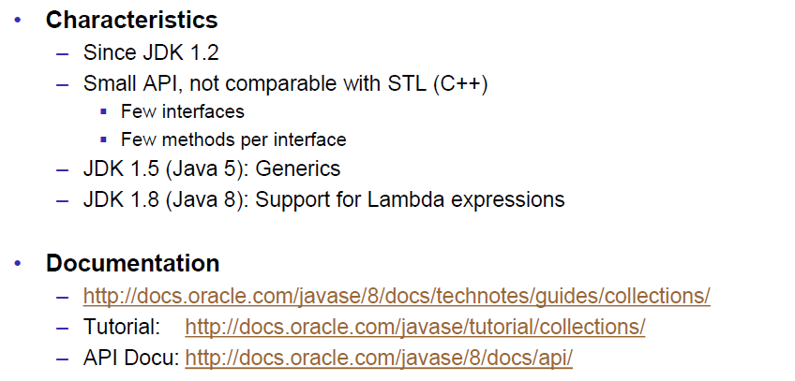

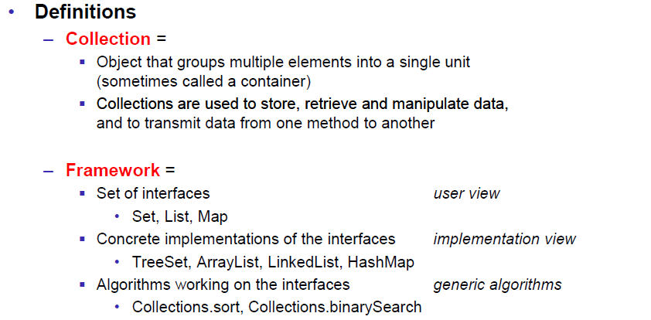

### Interfaces

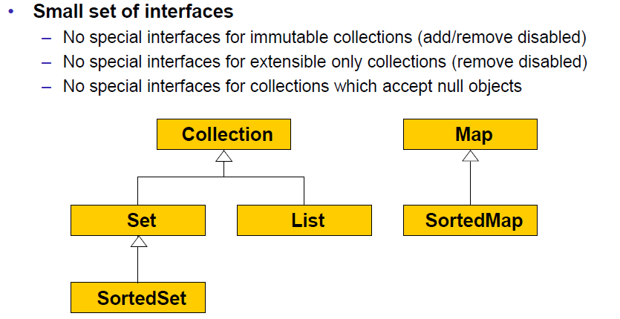

### Collection

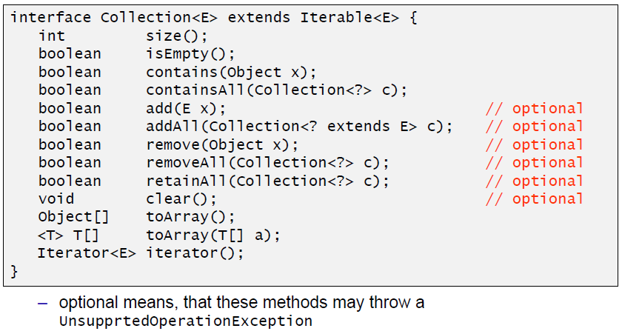

### Iterator

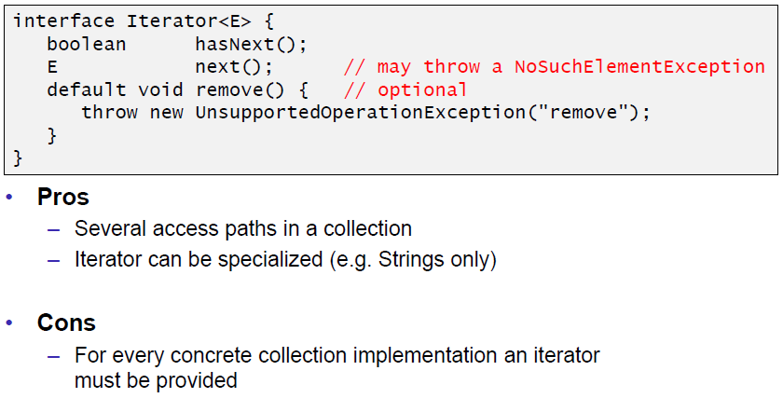

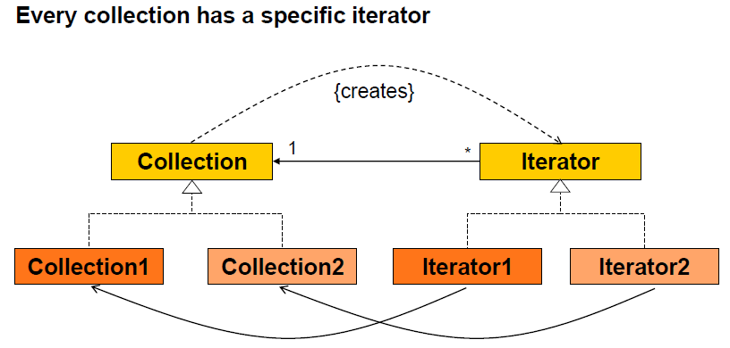

### Generic Algorithms

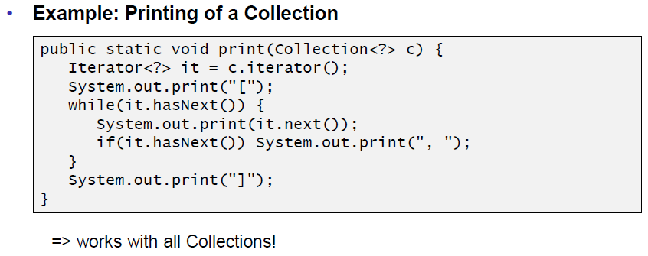

### Iterator

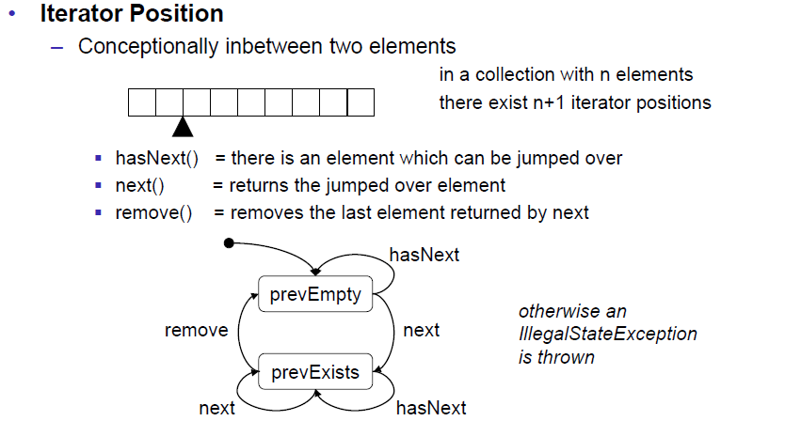

### Implementation

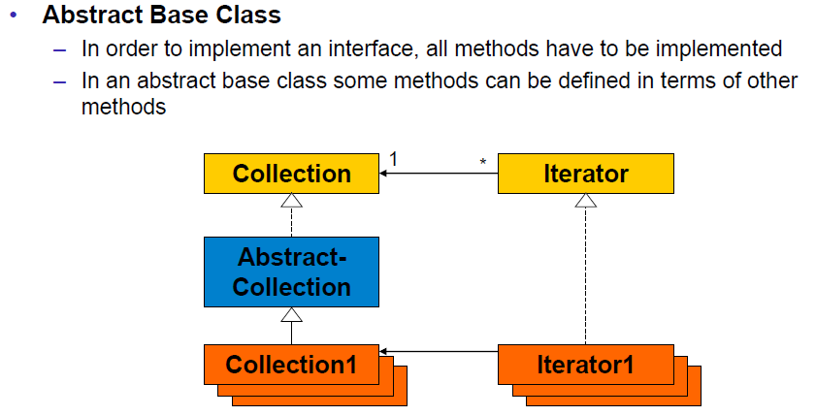

### Abstract Collection

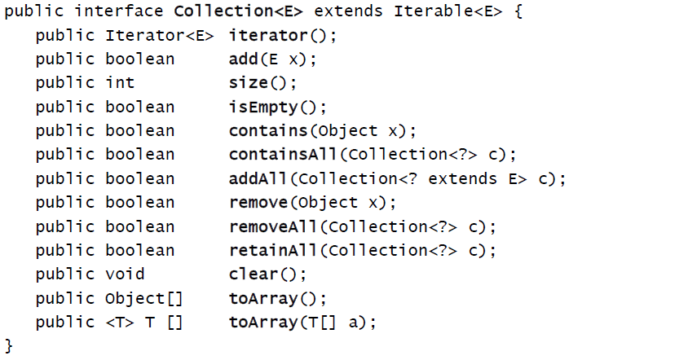

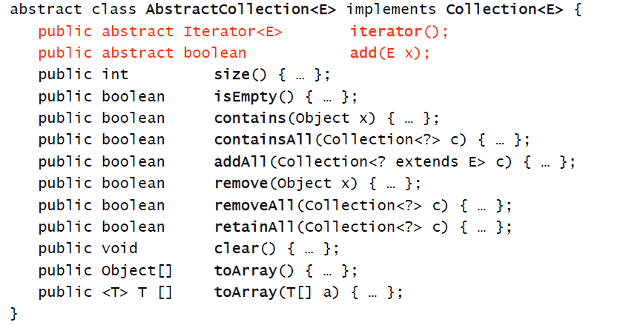

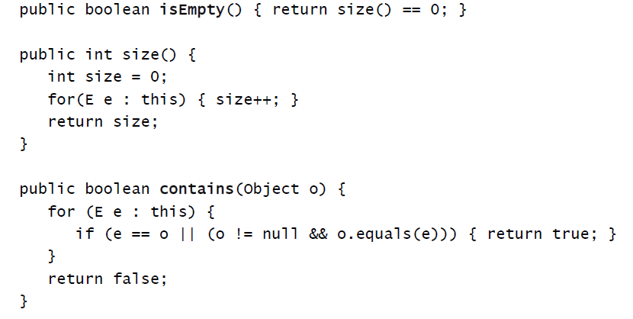

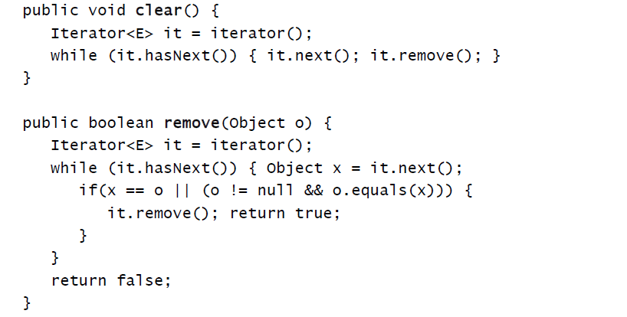

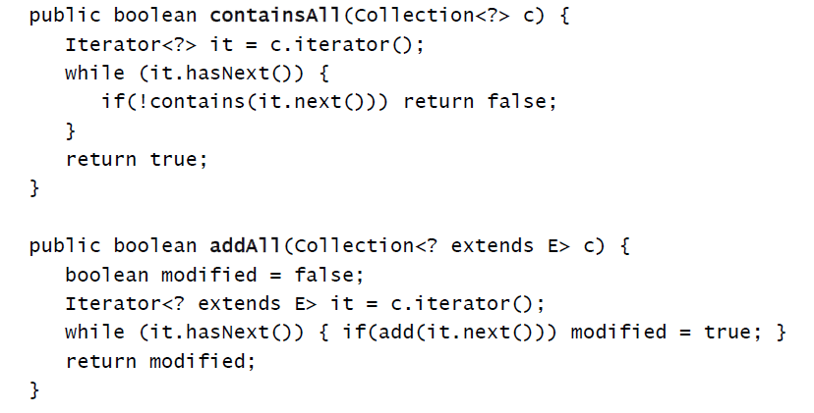

### Example of a Simple Collection

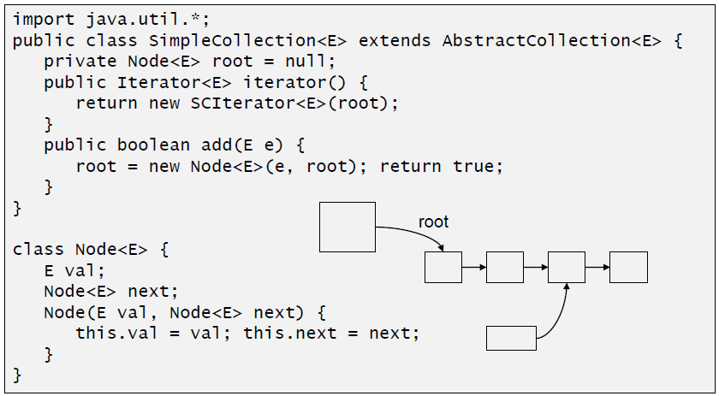

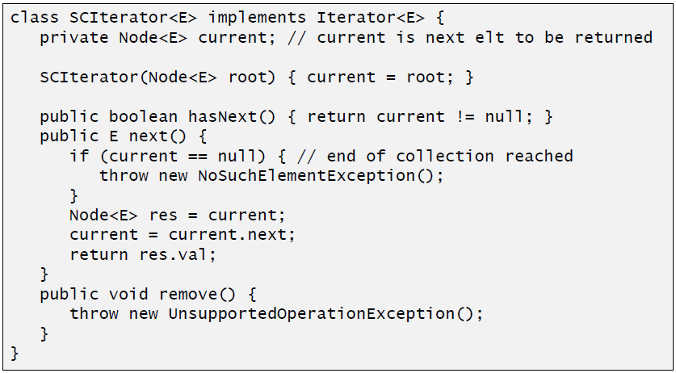

### Implementations

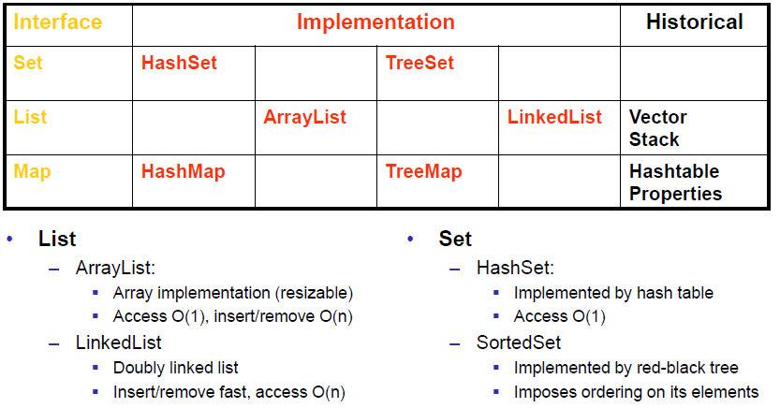

### Collection Framework Overview

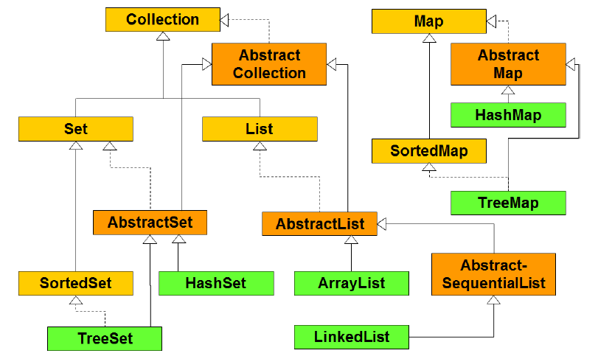

# Woche 2

## Review of the Exercise

* Updating all UI elements manually = complete mess
* Instead: Open-Closed principle: Software should be open for extensions but should be closed for modifications
* Example
  + New console
  + Define the behaviour (Listeners)
  + Adjust the other controls
  + Adjust all existing listeners
  + In general 🡪 Single Source of Truth

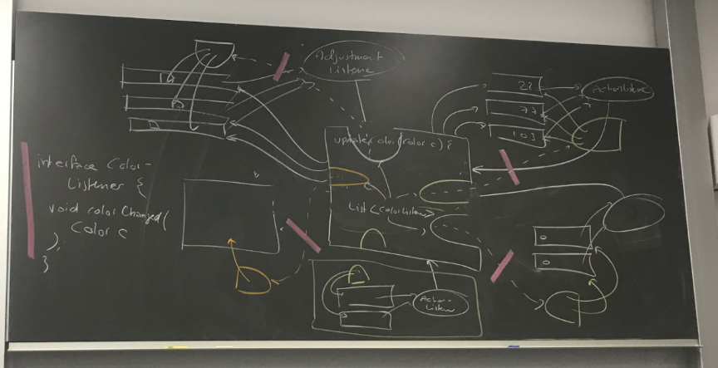

## What is a Design Pattern

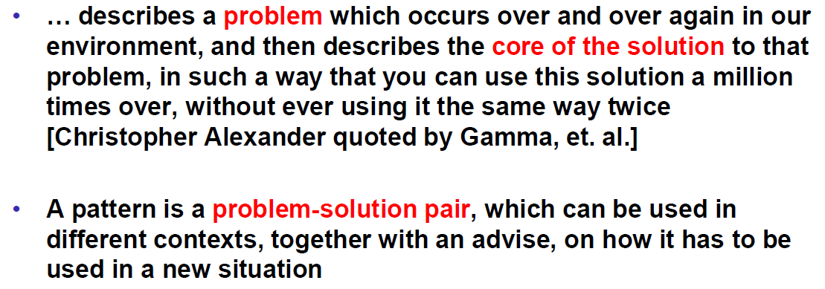

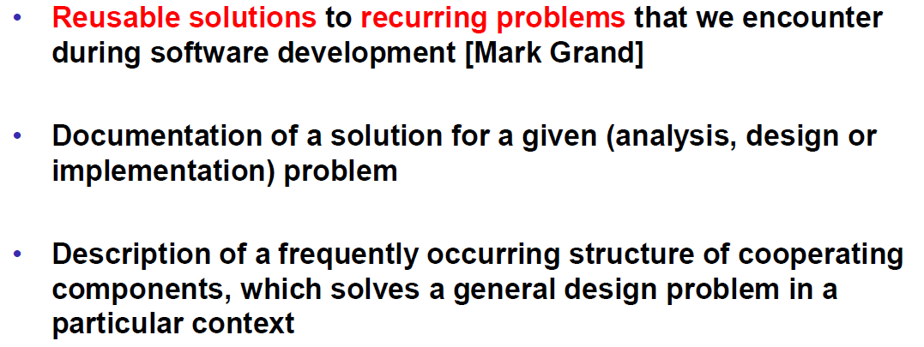

## History of Design Patterns

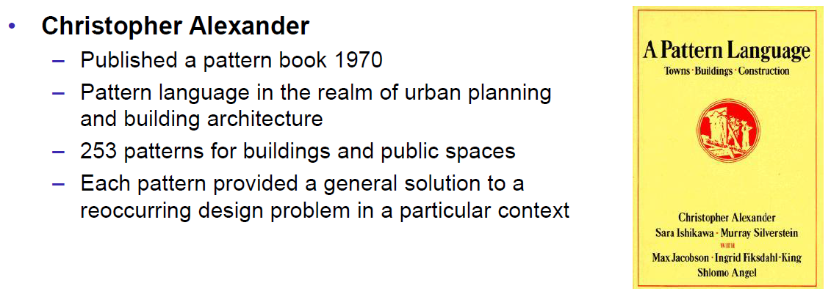

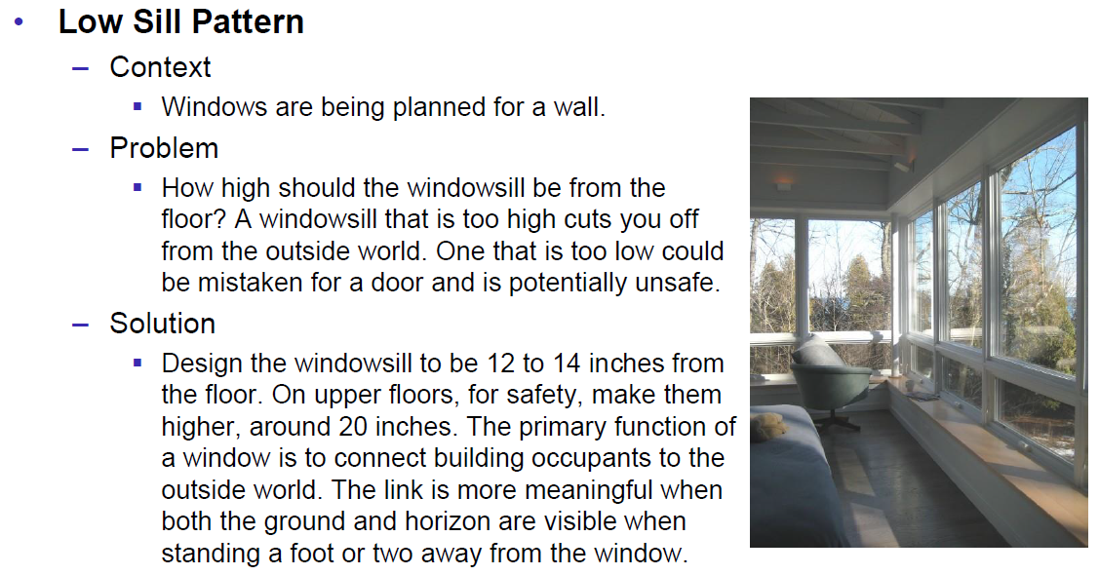

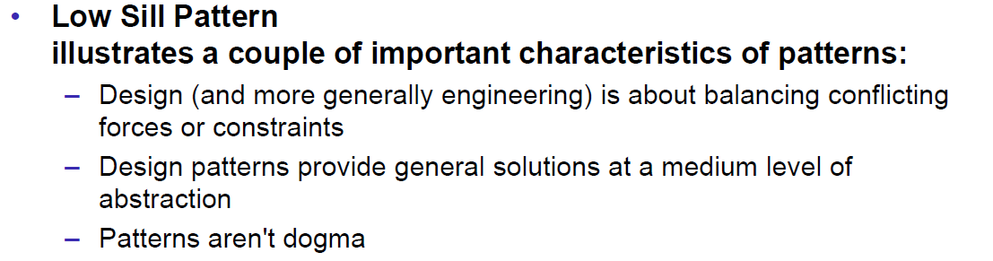

## Why Design Patterns

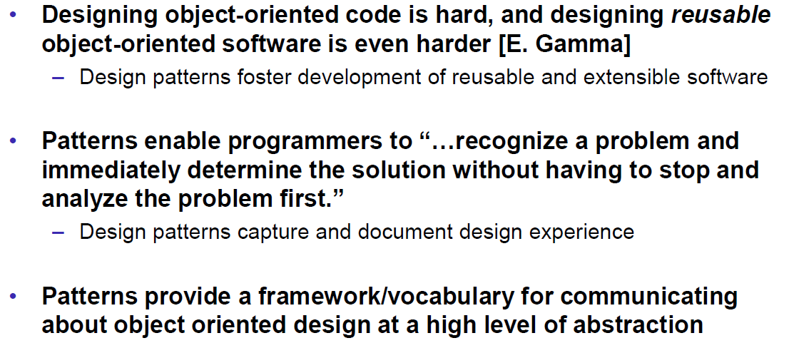

## Properties

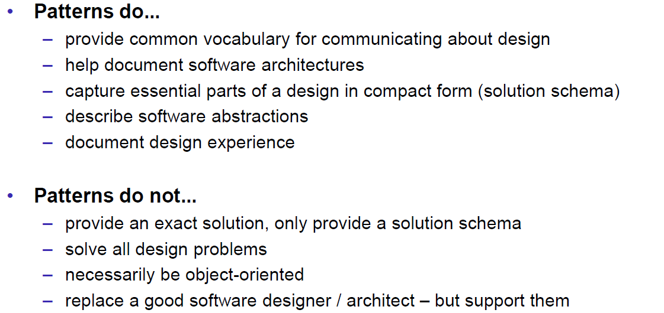

## Types of Patterns

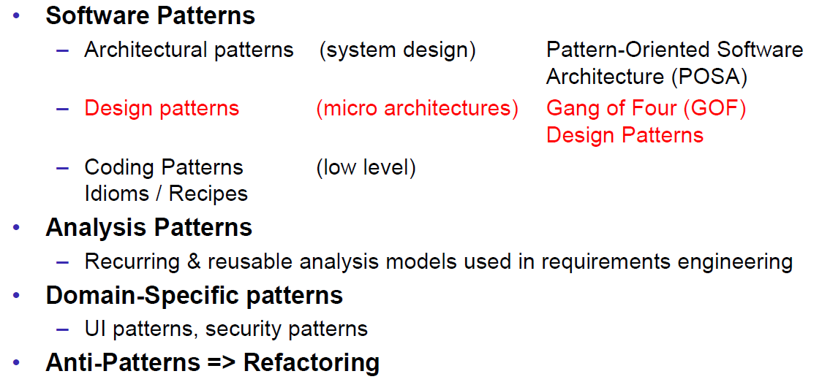

## Types of Software Patterns

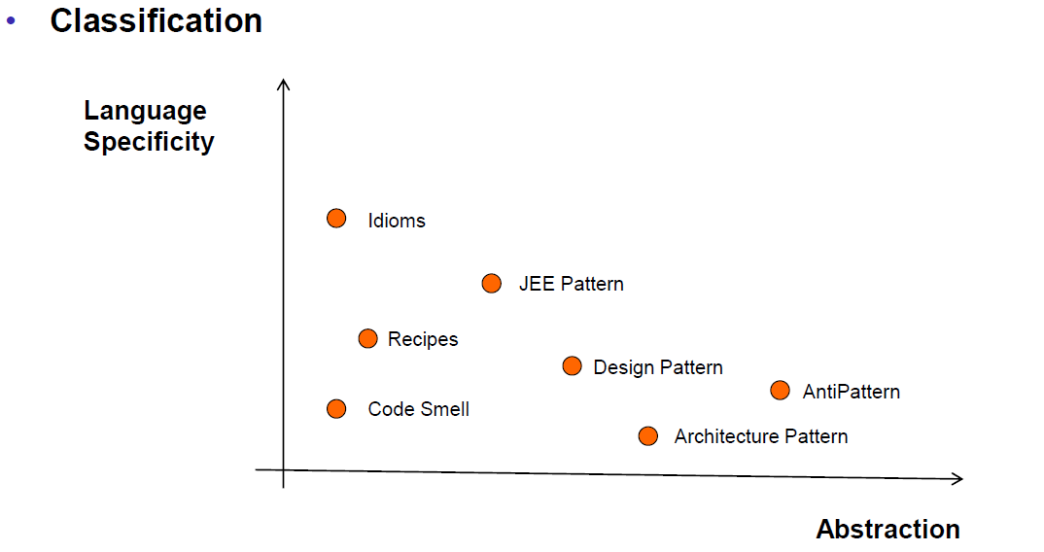

## Pattern Form: GoF

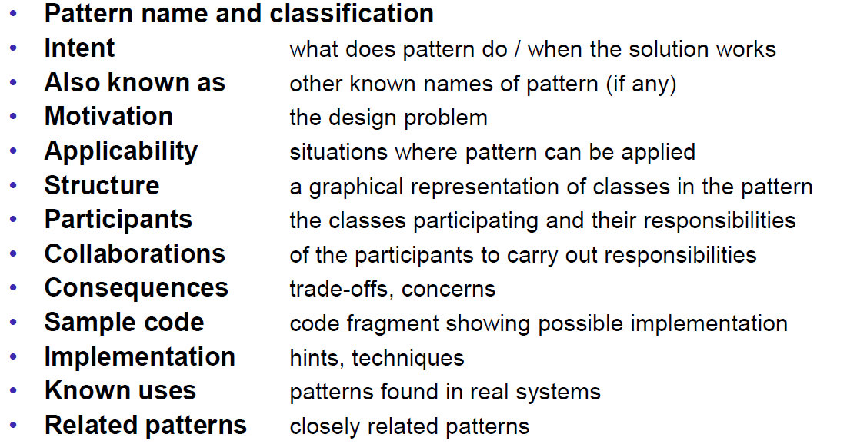

## References

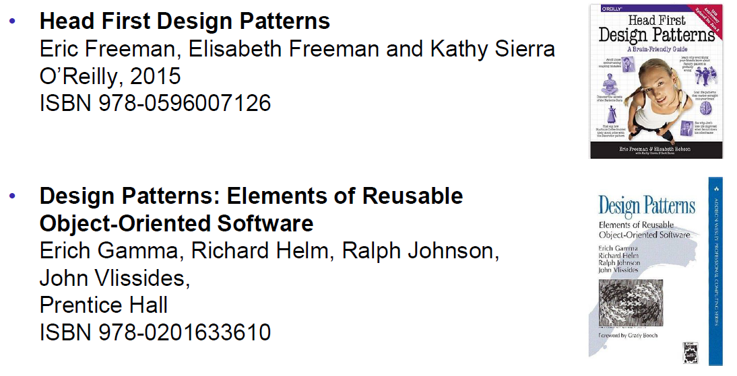

## Observer Pattern

### Overview

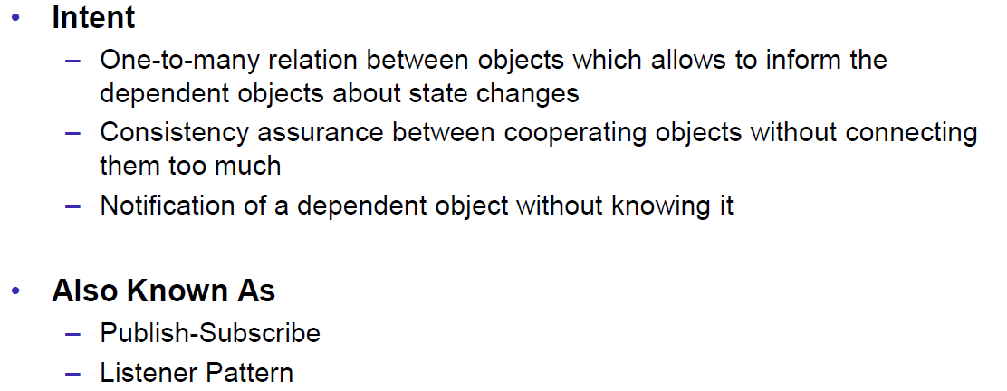

### Motivation

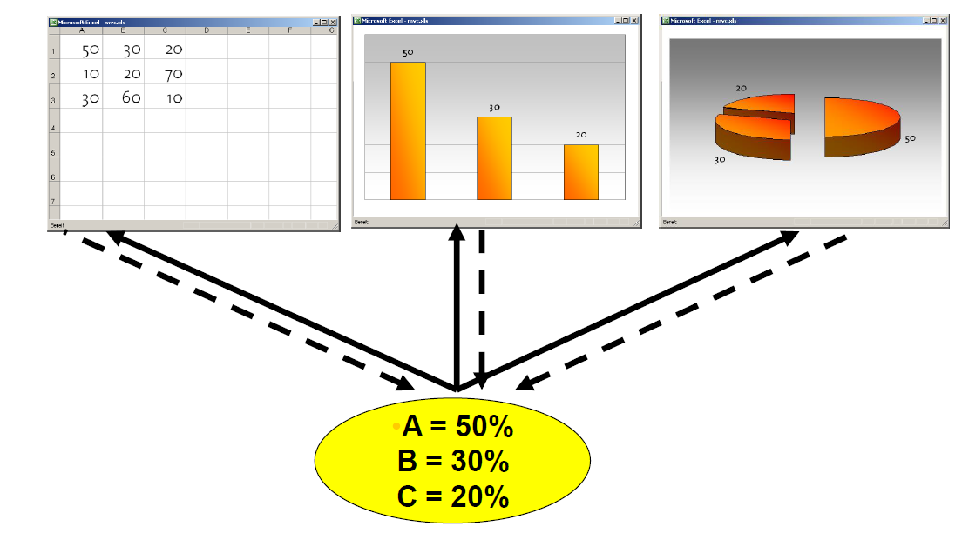

### Structure

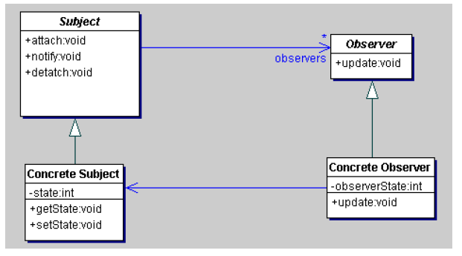

### Participants

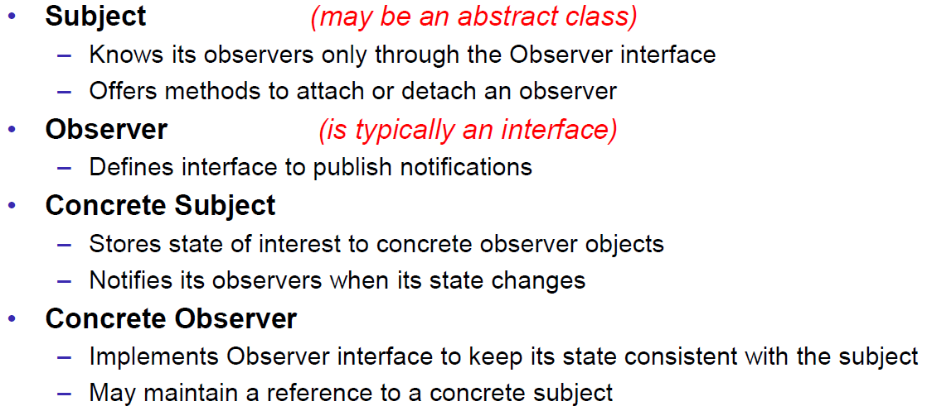

### Collaboration

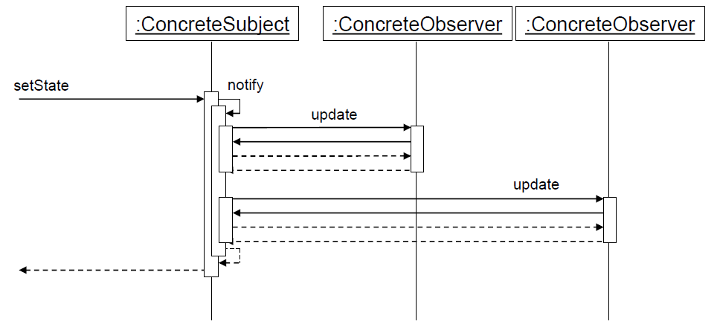

### Consequences

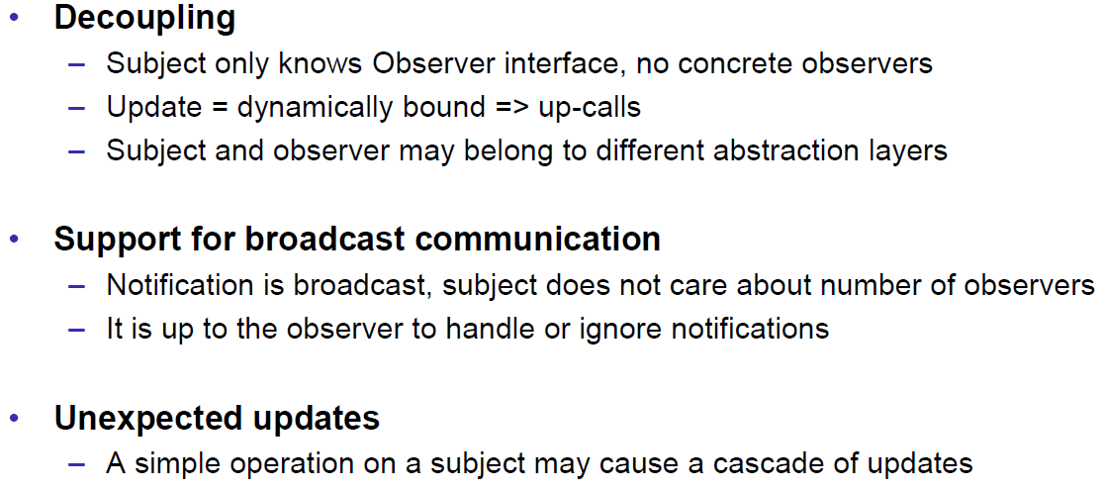

### Sample Code

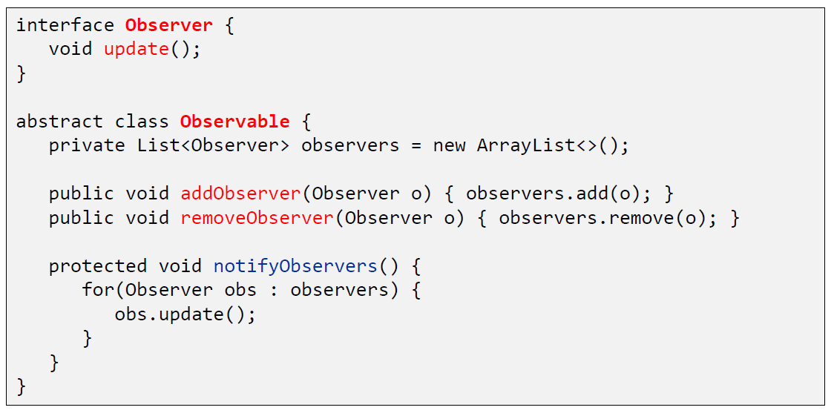

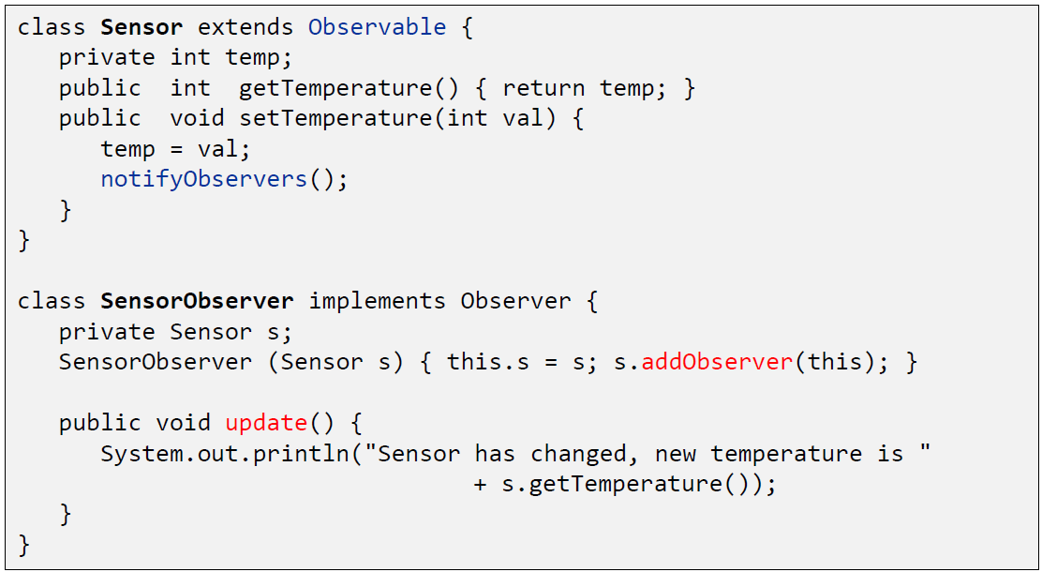

### Known Uses

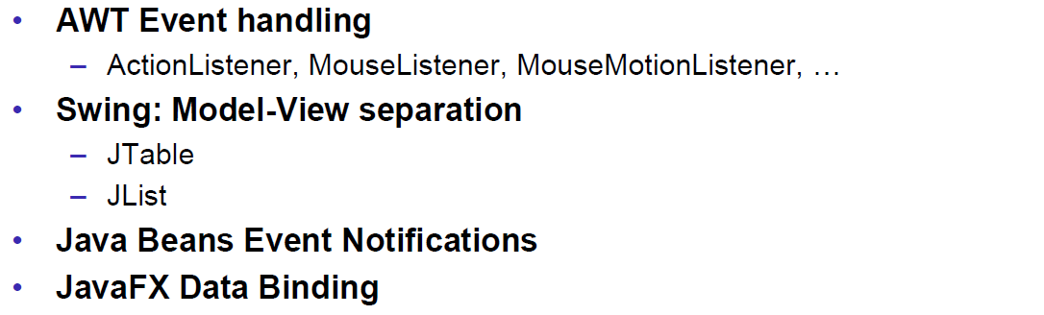

# Woche 3

## Aufgabe 1: java.util.Observer

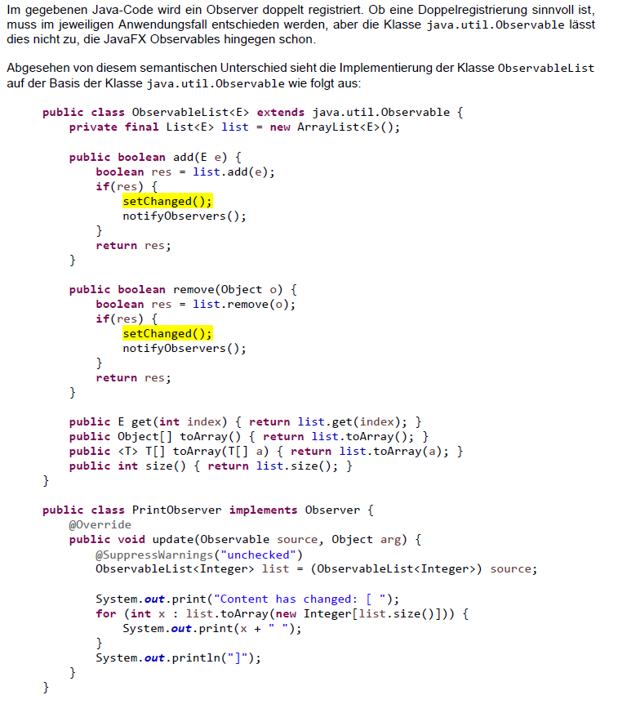

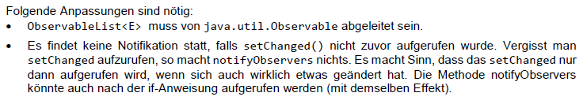

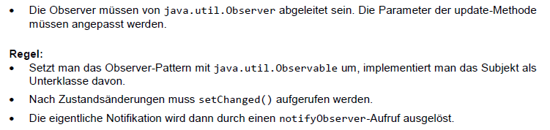

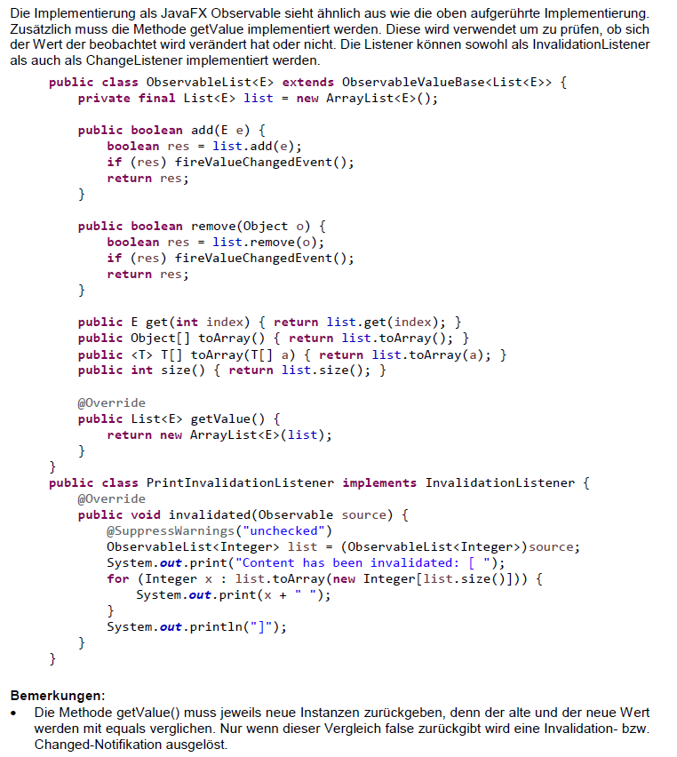

## Aufgabe 2: Observer & Resourcen

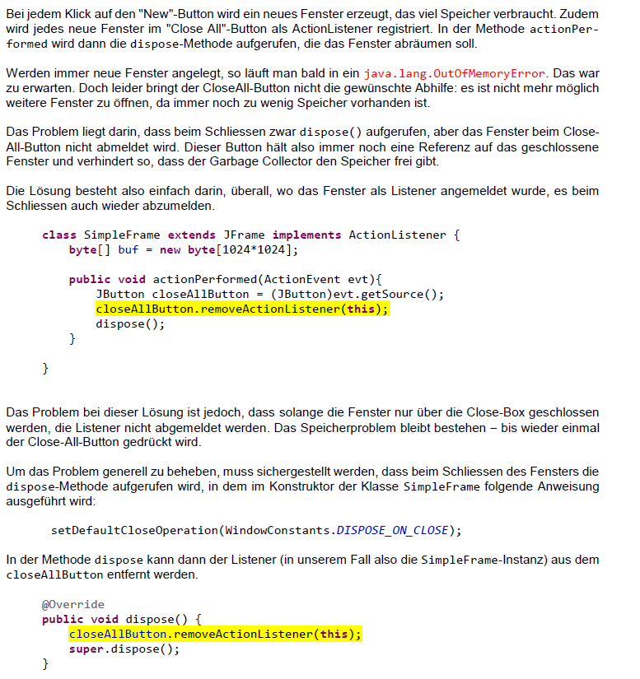

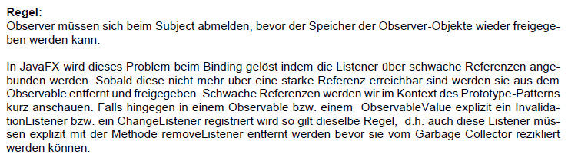

## Aufgabe 3: Nebeneffekte von Änderungen

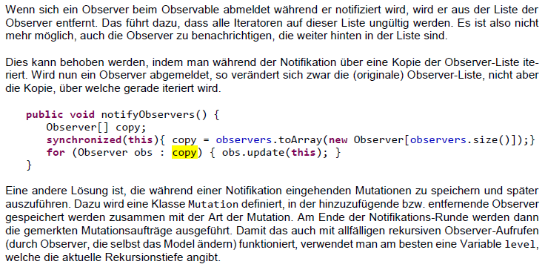

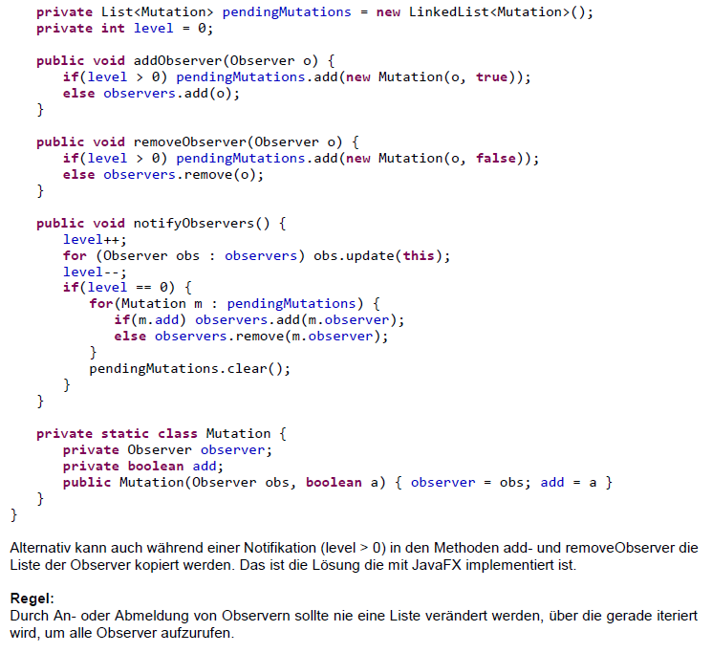

## Aufgabe 4: Zyklische Abhängigkeit

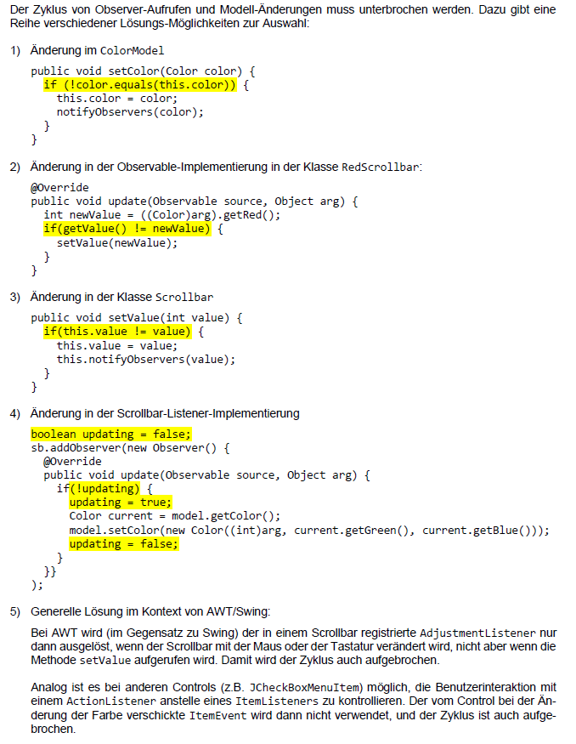



## Aufgabe 5: Kausalität von Änderungen

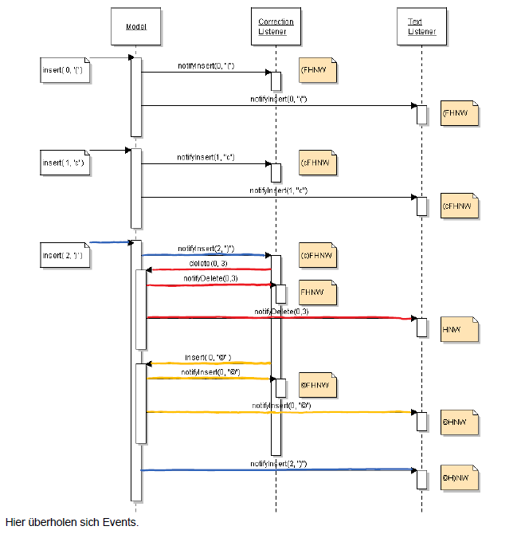

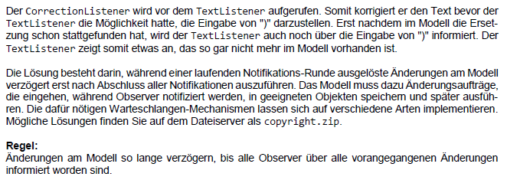

## Aufgabe 6: Was ist das Modell, wie wird es verändert?

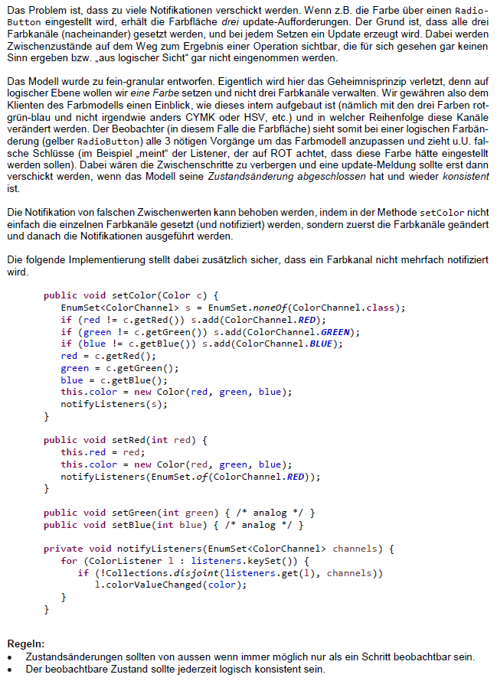

# Woche 4

## State Pattern

### Motivation

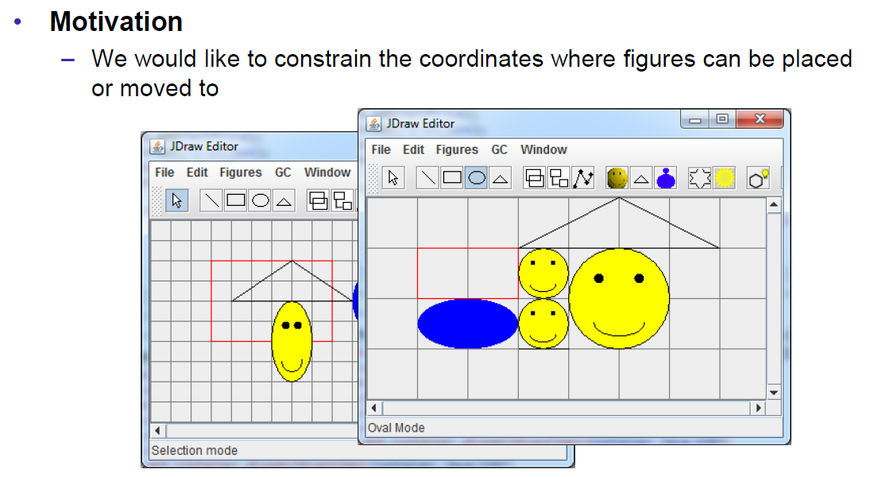

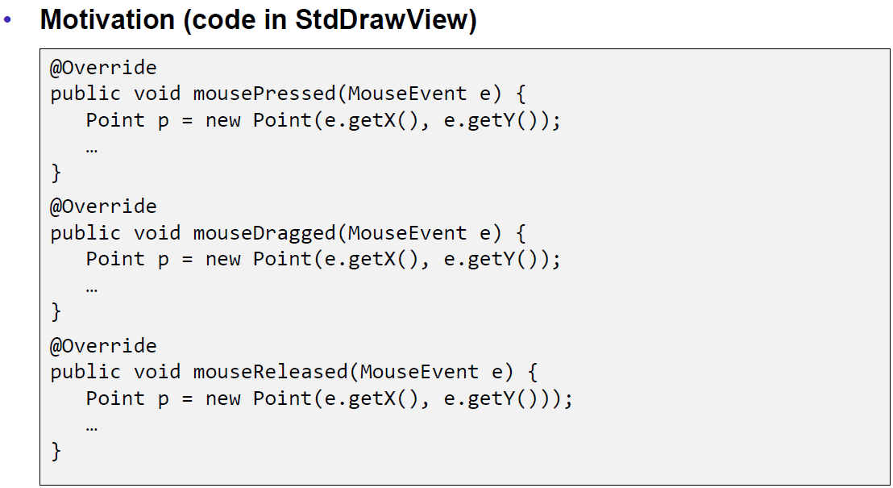

### Overview

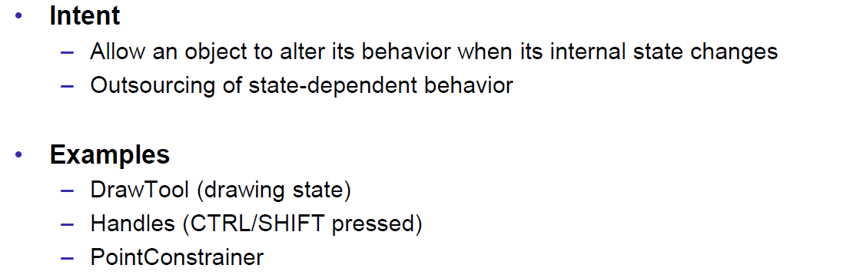

### Structure

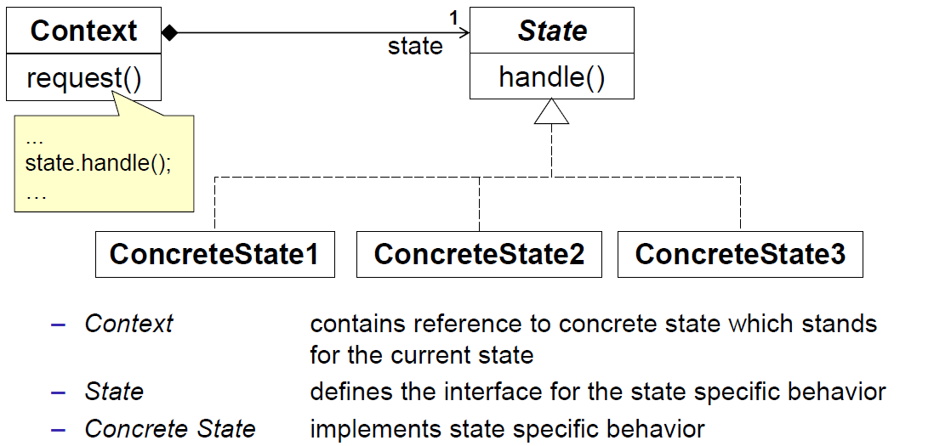

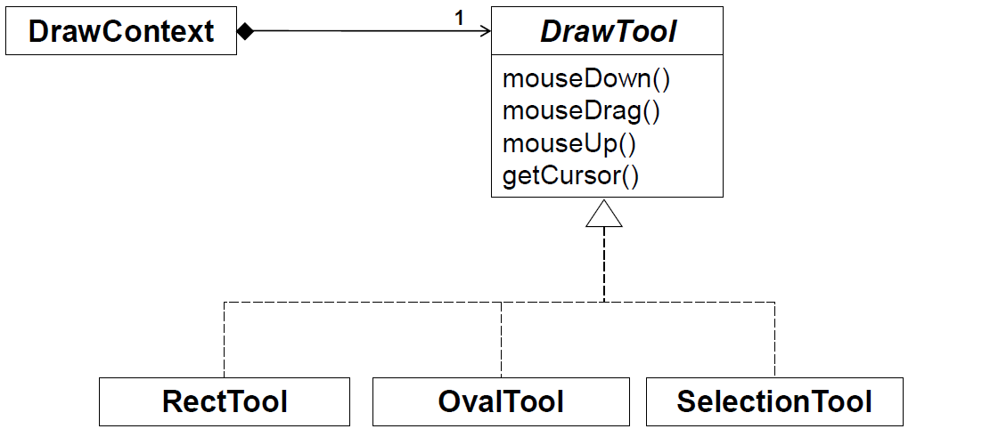

### Example

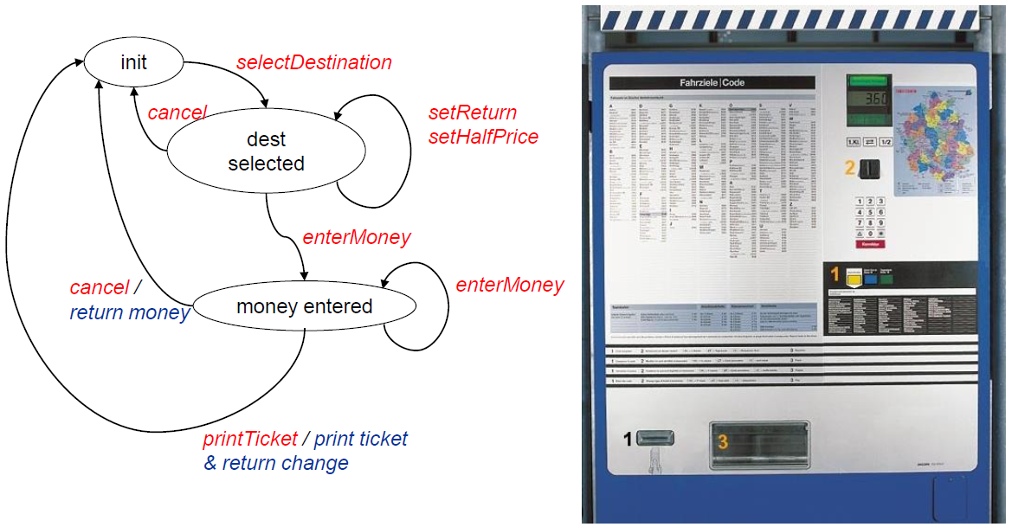

### Example (Without a State Pattern)

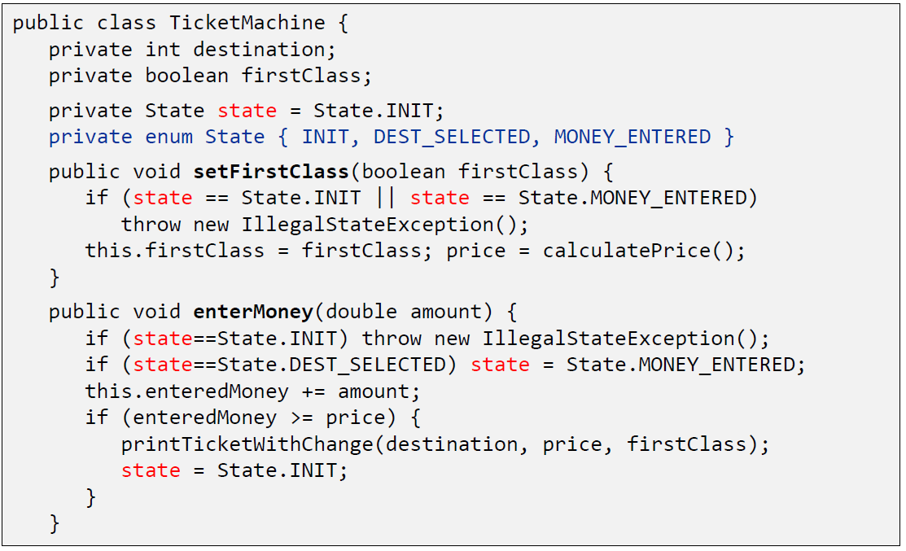

### Example (With a State Pattern)

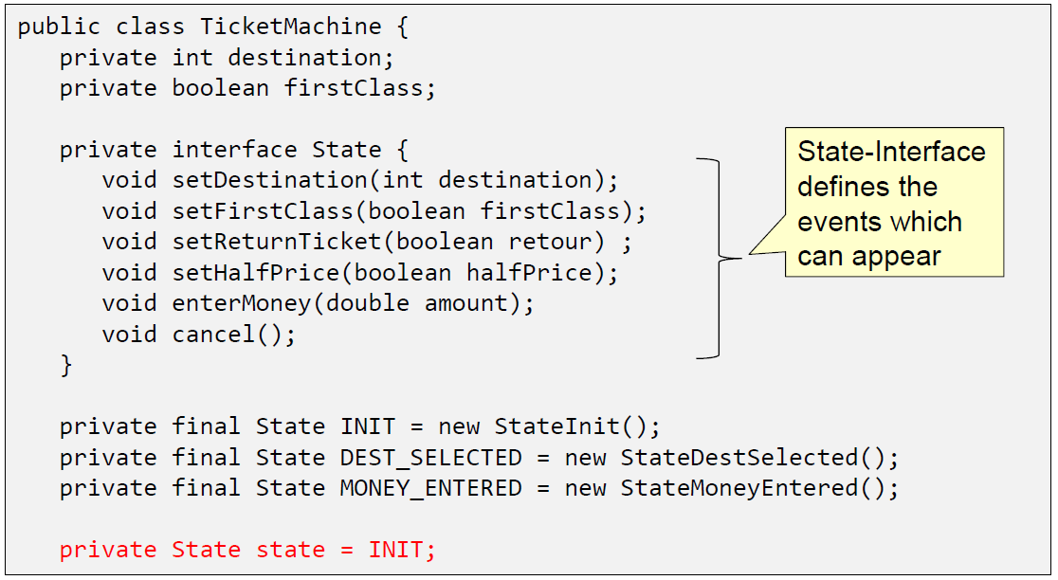

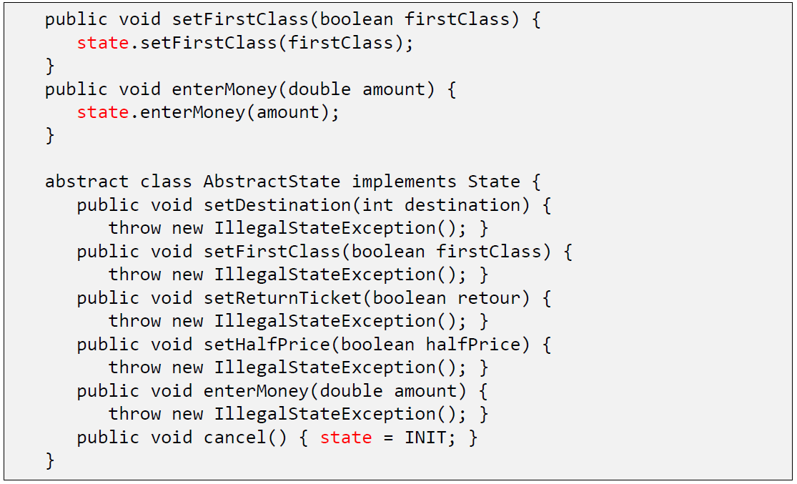

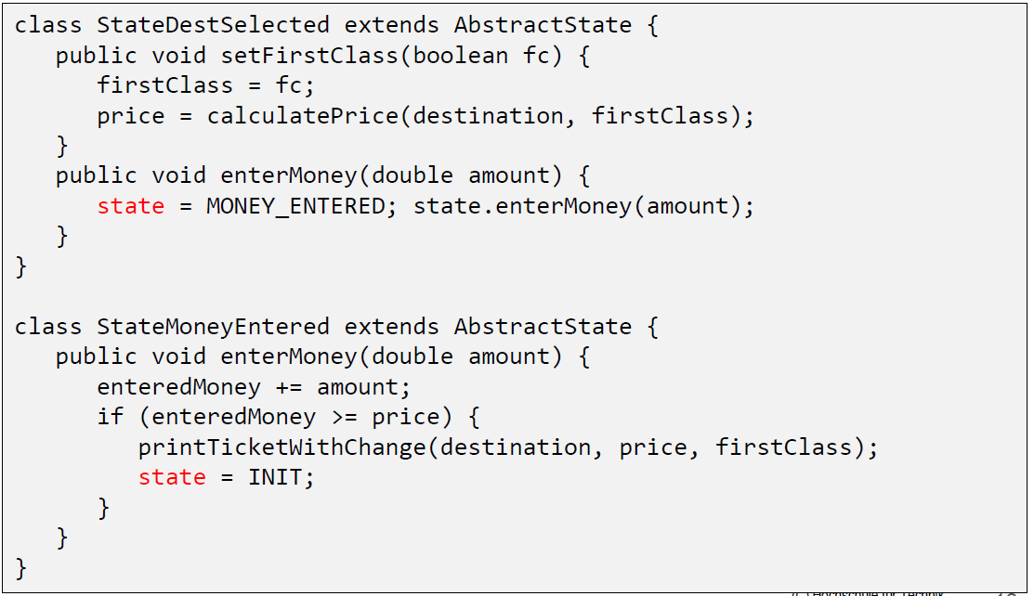

### Issues

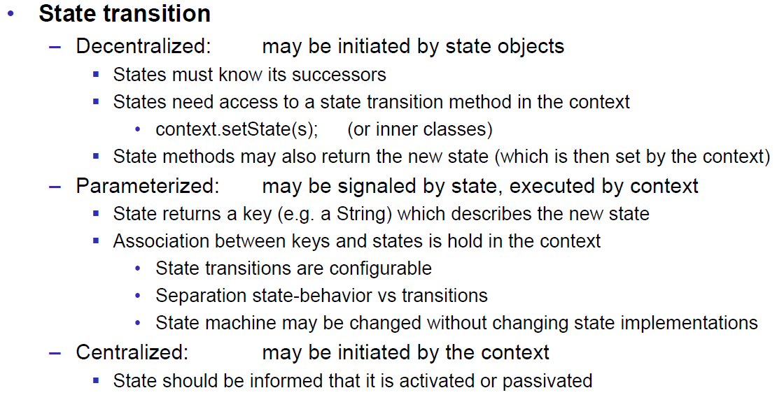

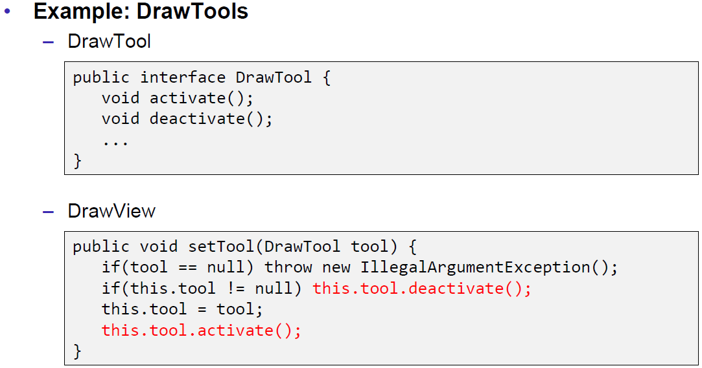

### Example

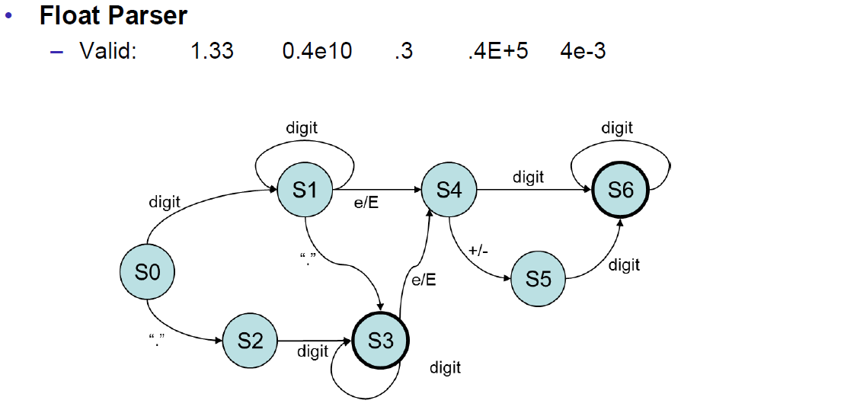

### Issues

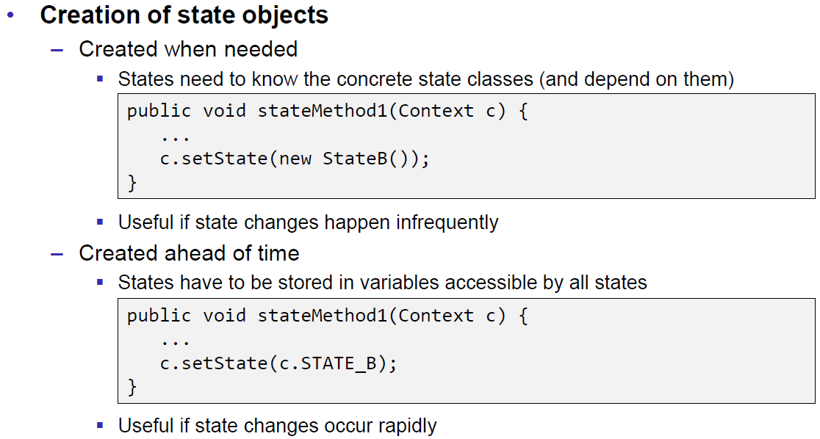

### Applicability

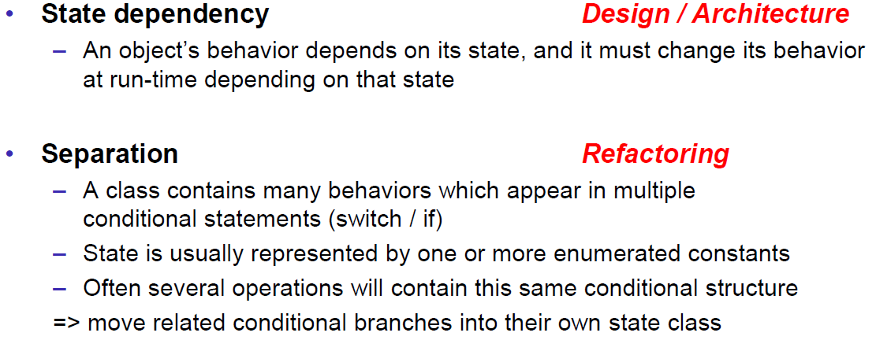

## Example for parsing a float Value

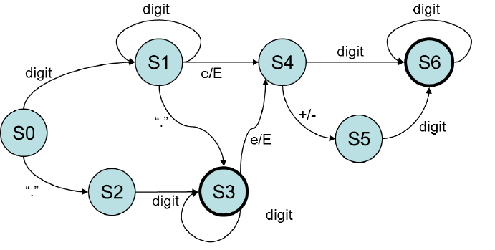



|  |
| --- |
| package patterns.state.parser;  import java.io.BufferedReader;  import java.io.InputStreamReader;  public class FloatConverter3 {    public static void main(String[] args) throws Exception {  BufferedReader r = new BufferedReader(new InputStreamReader(System.in));  String s = r.readLine();  while(s != null && s.length() > 0){  try {double d = parseFloat(s); System.out.println(d);}  catch(IllegalArgumentException e){System.out.println("Illegal Format");}  s = r.readLine();  }  }    enum State {  S0() {  @Override public State handleDigit(FloatData data, int value) { data.m = value; return S1; }  @Override public State handleDot(FloatData data){return S2;}  },  S1() {  @Override public State handleDigit(FloatData data, int value) { data.m = 10*data.m + value; return S1; }  @Override public State handleDot(FloatData data) { return S3; }  @Override public State handleE(FloatData data) { return S4; }  },  S2() {  @Override public State handleDigit(FloatData data, int value) { data.m = data.m + value/data.quo; data.quo = 10*data.quo; return S3; }  },  S3() {  @Override public State handleDigit(FloatData data, int value) { data.m = data.m + value/data.quo; data.quo = 10*data.quo; return S3; }  @Override public State handleE(FloatData data){return S4;}  },  S4() {  @Override public State handlePlus(FloatData data) { return S5; }  @Override public State handleMinus(FloatData data) { data.exp_sign = -1; return S5; }  @Override public State handleDigit(FloatData data, int value) { data.exp = value; return S6; }  },  S5() {  @Override public State handleDigit(FloatData data, int value) { data.exp = value; return S6; }  },  S6() {  // @Override public State handleDigit(FloatData data, int value) { data.exp = 10*data.exp + value; return S6; }  },  ERROR;  public State handleDigit(FloatData data, int value) { return ERROR; }  public State handleE(FloatData data) { return ERROR; }  public State handleDot(FloatData data) { return ERROR; }  public State handlePlus(FloatData data) { return ERROR; }  public State handleMinus(FloatData data) { return ERROR; }  }  static class FloatData {  double m = 0, quo=10;  int exp = 0, exp_sign = 1;  double getValue() { return m * Math.pow(10, exp_sign * exp); }  }  private static double parseFloat(String str) {  State s = State.S0;  FloatData data = new FloatData();  int pos = 0;  while(s != State.ERROR && pos < str.length()) {  char ch = str.charAt(pos++);  if(Character.isDigit(ch)) s = s.handleDigit(data, Character.getNumericValue(ch));  else if(ch == '.') s = s.handleDot(data);  else if(ch == '+') s = s.handlePlus(data);  else if(ch == '-') s = s.handleMinus(data);  else if(ch == 'E') s = s.handleE(data);  else if(ch == 'e') s = s.handleE(data);  else s = State.ERROR;  }  if(s == State.S3 || s == State.S6) {  return data.getValue();  }  else {  throw new IllegalArgumentException();  }  }  } |

# Woche 5

## Strategy Pattern

### Overview

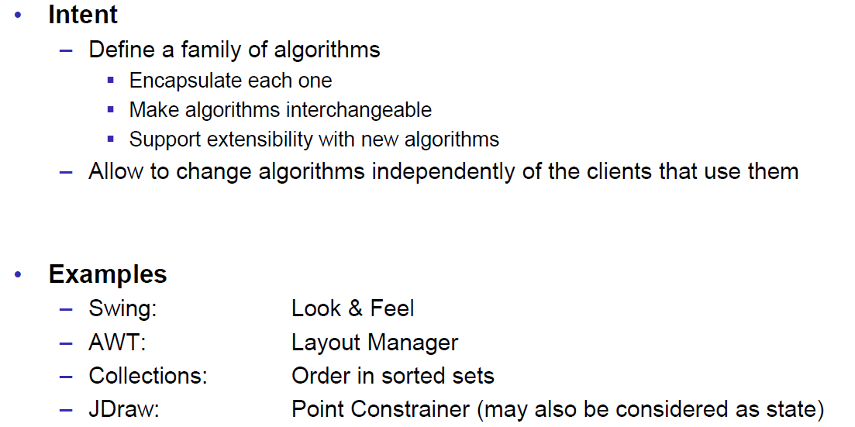

### Structure

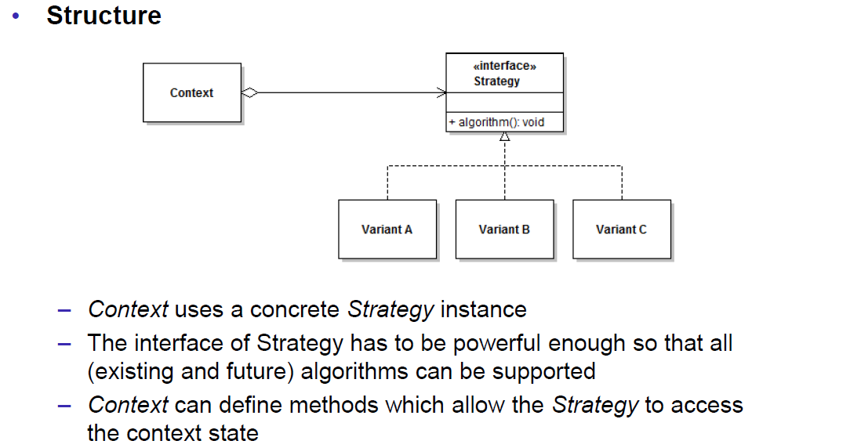

### Motivation

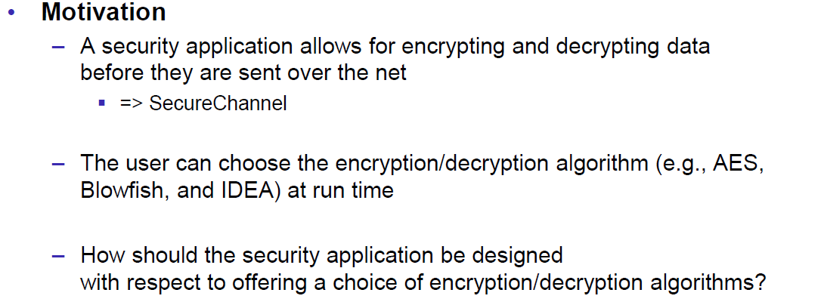

### Example

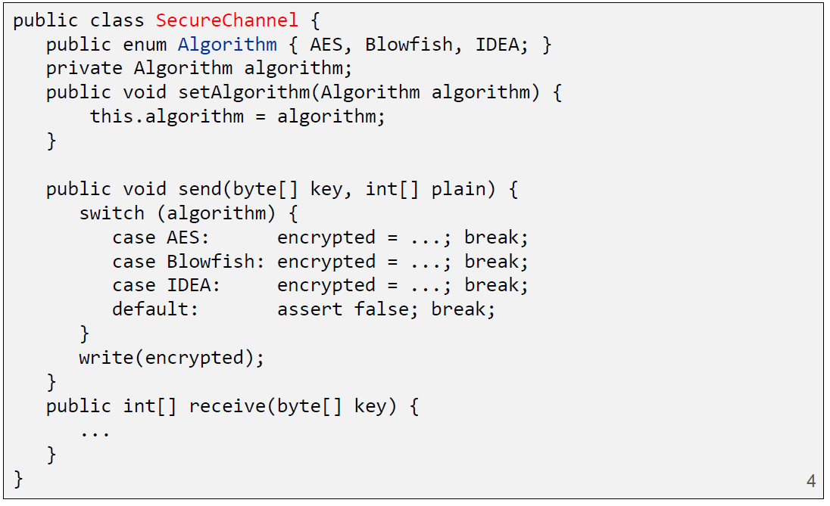

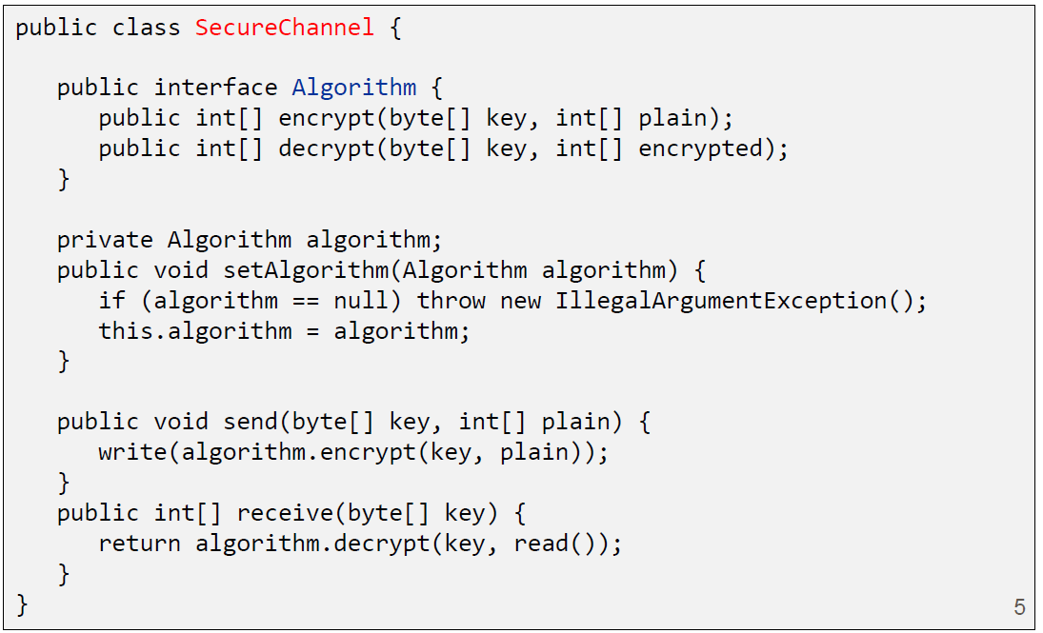

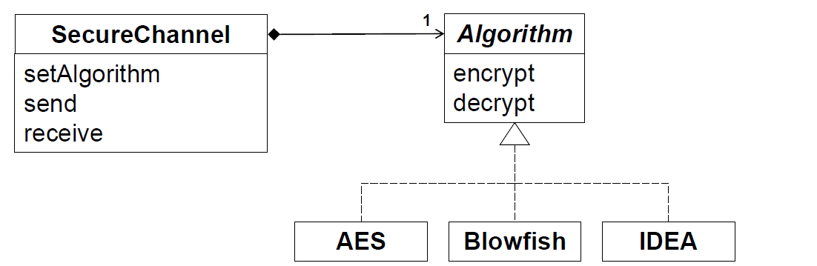

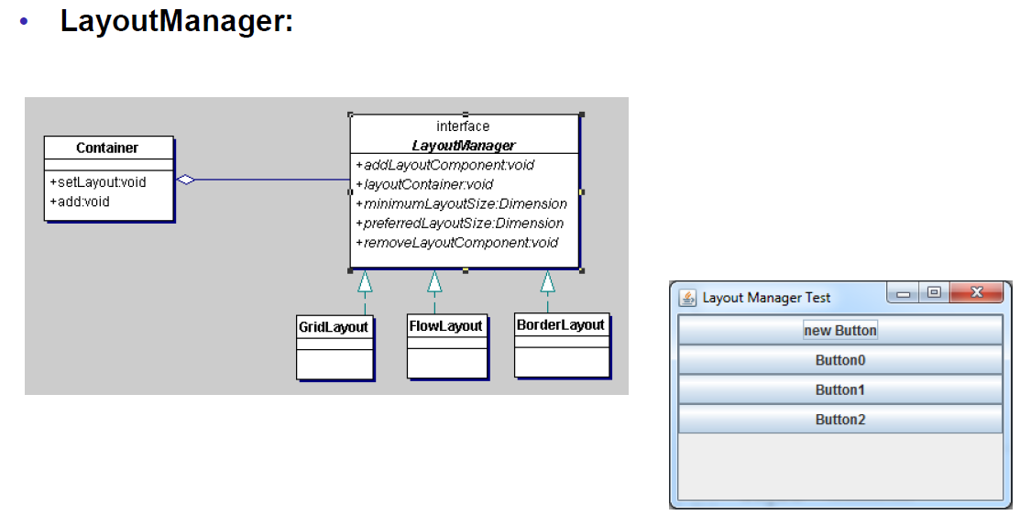

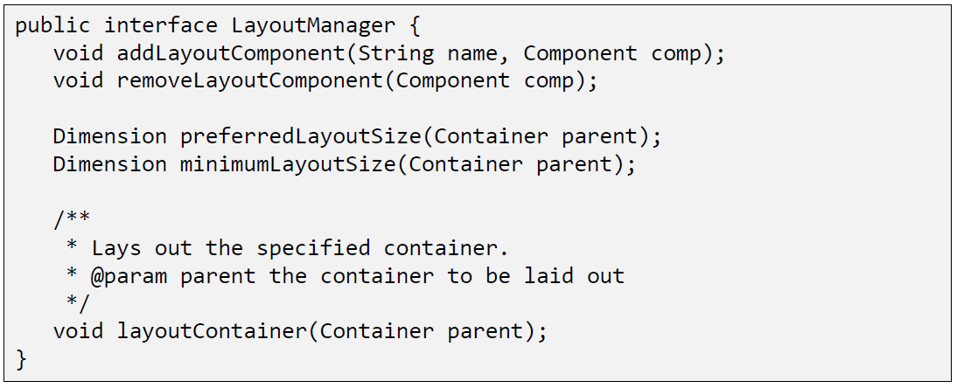

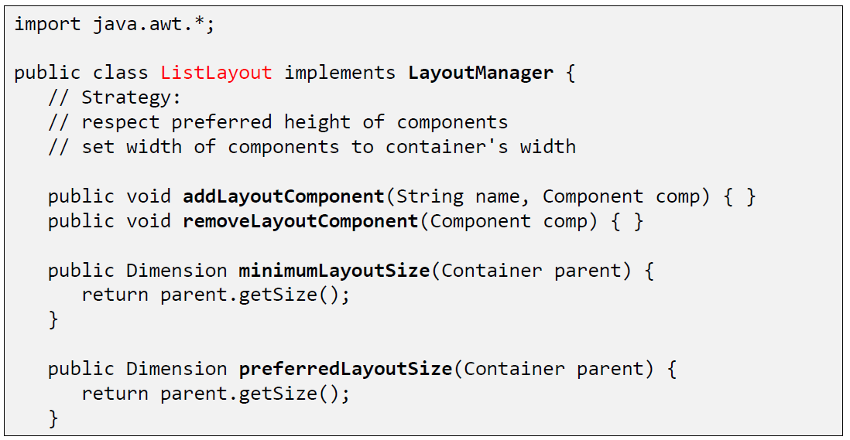

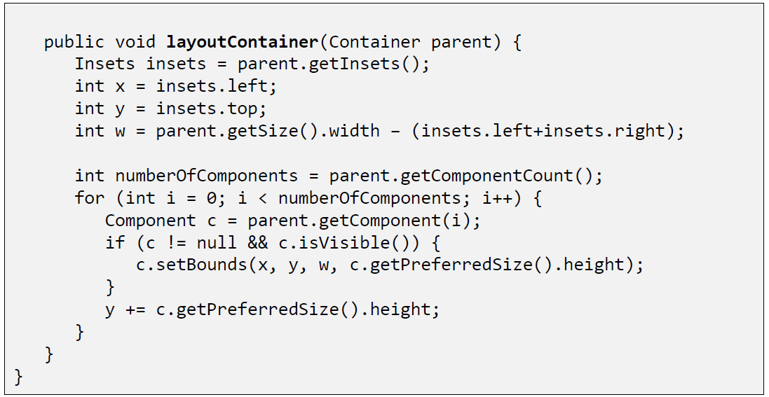

### Preconditions

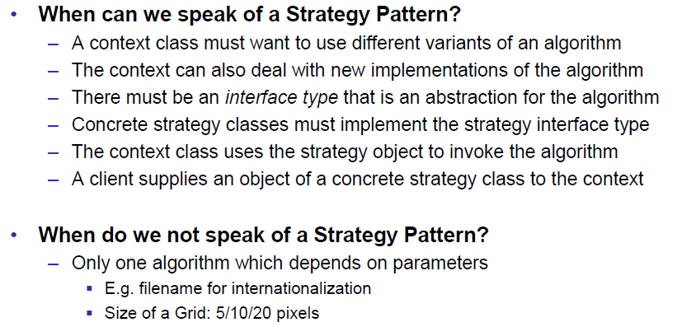

### Applicability

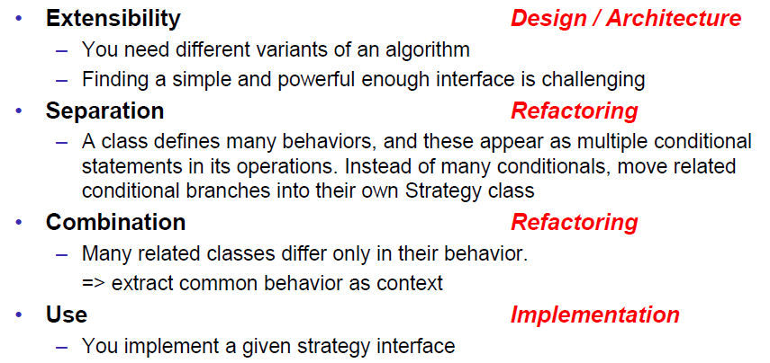

## Strategy vs. State

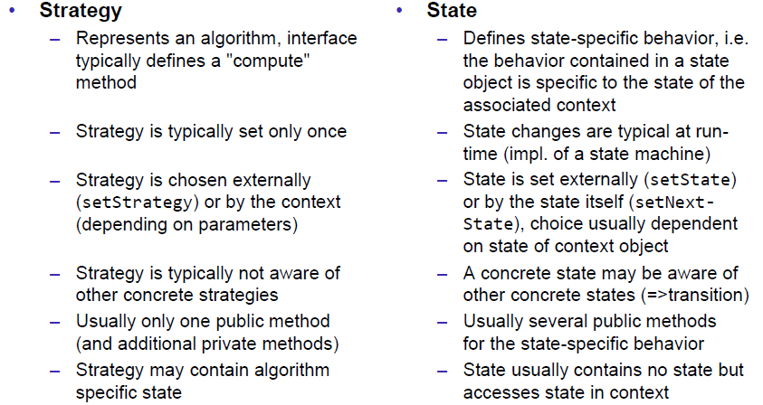

## Strategy vs. Inheritance Approach

* Strategy
  + Provide an interface that will be implemented
  + Advantages
    - Exchange of the strategy is possible at runtime
    - Strategy is shareable
    - Strategy could use several strategies
* Inheritance
  + Provide an abstract class that will be extended
  + Advantages
    - All information from the context is available in subclasses, direct access to the context, including protected parts
  + Disadvantages
    - Violates the Single Responsibility Principle, i.e. context and strategy are mixed
    - Inheritance dimension is used

## Null Object Pattern

### Overview

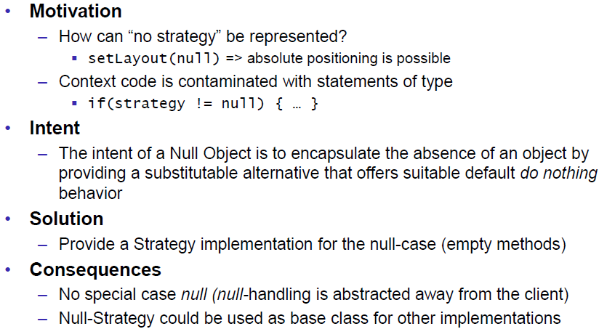

### NullLayout

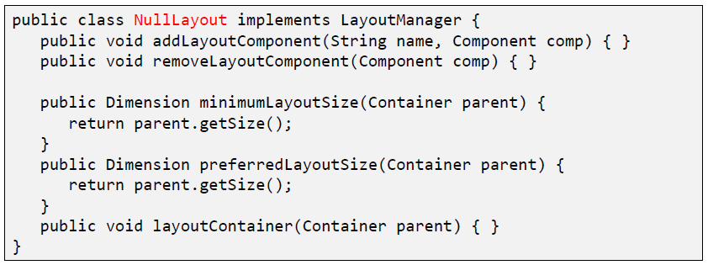

# Woche 6

## Composite Pattern

### Motivation

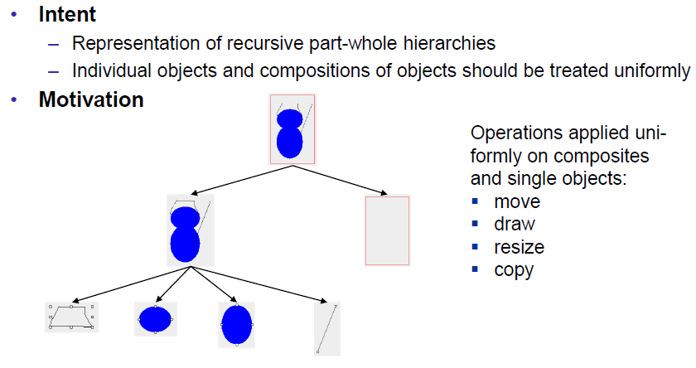

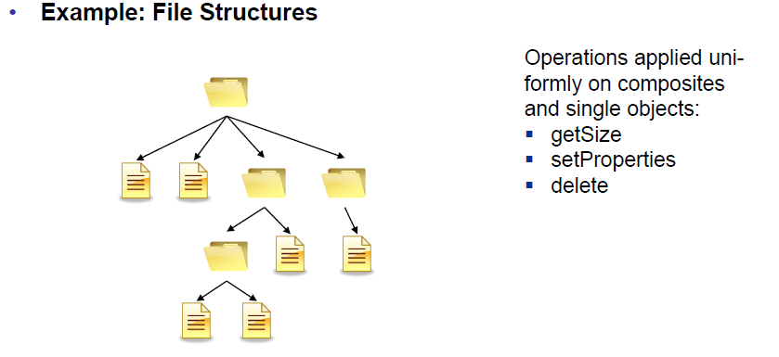

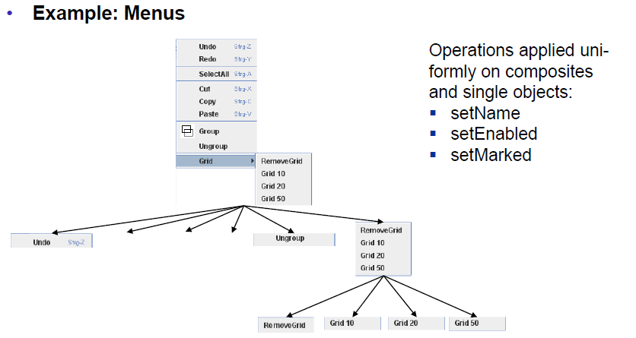

### Structure

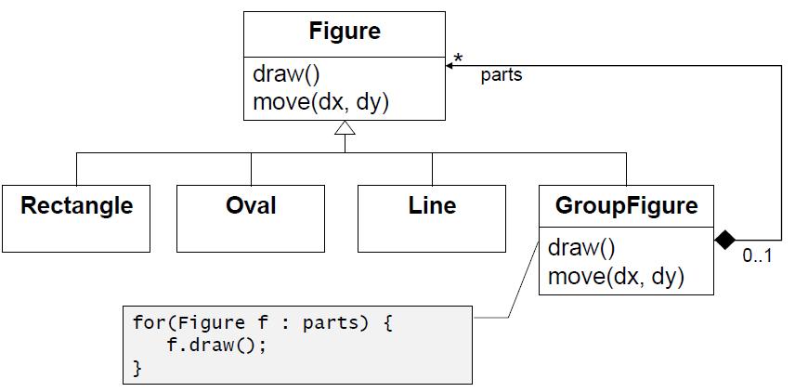

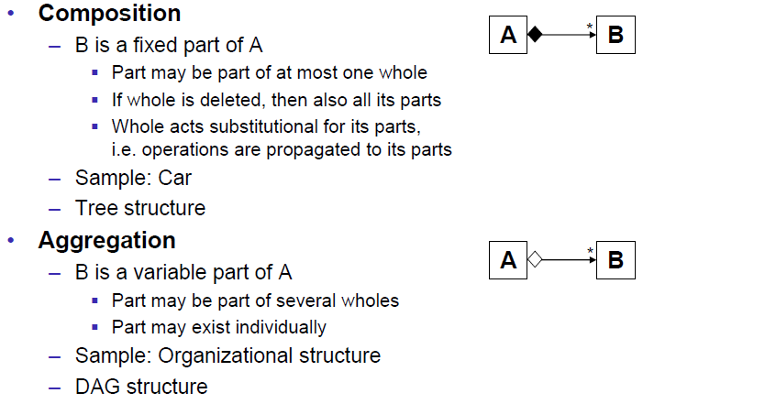

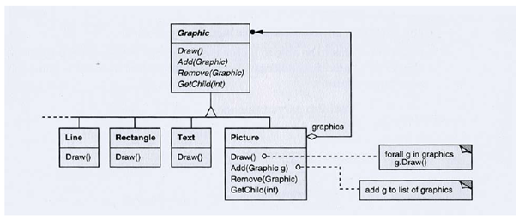

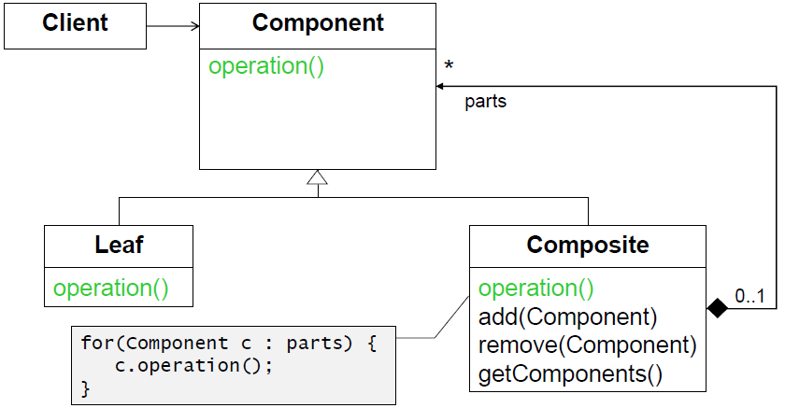

### Participants

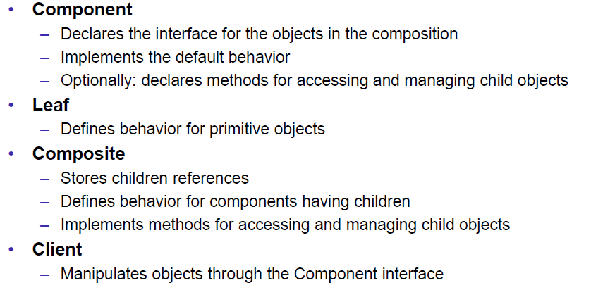

## Example Group Figure

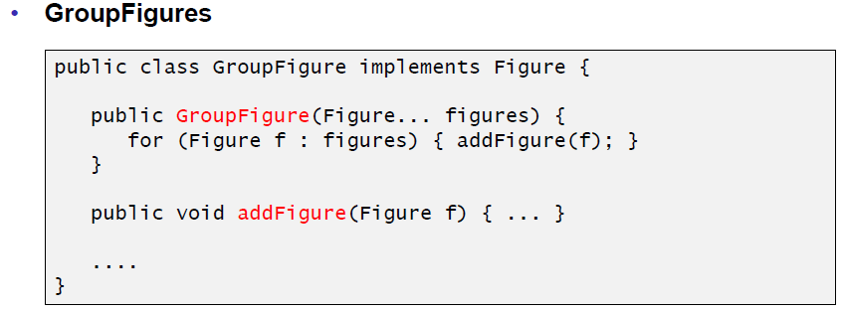

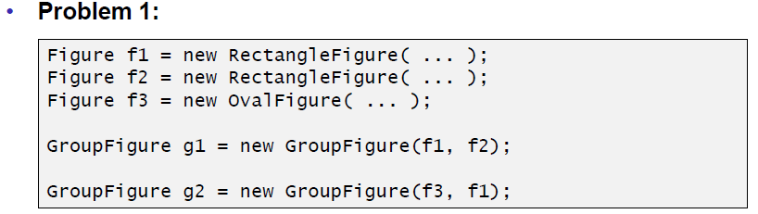

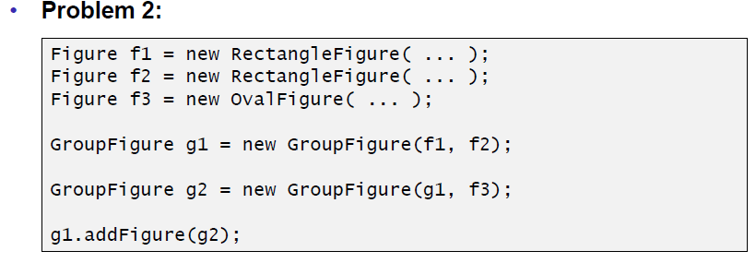

## Structure of the Composite Pattern

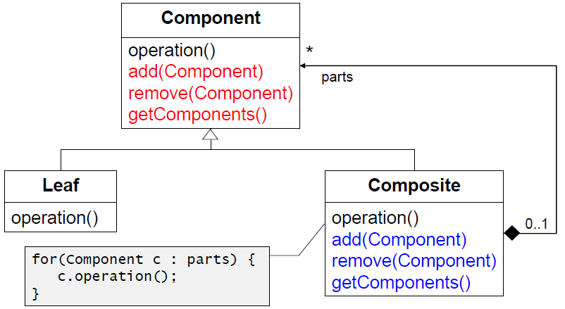

## Composite Pattern

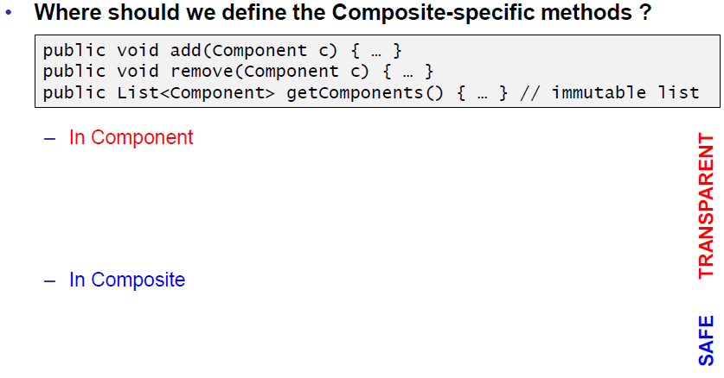

## Composite Pattern in AWT

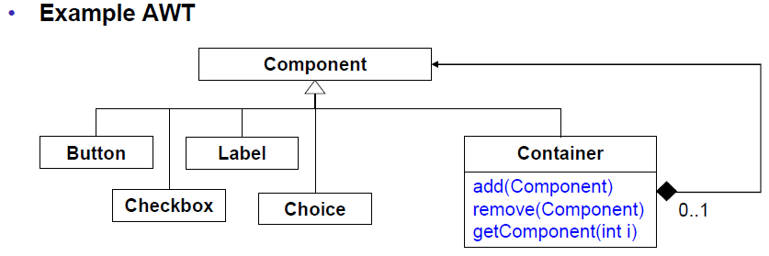

## Composite Pattern in Swing

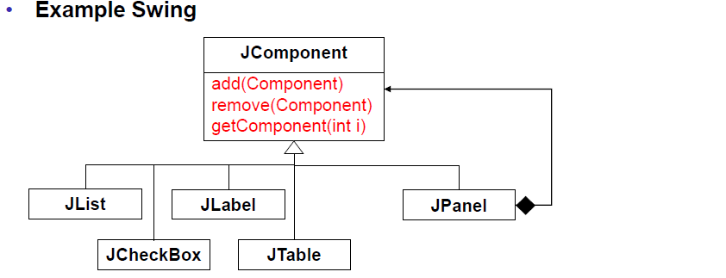

## Composite Pattern in AWT/Swing

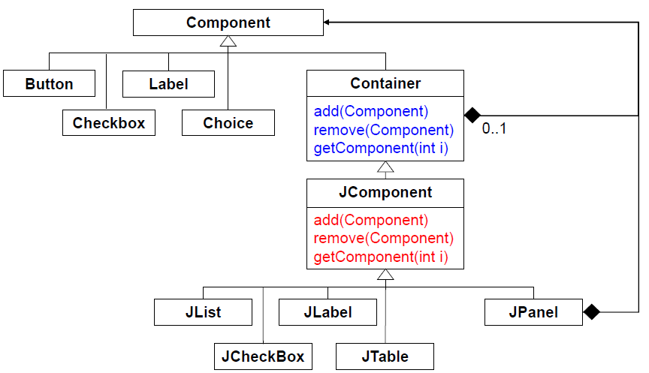

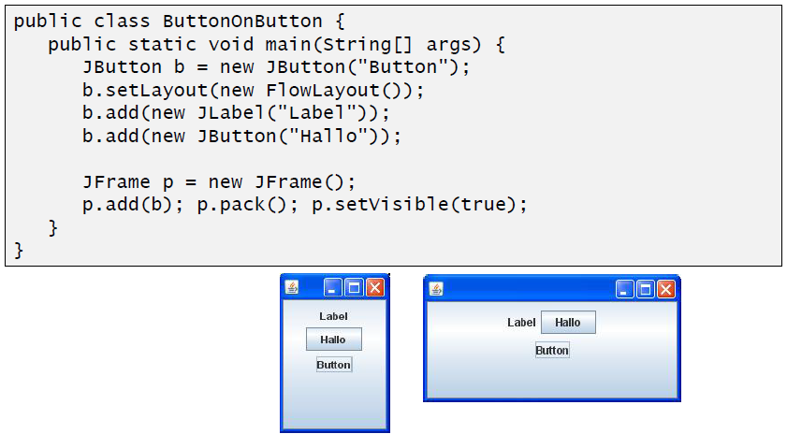

## Composite Pattern in JavaFX Scene Graphs

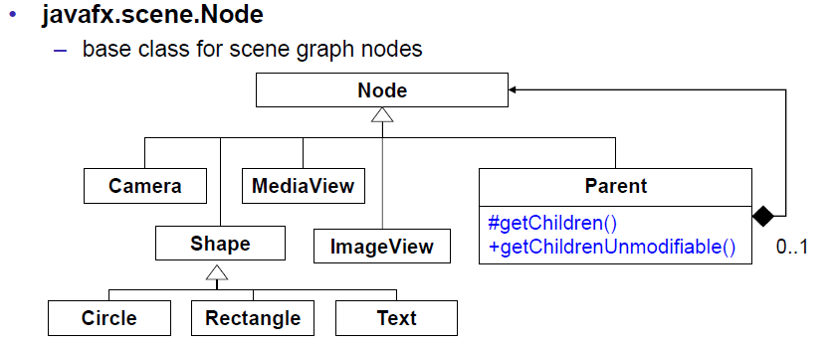

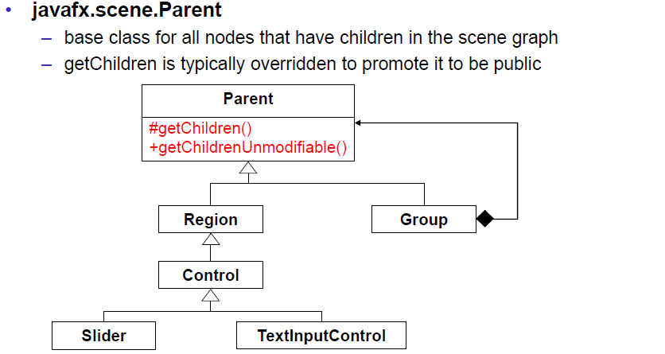

# Woche 7

## Prototype Pattern

### Motivation

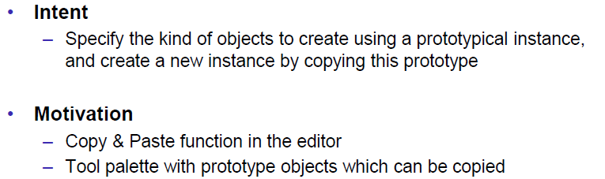

### Problem

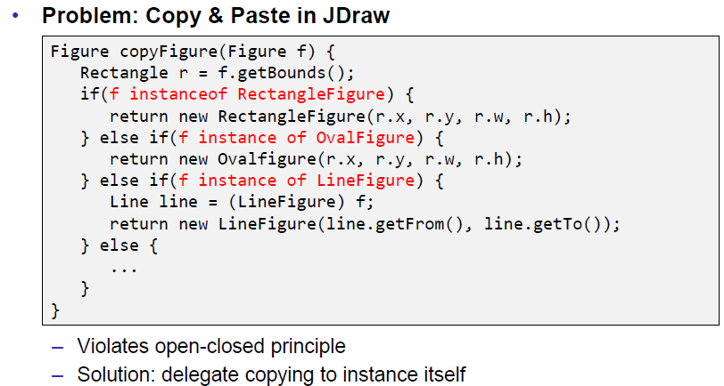

### Structure

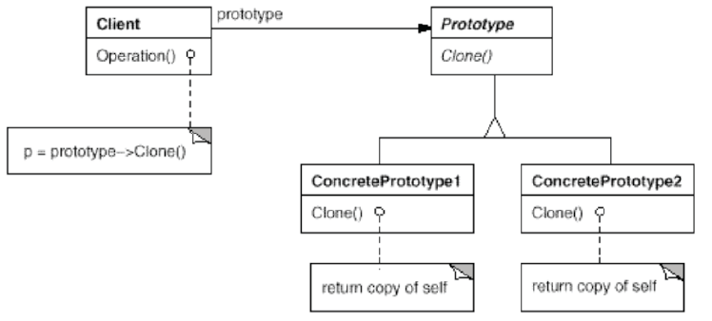

### Implementation

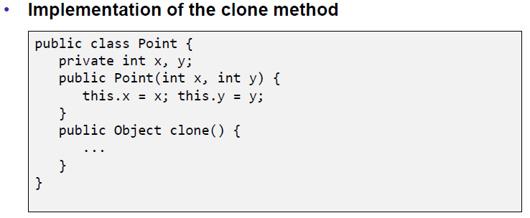

## Object.clone

### Method

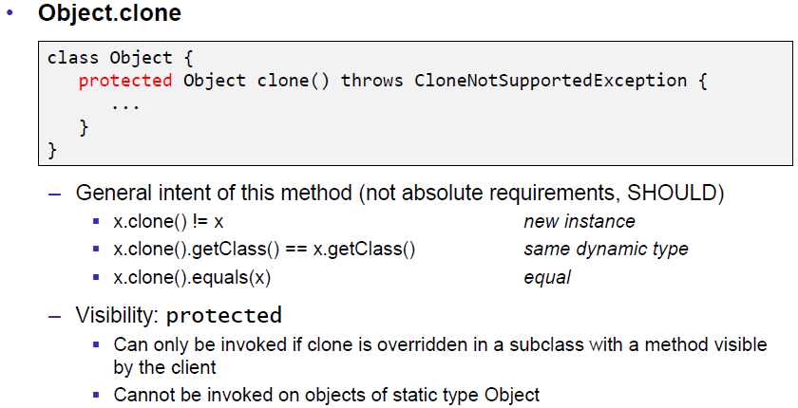

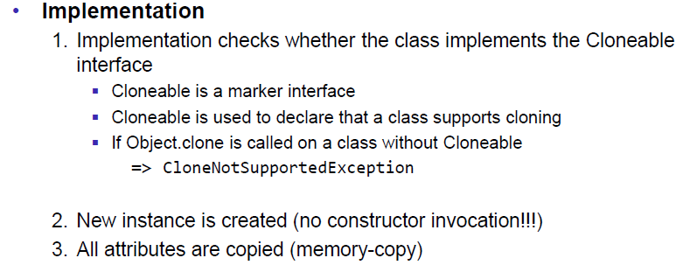

### Harmony Implementation

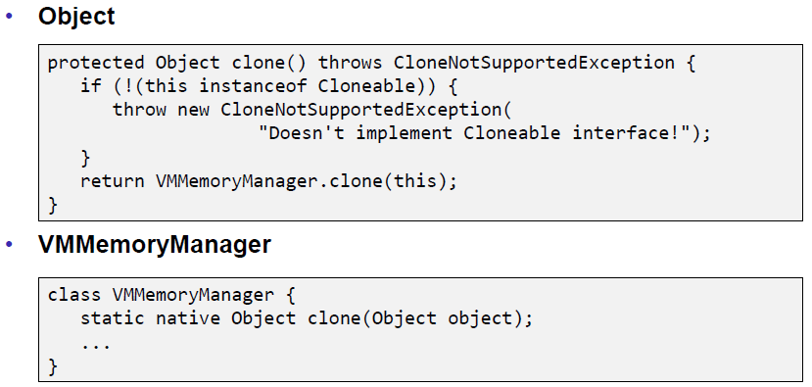

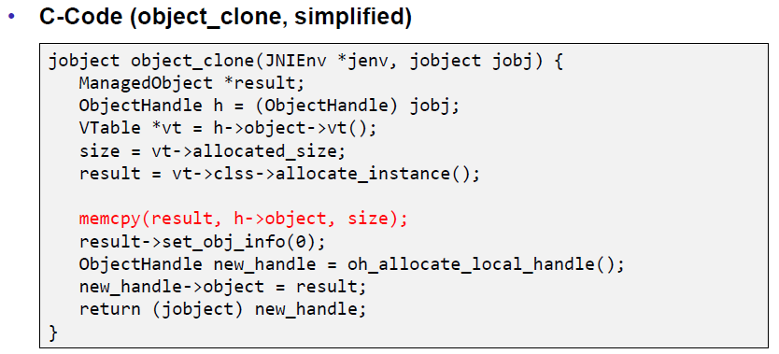

### Example Point

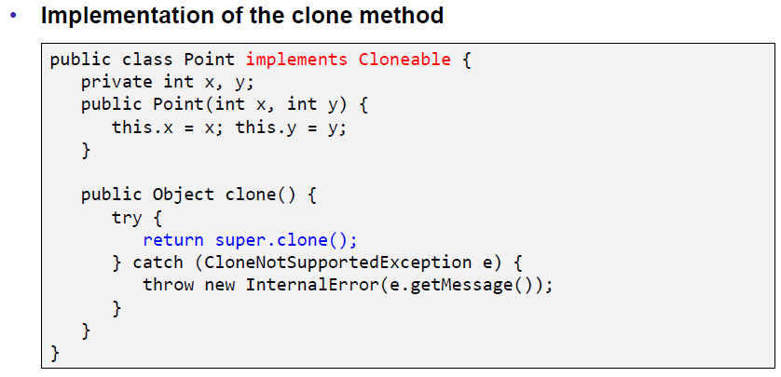

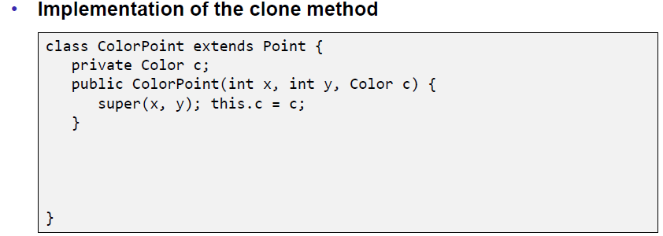

## Deep vs. Shallow Copy

### Source Code

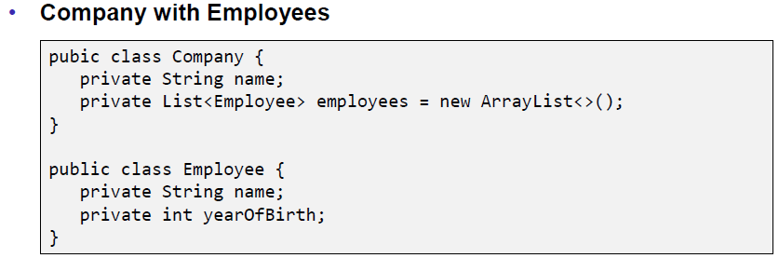

### Normal Object

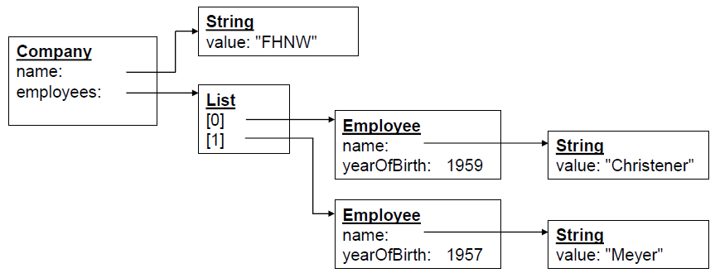

### Shallow Copy

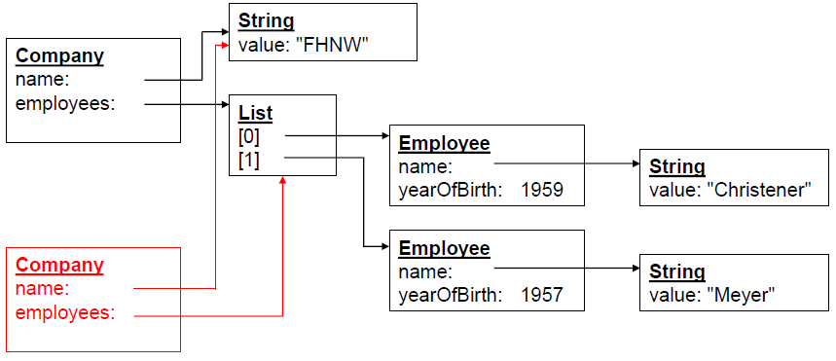

### Deep Copy

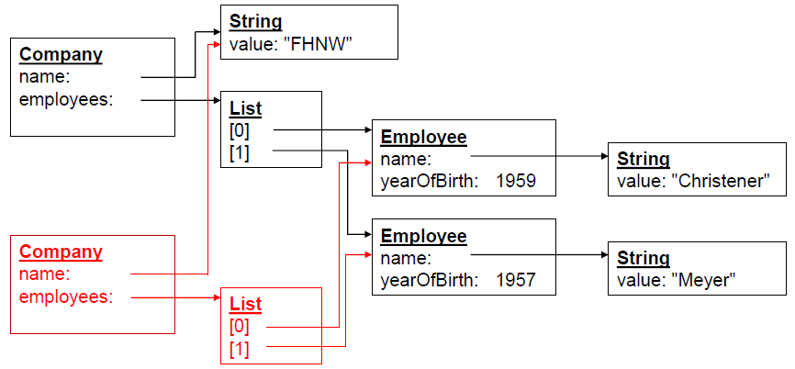

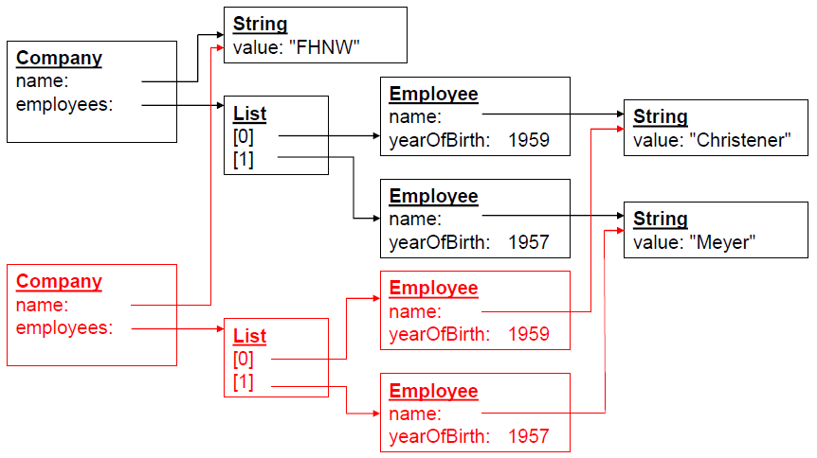

## Remarks

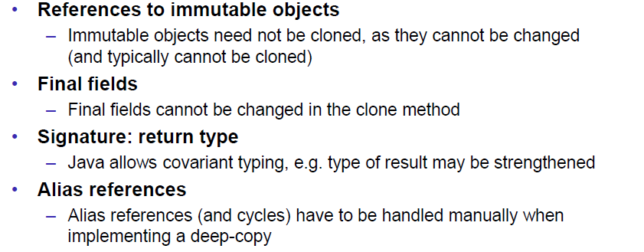

## Clone with Copy Constructor

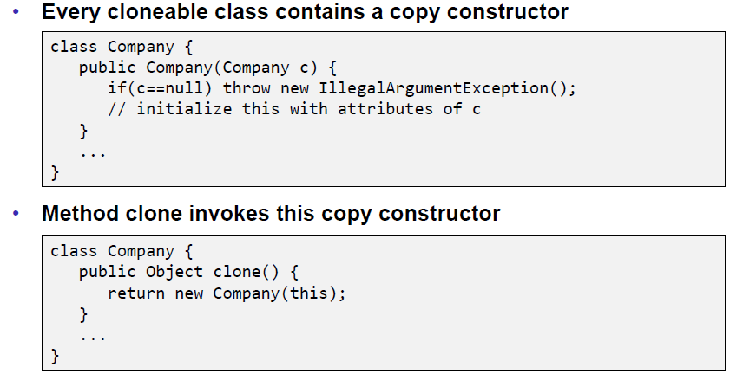

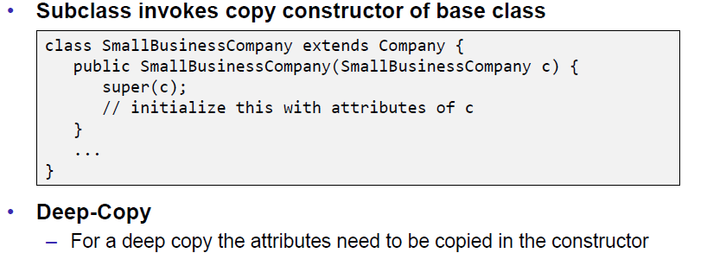

# Woche 8

## Information Hiding

### Information Hiding

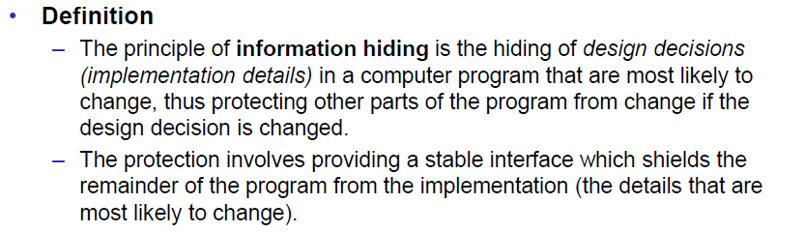

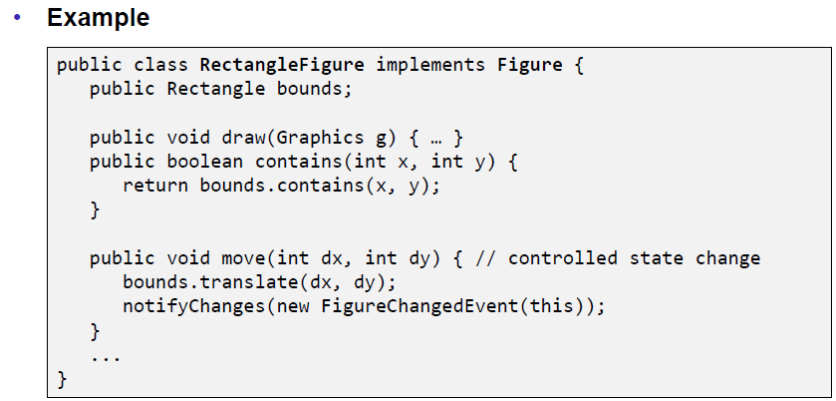

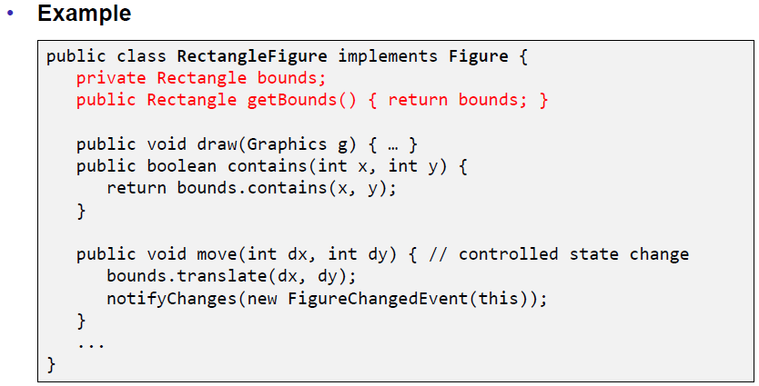

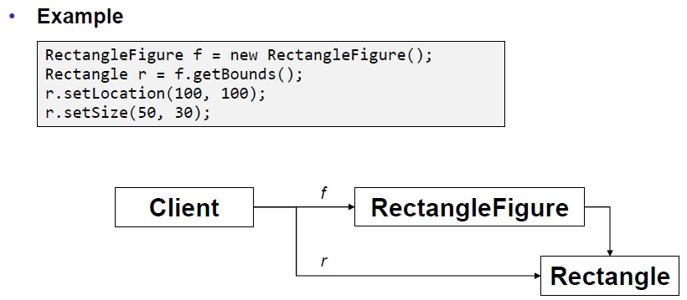

### Mutable Parameters

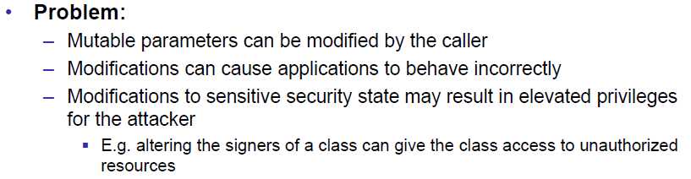

### Example from JDK 1.1

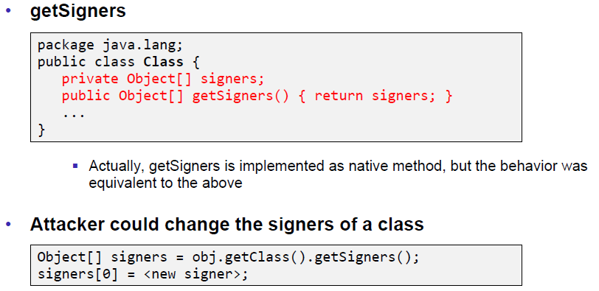

### Robust Programming Guideline

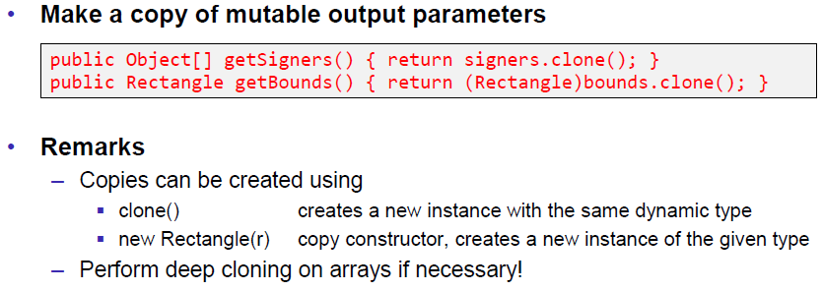

### Rectangle Example revisited

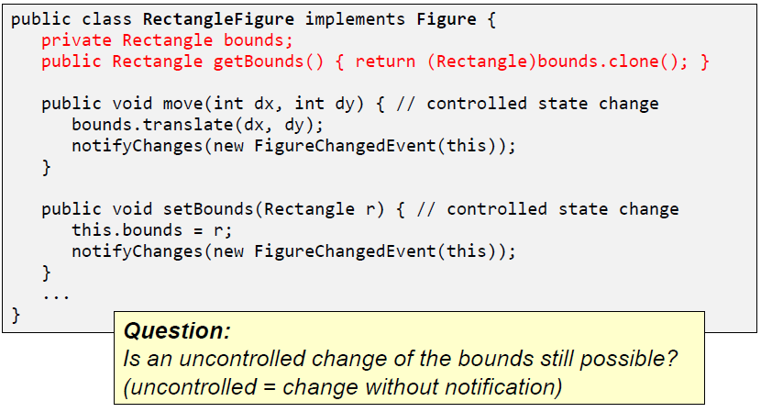

### Robust Programming Guideline

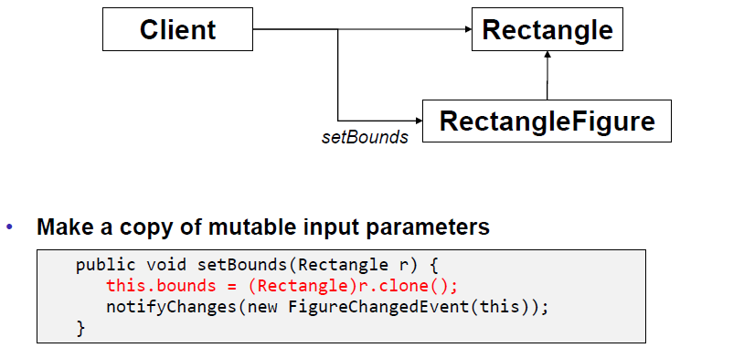

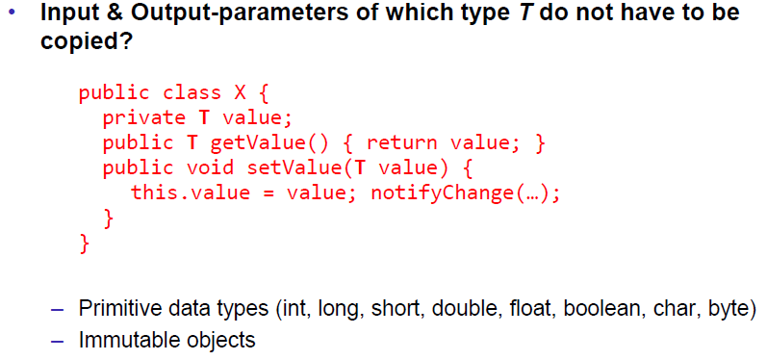

## Immutability

### Immutable Objects

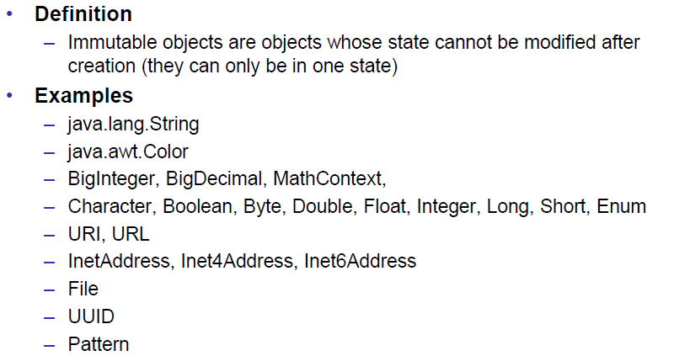

### Benefits of Immutable Objects

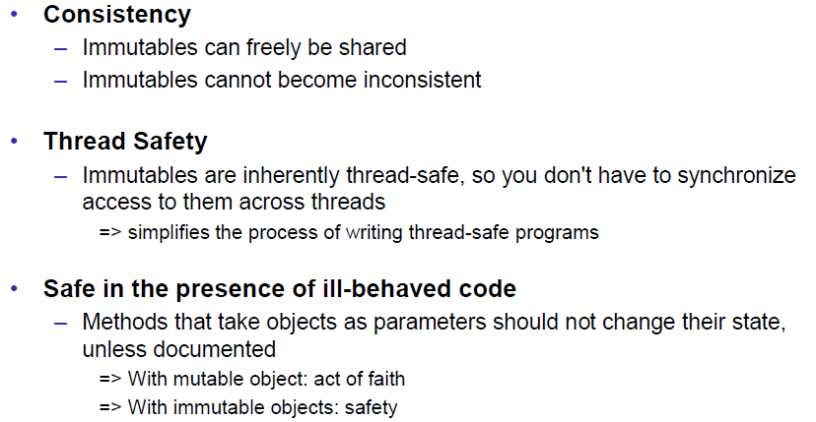

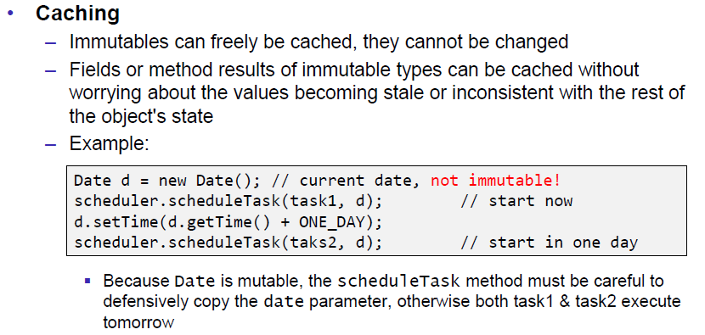

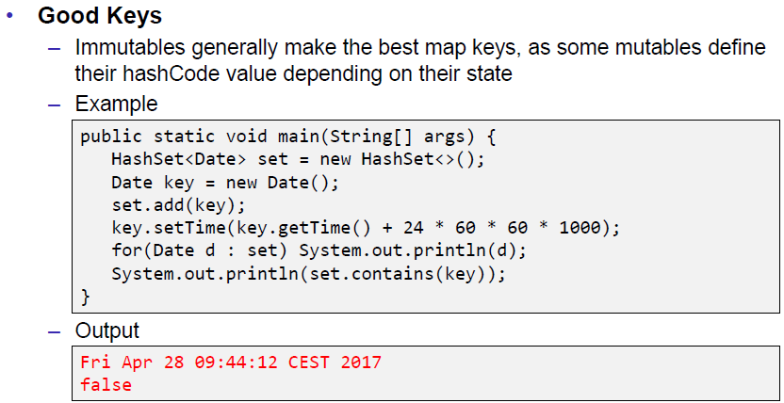

### Fraction as Example of a mutable Object

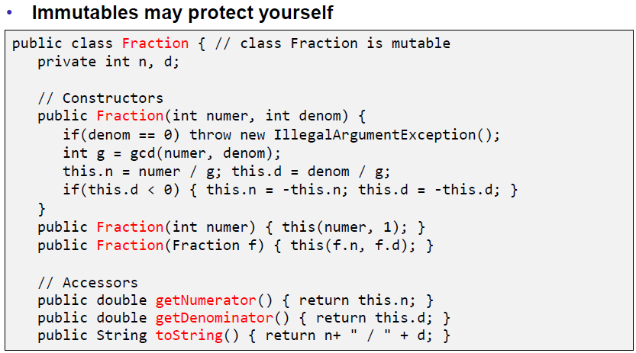

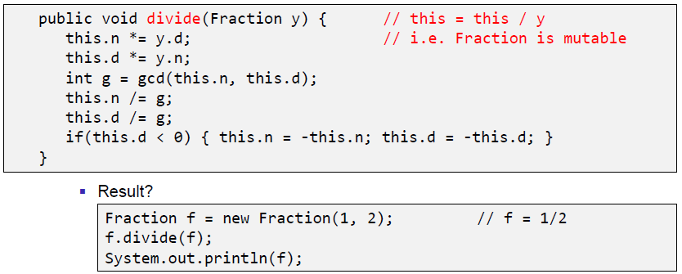

### Persistent & Immutable Data Structures

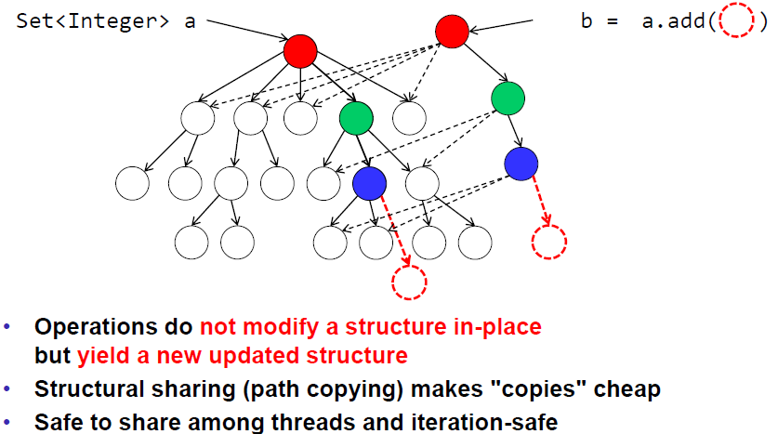

## Summary

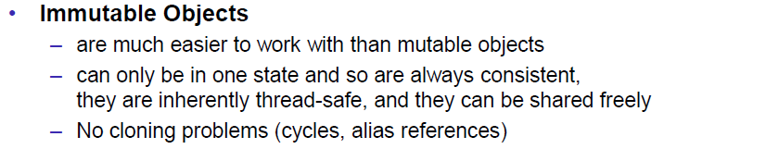

# Woche 9

In Woche 9 fand die Prüfung statt.

# Woche 10

## Vibrating & Skin Phones

### Problem

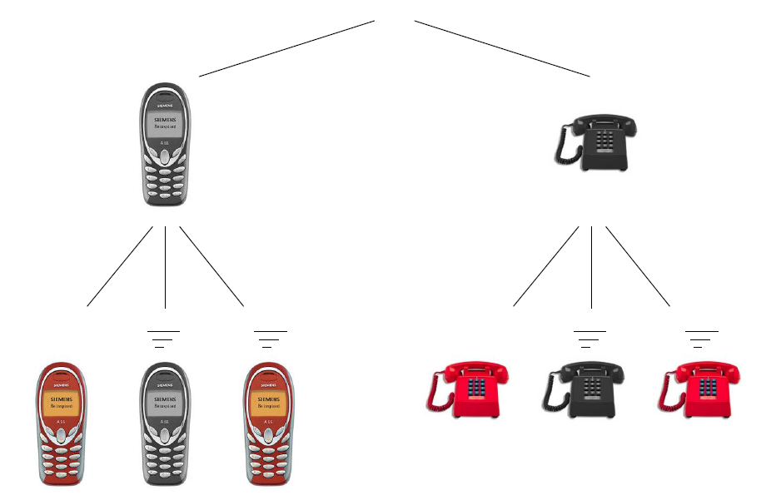

### Implementation with Inheritance

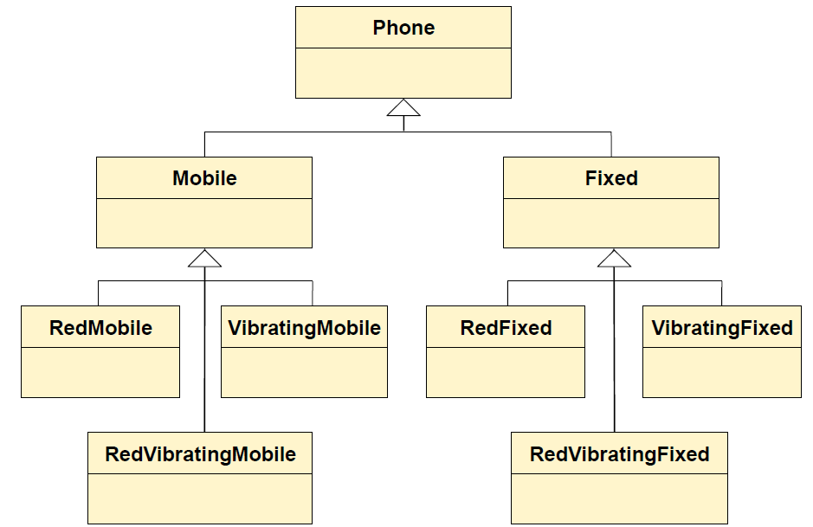

### Implementation with a Decorator

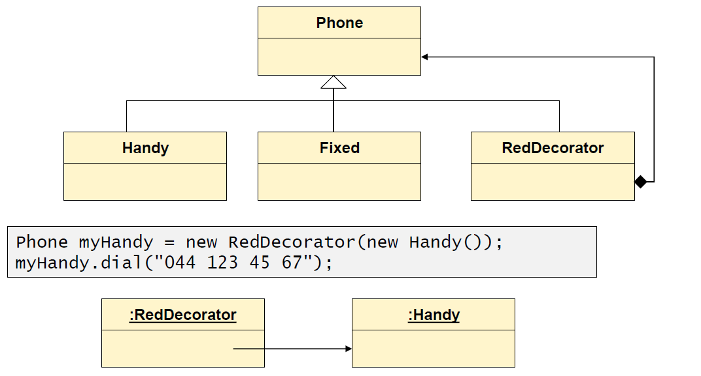

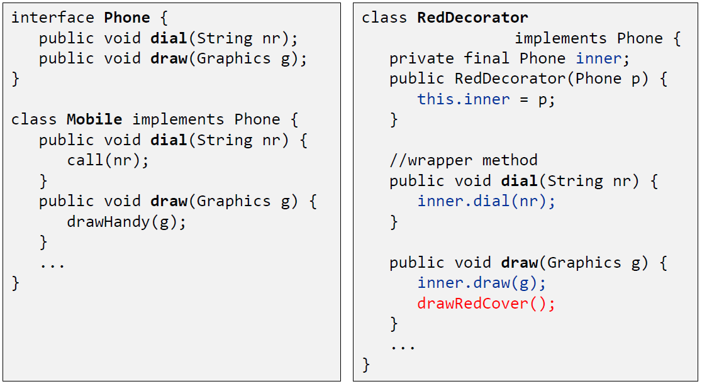

## Decorator Pattern

### Structure

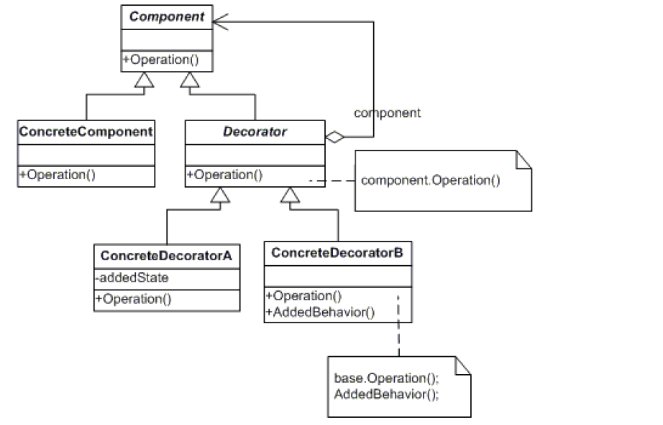

### Dynamics

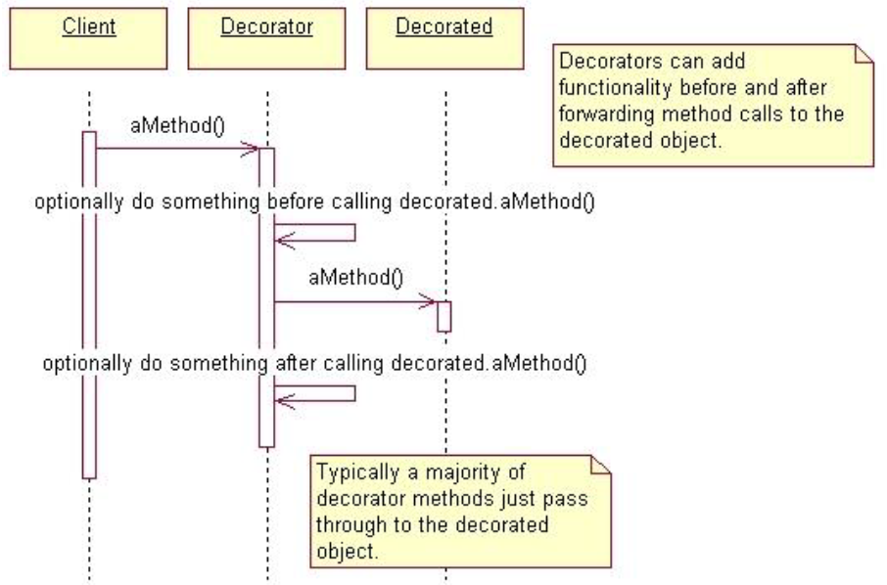

### Number of Classes

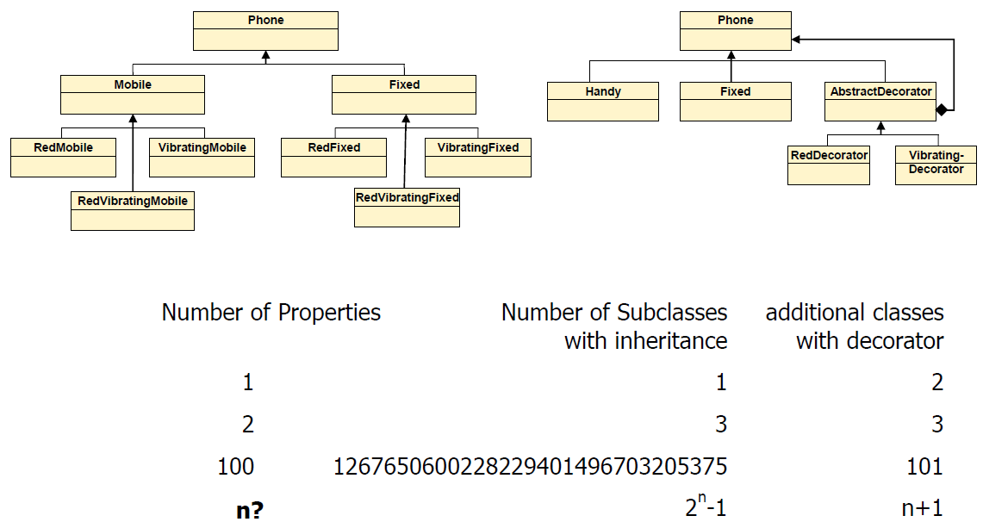

### Number of Classes (With Inheritance)

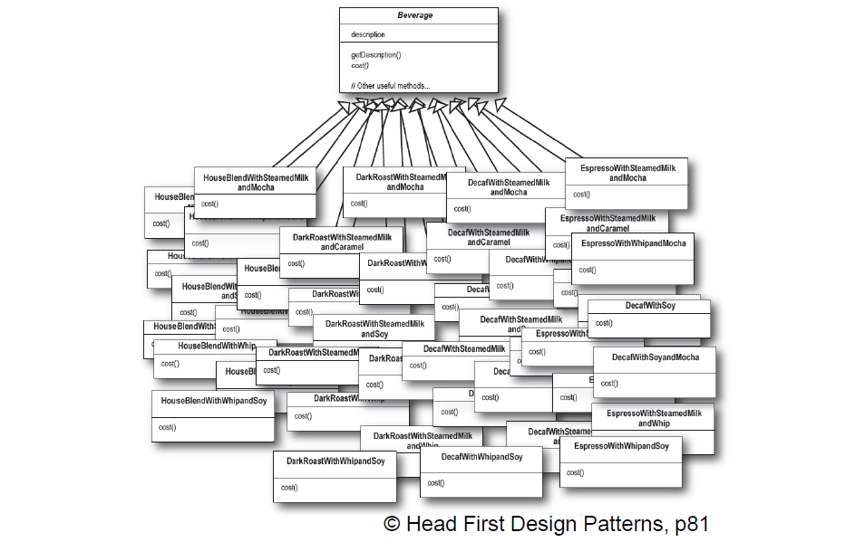

## Java API Samples of the Decorator Pattern

### JScrollPane

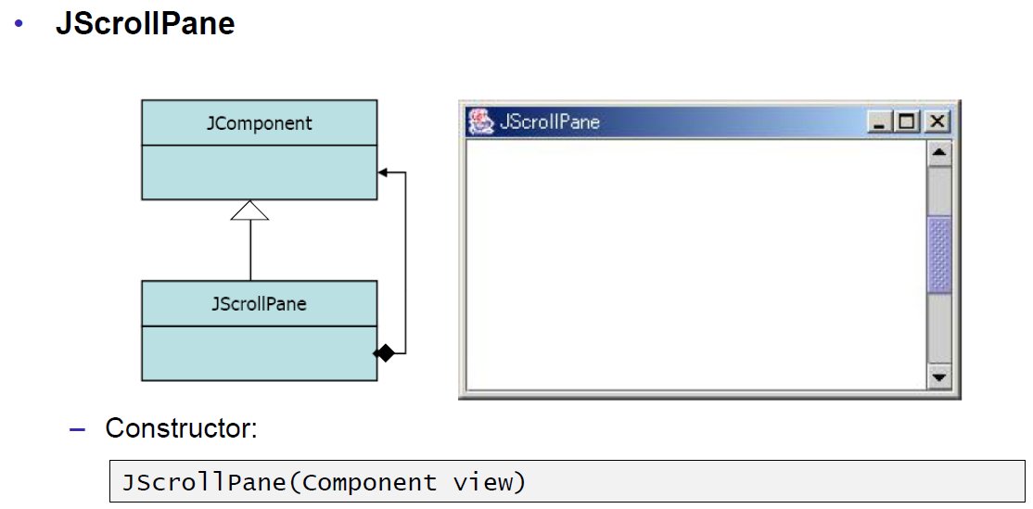

### Collection Decorators

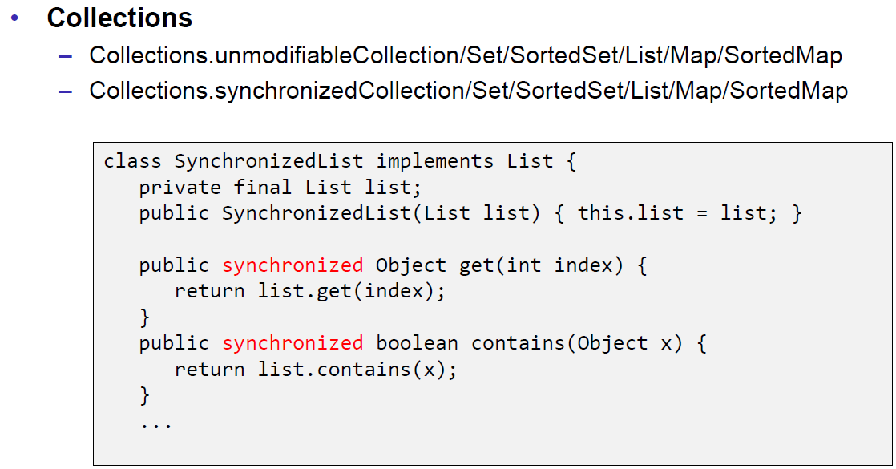

## Java IO (Streams)

### OutputStream

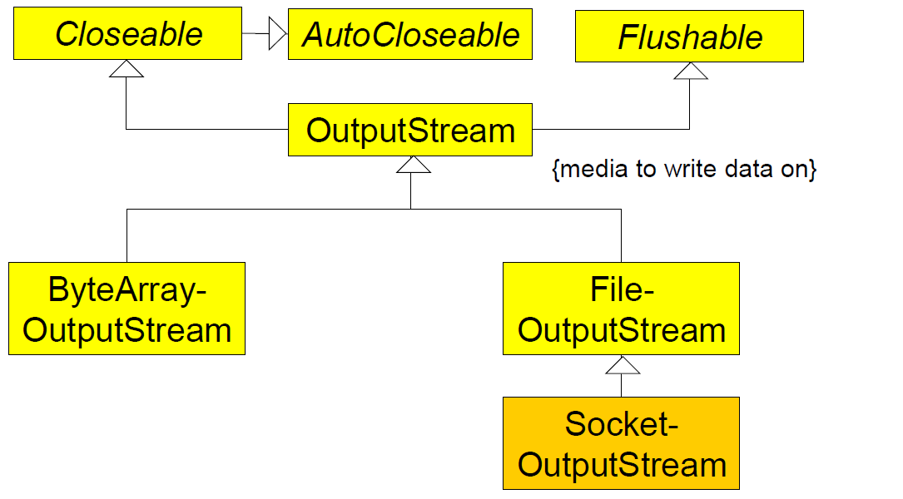

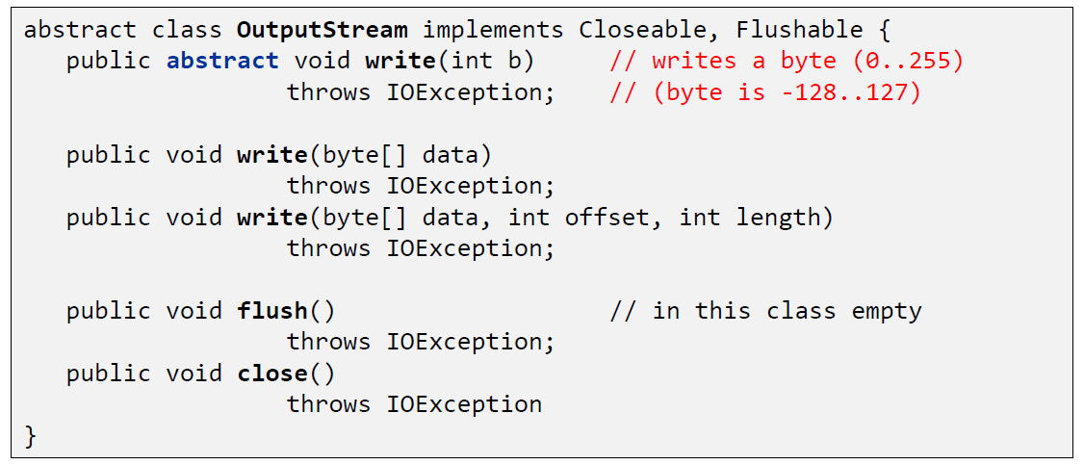

### FilterOutputStream

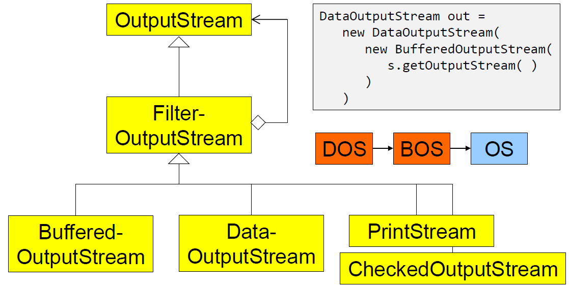

### DataOutputStream

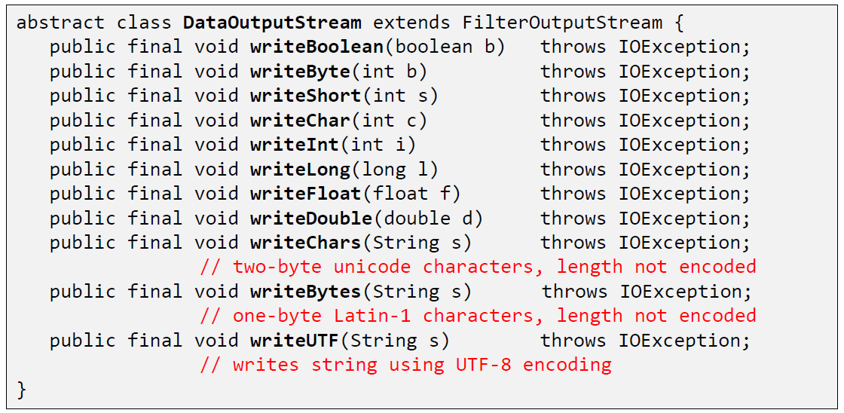

### InputStream

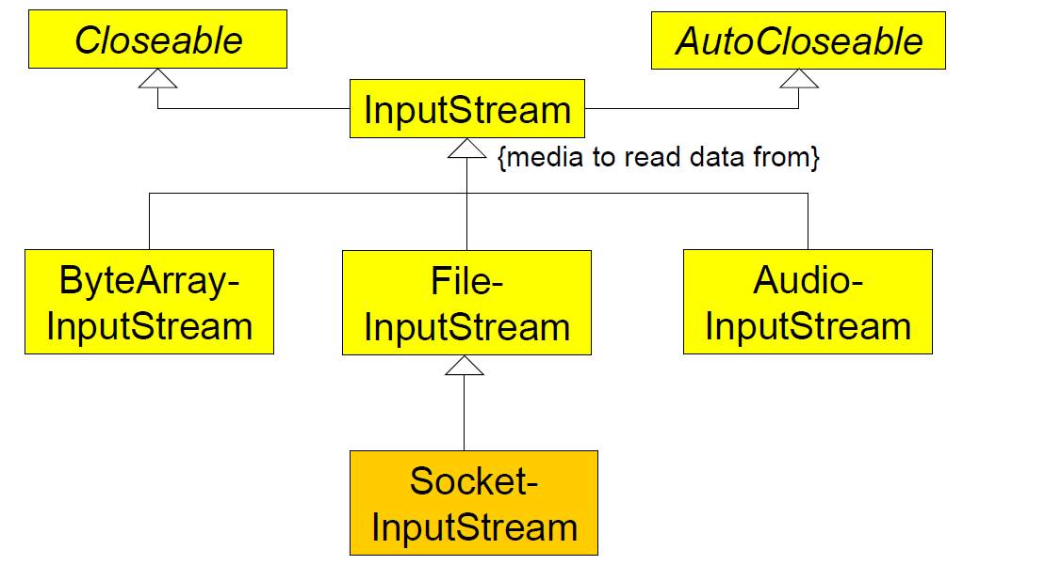

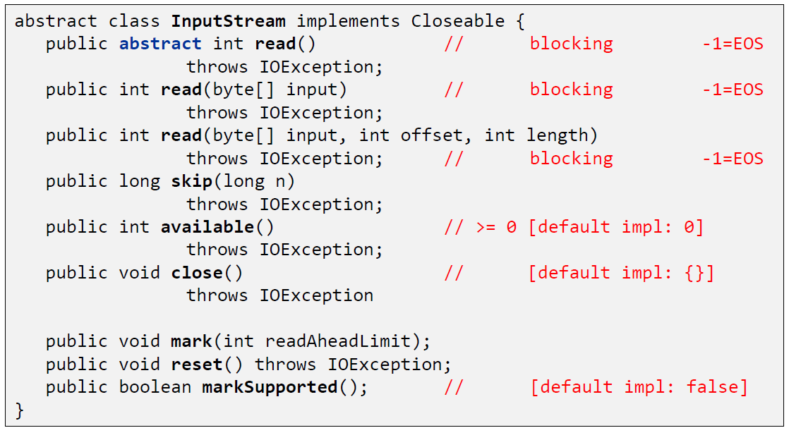

### FilterInputStream

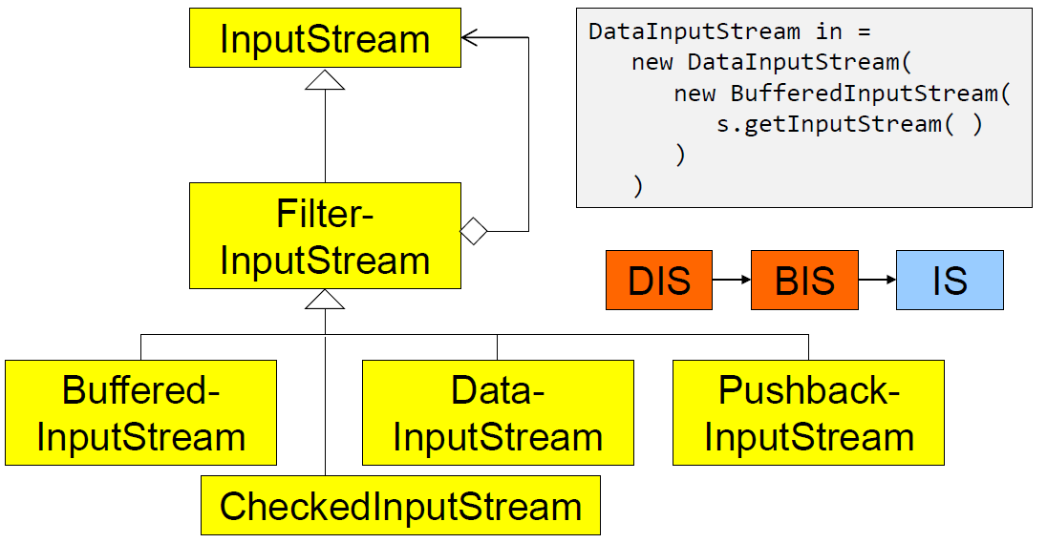

### ObjectStream

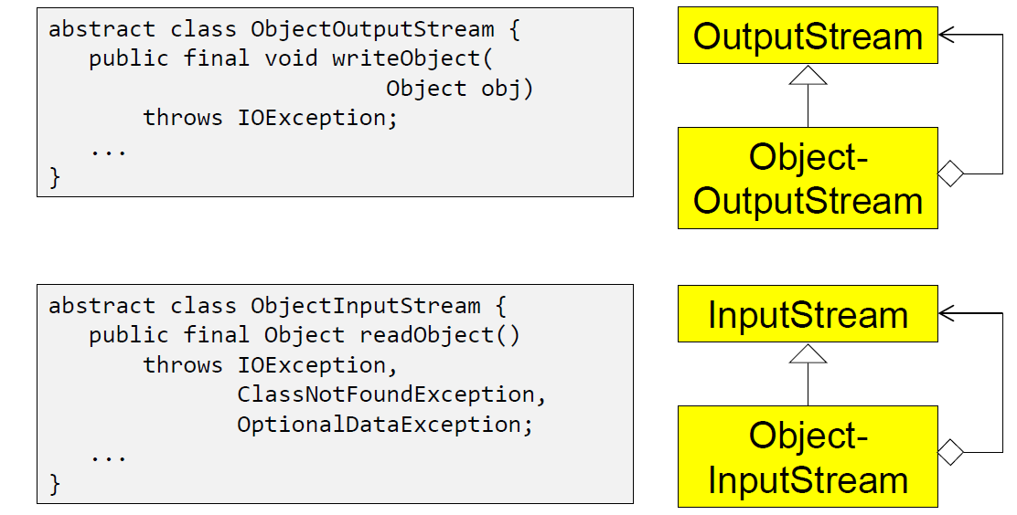

### Decorator Classes

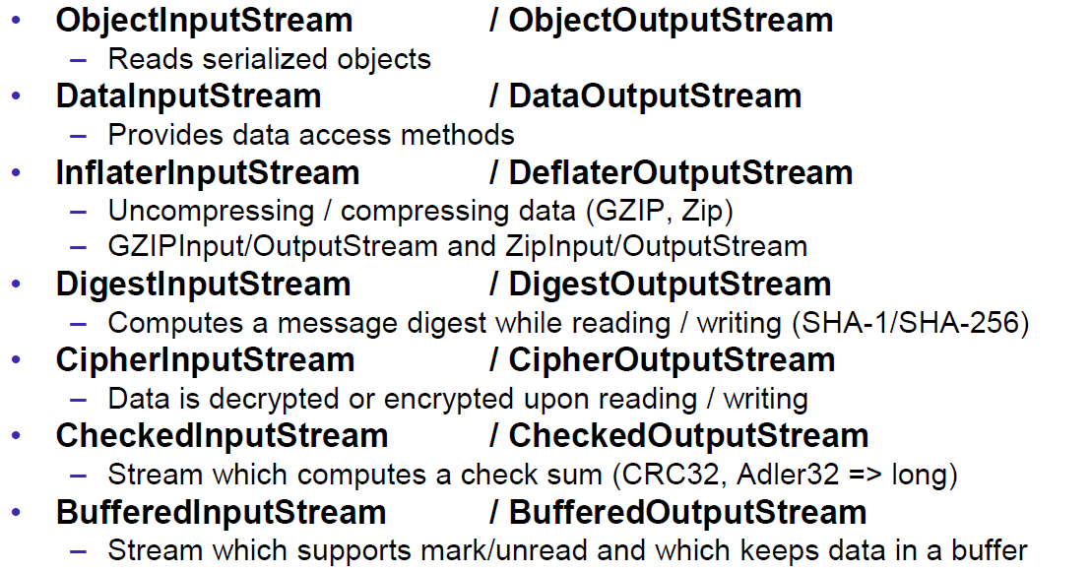

### Whole Picture: InputStream

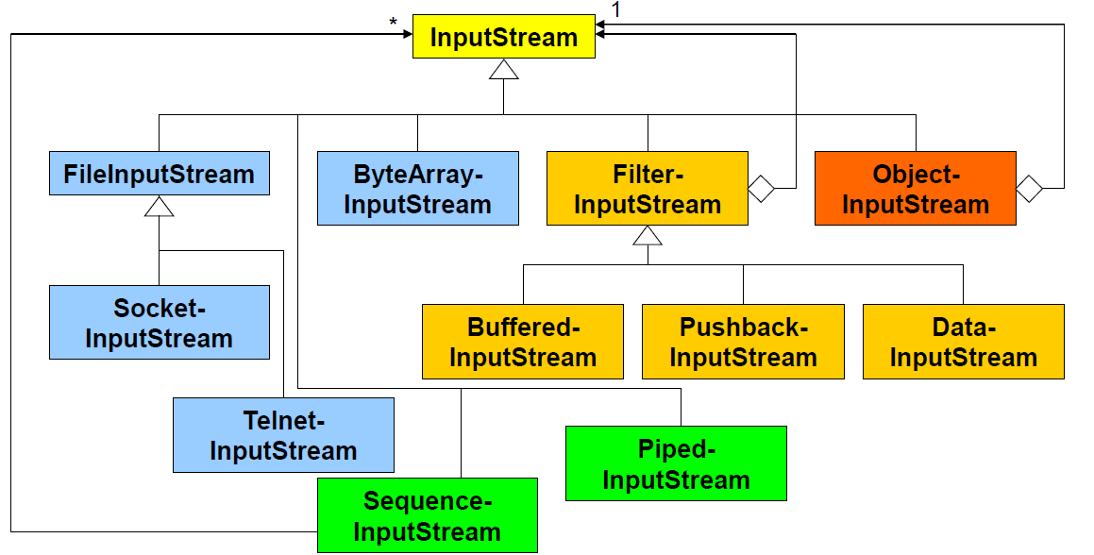

### Whole Picture: OutputStream

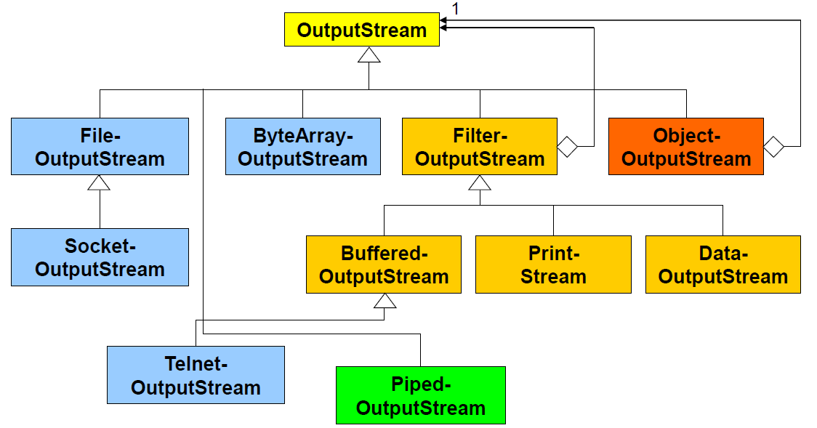

## Demo

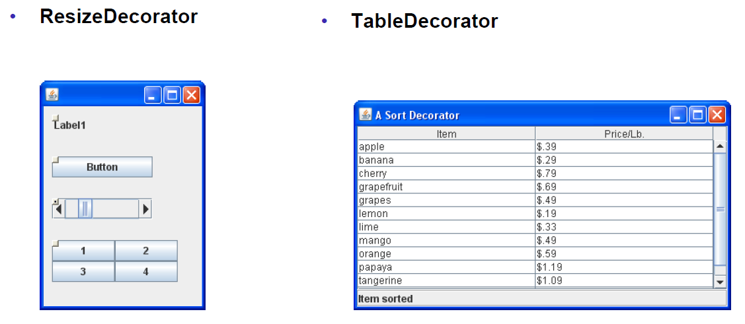

# Woche 11

## Proxy Pattern

### Overview

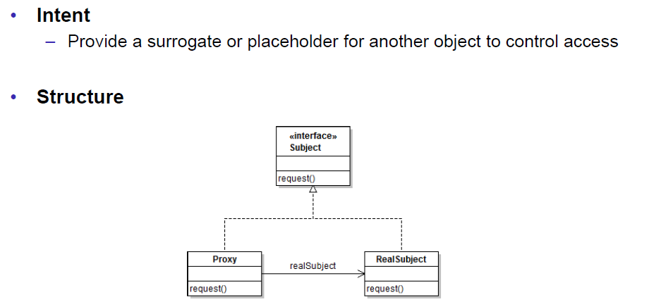

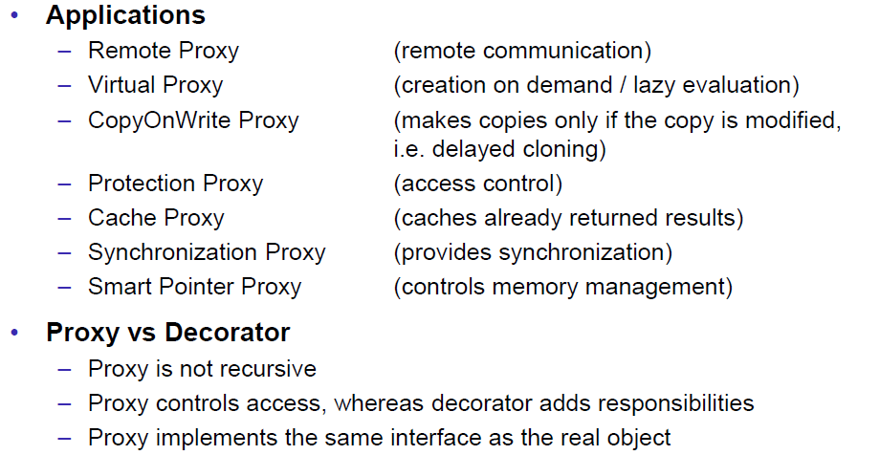

## Dynamic Proxy Class

### Overview

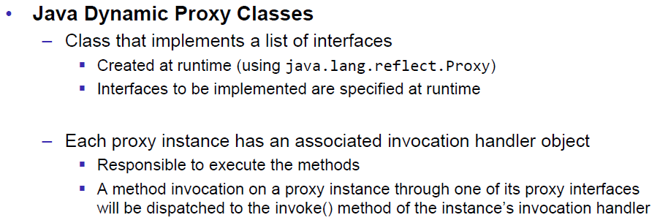

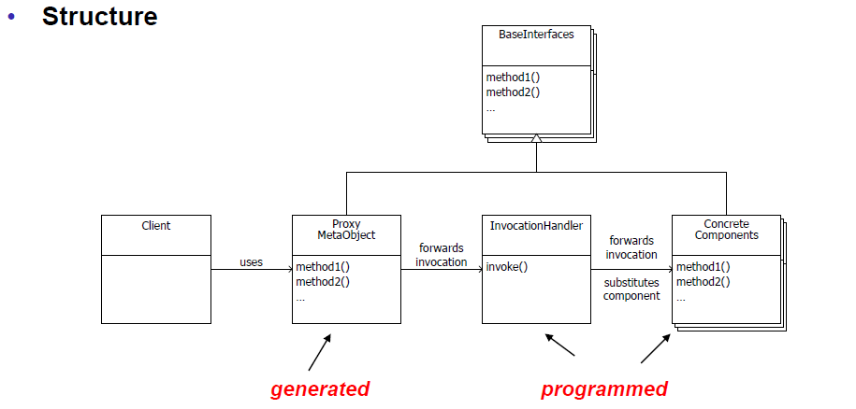

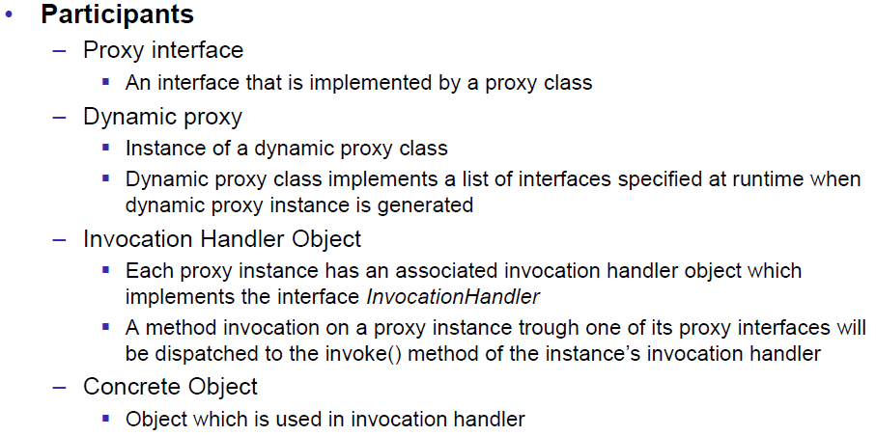

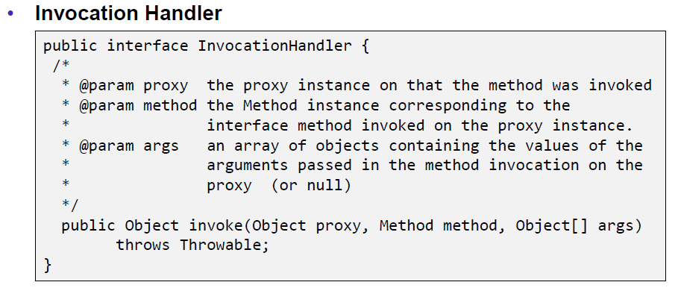

### Example

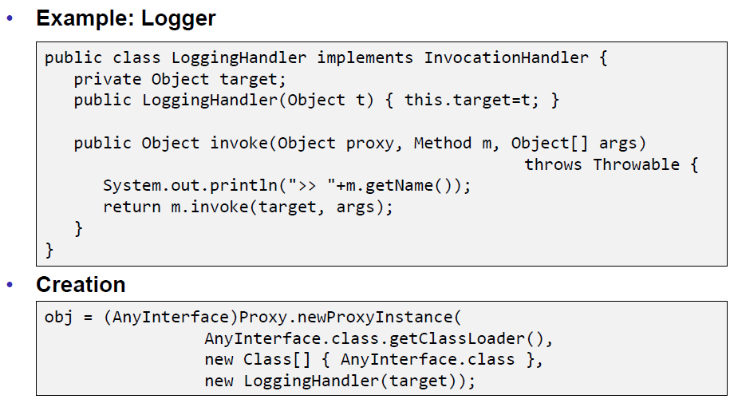

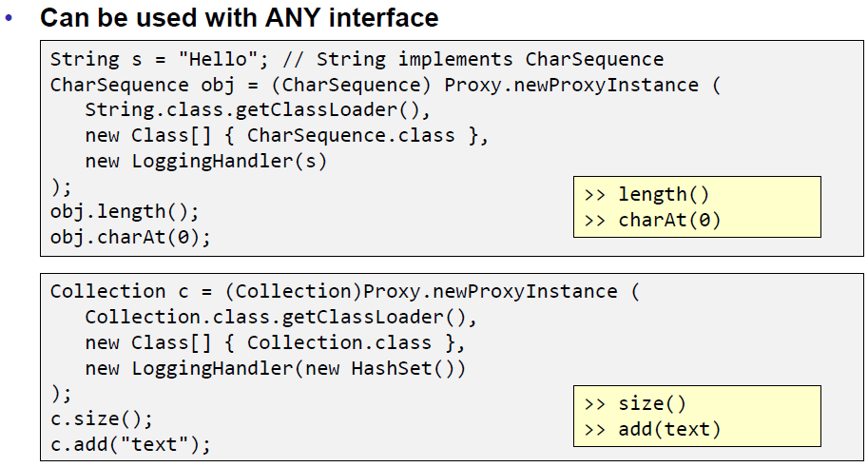

# Woche 12

## Command Pattern

### Goal

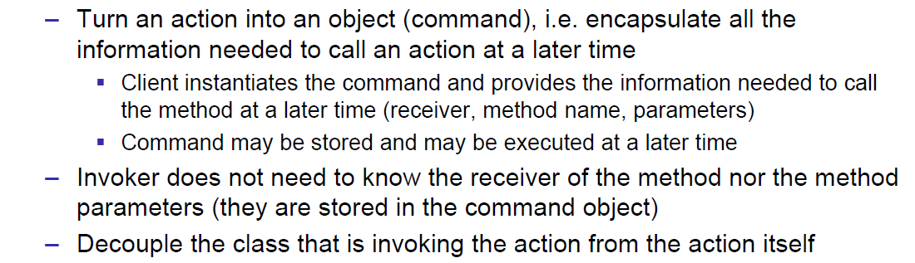

### Applications

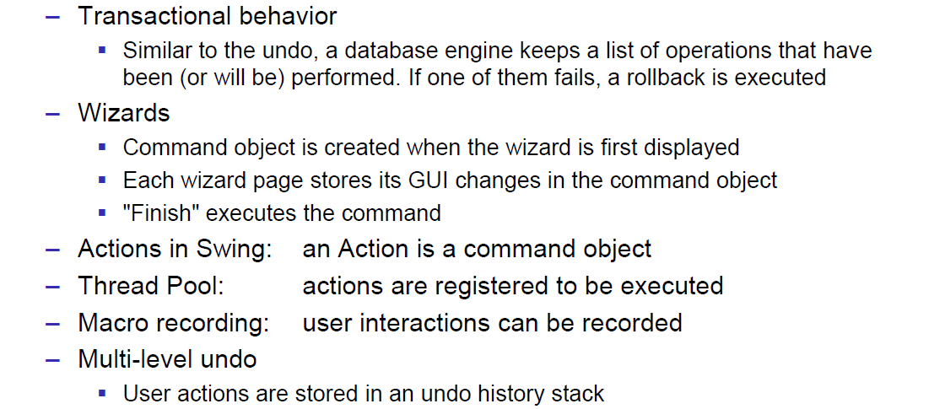

## Undo/Redo

### Motivation

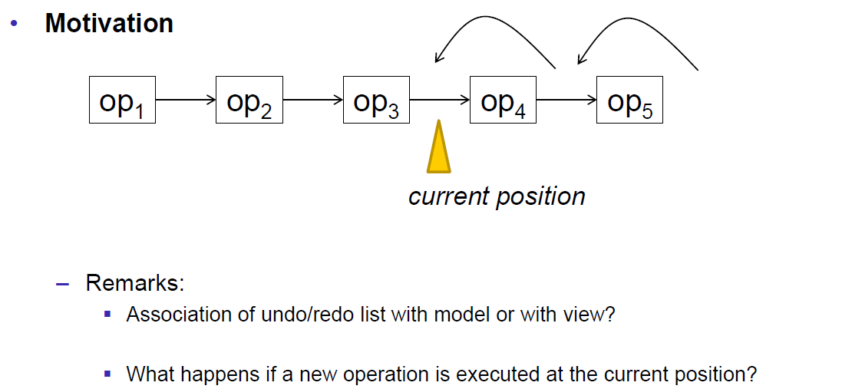

### Implementation

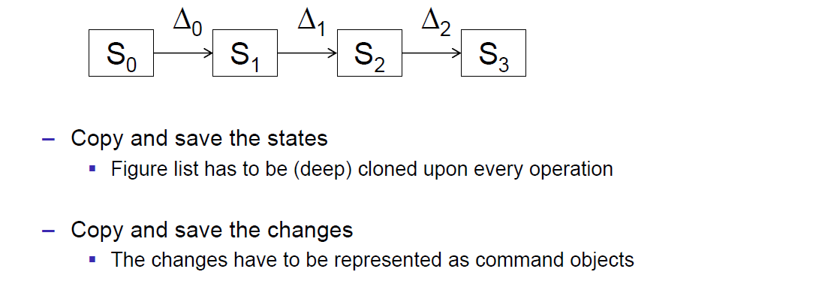

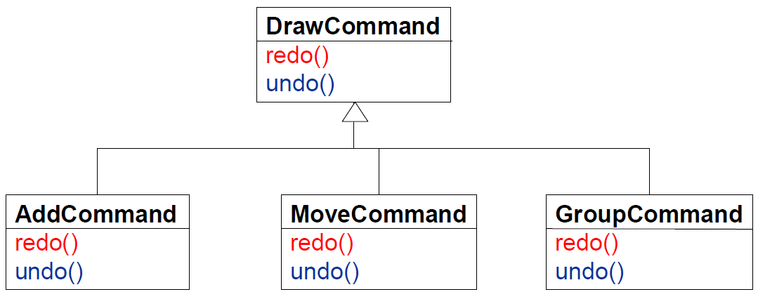

* Add:
  + Redo: mode.addFigure(figure)
  + Undo: model.removeFigure(figure)
* Move:
  + Redo: figure.move(dx, dy) 🡪 Save dx and dy
  + Undo: figure.move(-dx, -dy)
* Group:
  + Redo: model.addFigure(group)
  + Undo: for(Figure figure : group.parts()) model.removeFigure(figure)

### State Diagram for Commands

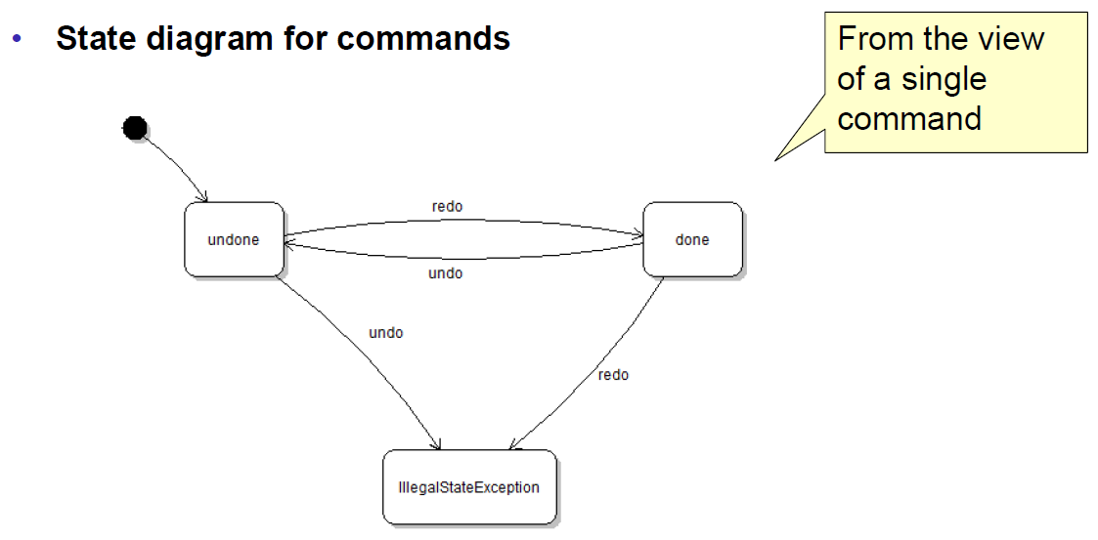

### Implementation via DrawCommandHandler

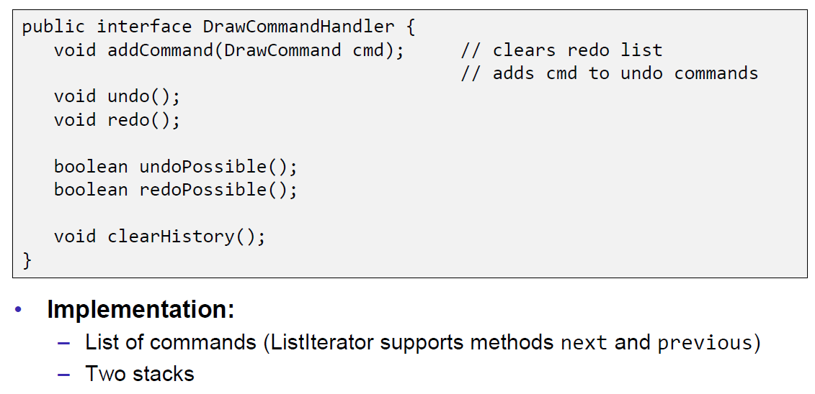

## Command Pattern

### Definition

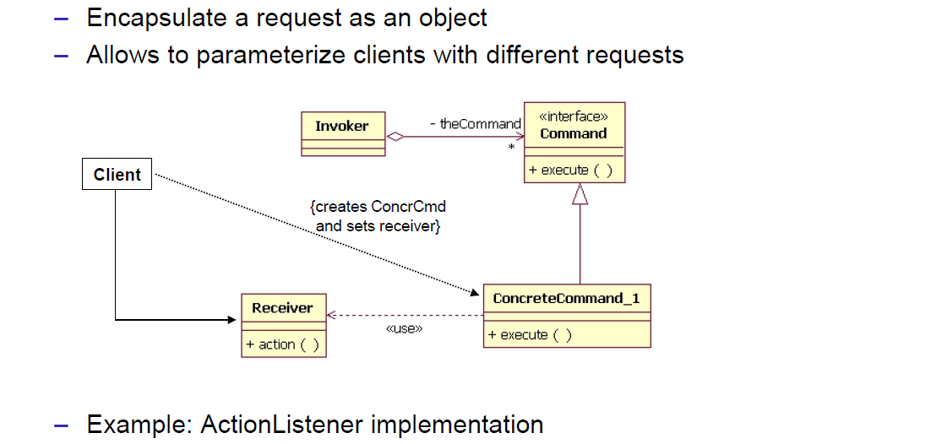

### Participants

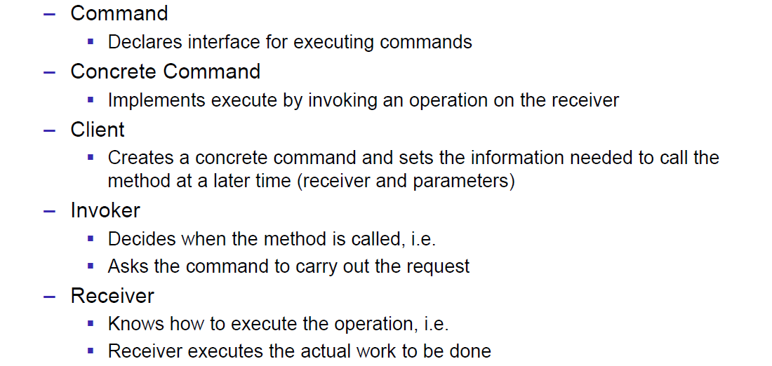

### Sequence Diagram

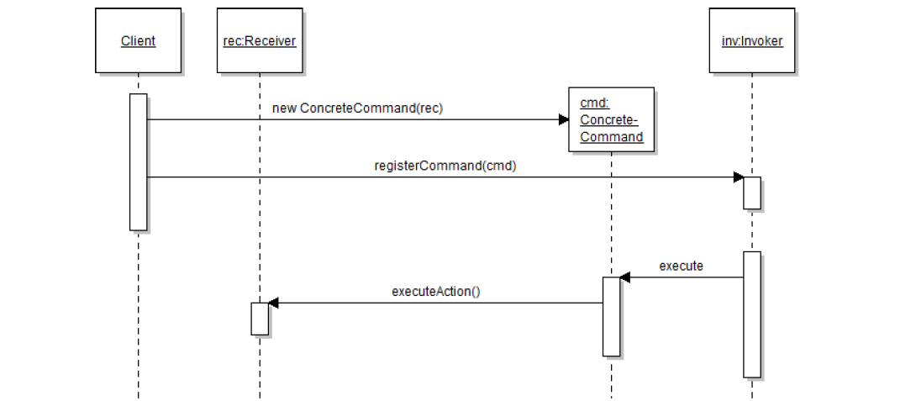

## Problem of Undo/Redo

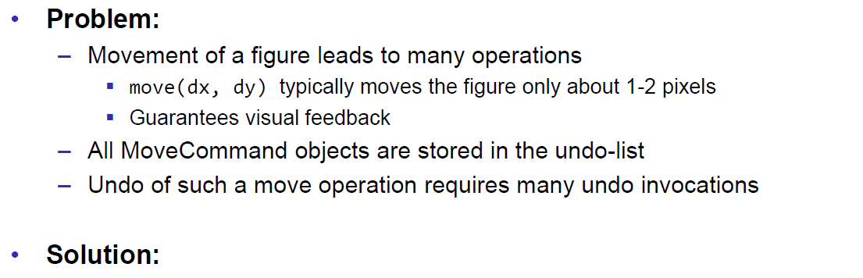

1. Delay the generation of the move command until the operation has been completed (Operation specific)
2. Combine commands (Check if the previous command was also a move command)
3. Combine commands using the composite pattrn. Undo/Redo are done over all n move commands

## Command Pattern

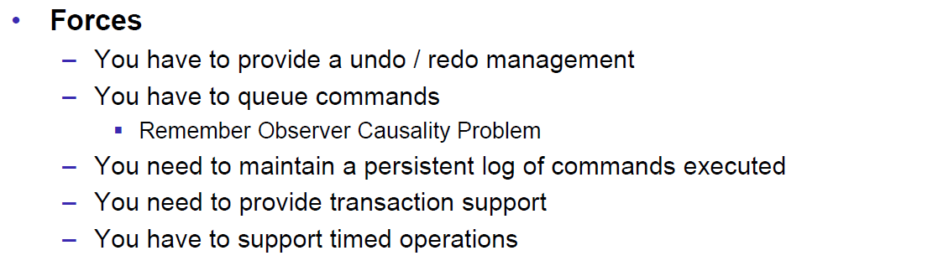

# Woche 13

## Factory Method Pattern

### Creational Patterns

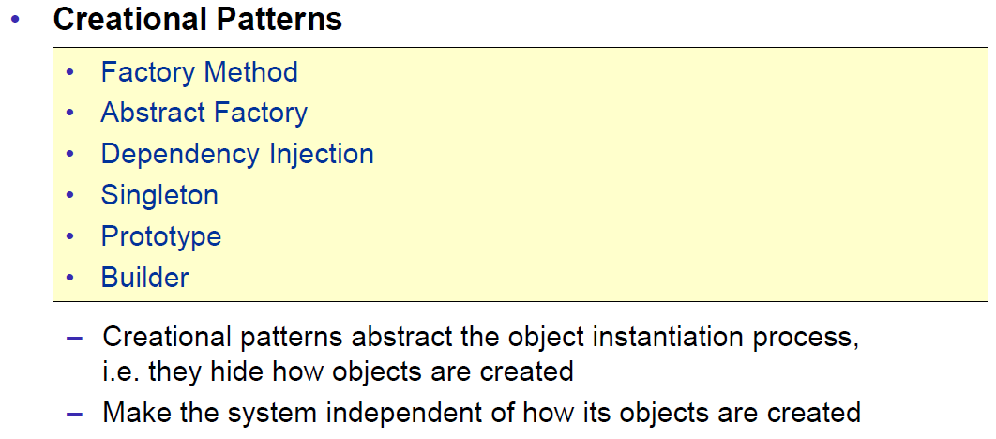

### Factory Patterns

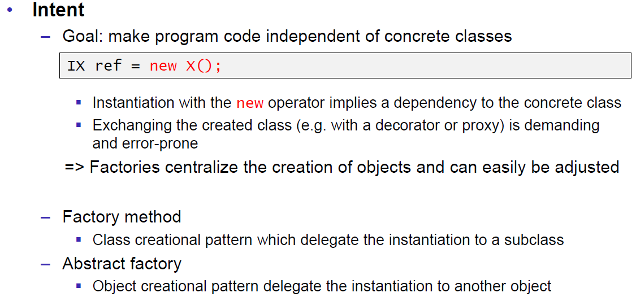

### Factory Method Pattern

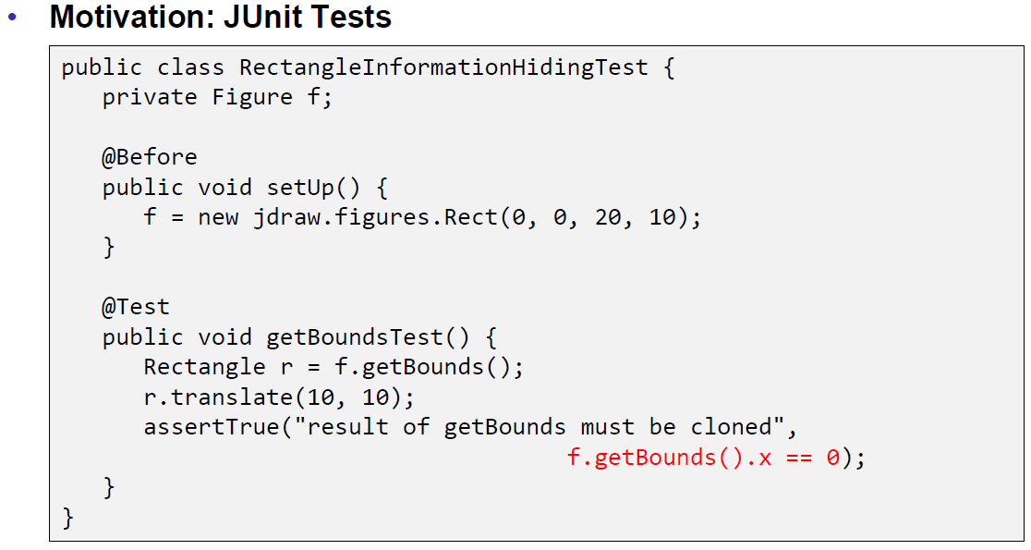

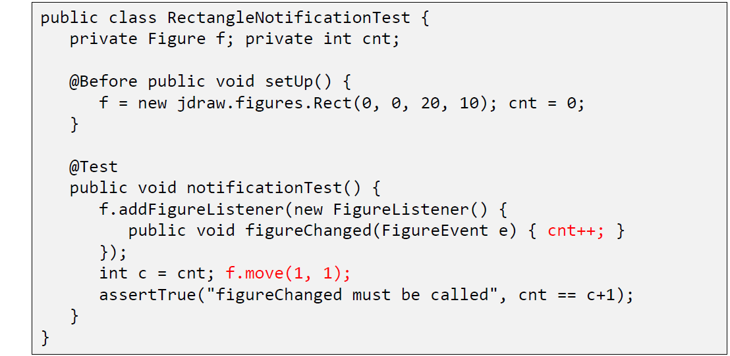

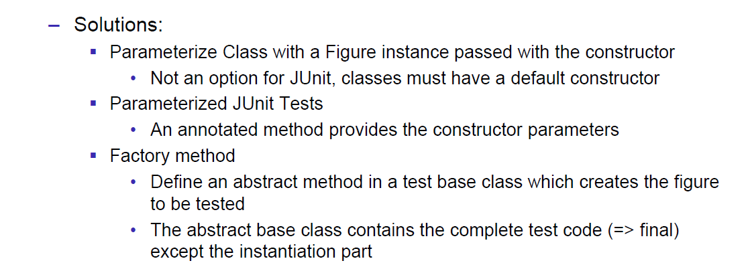

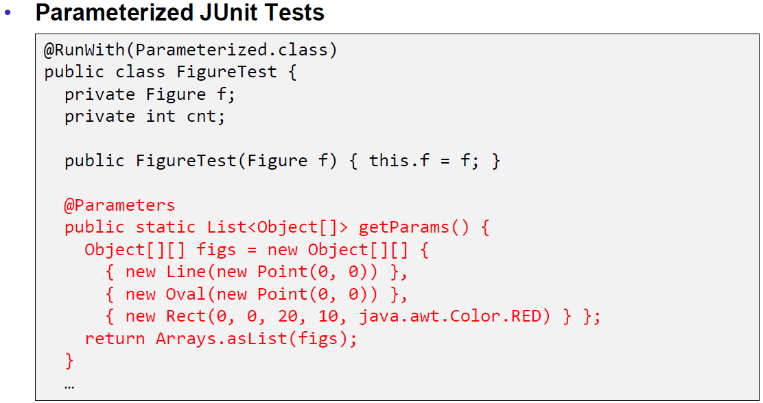

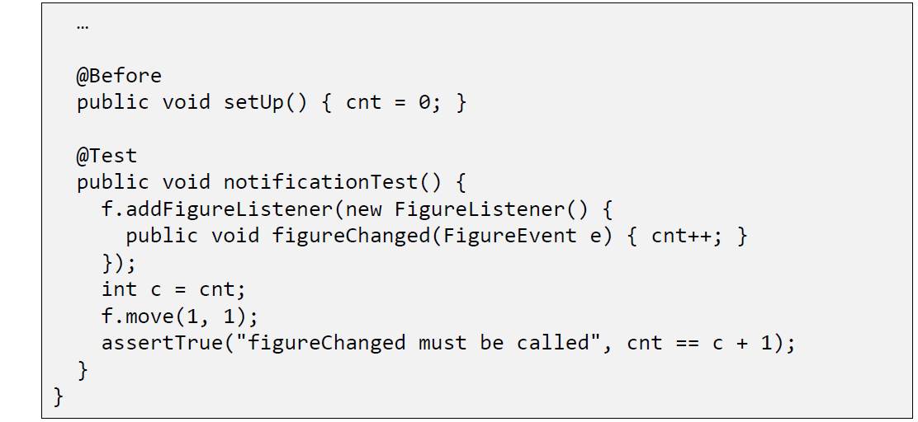

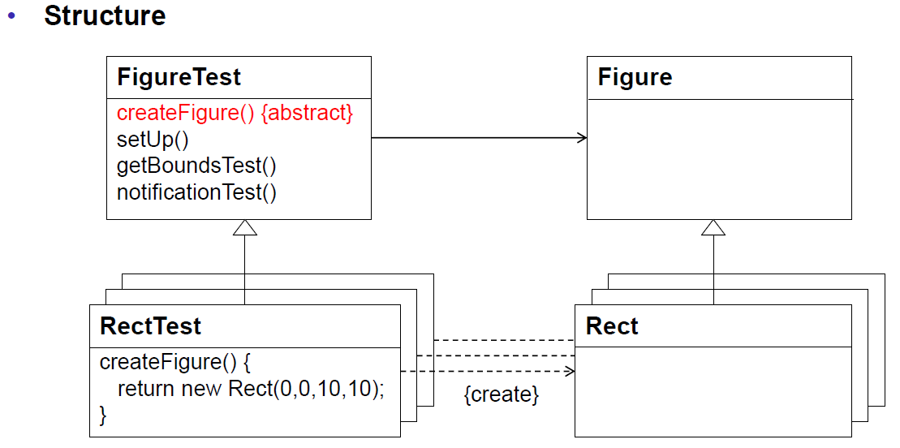

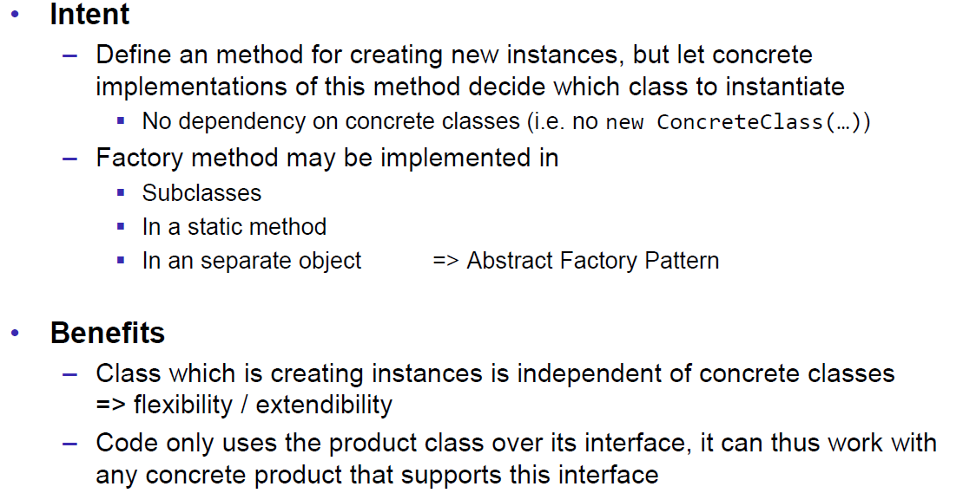

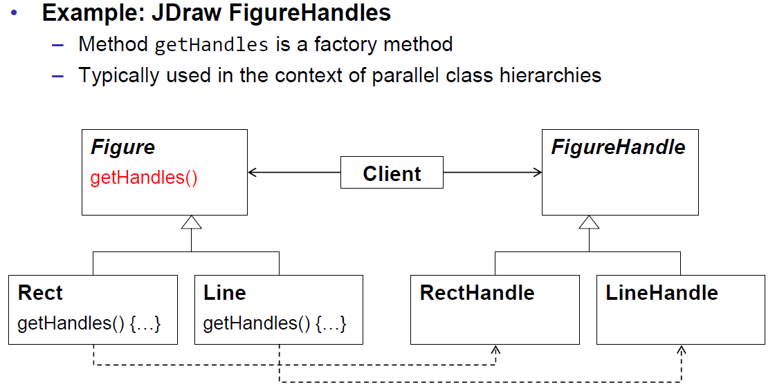

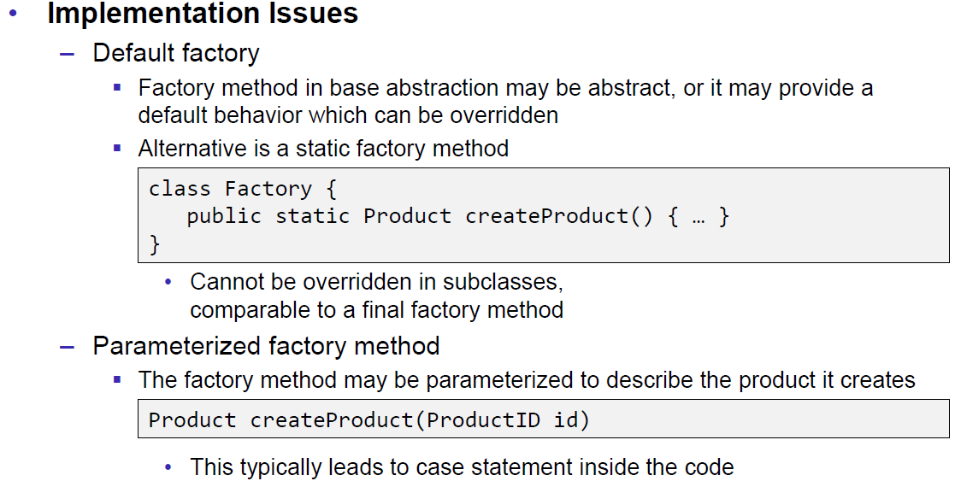

## Abstract Factory

### Abstract Factory Pattern

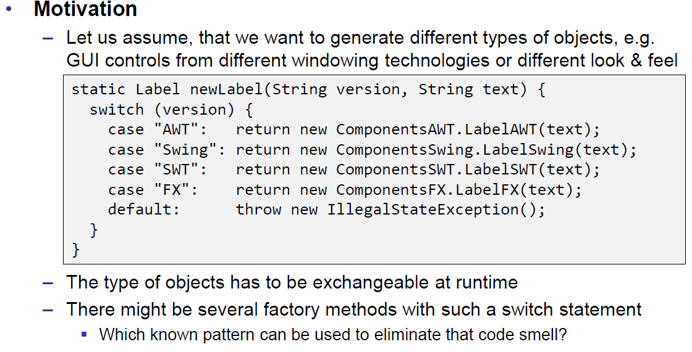

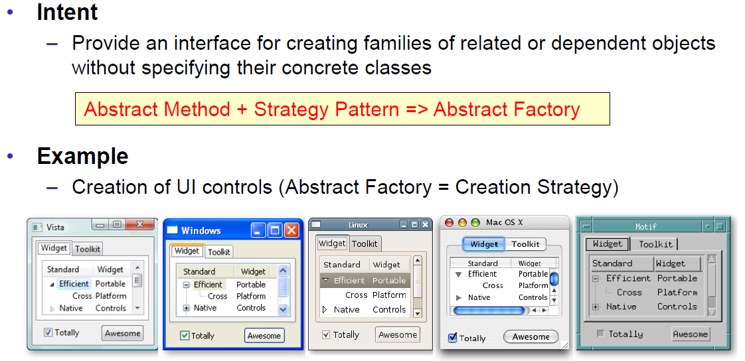

### Structure

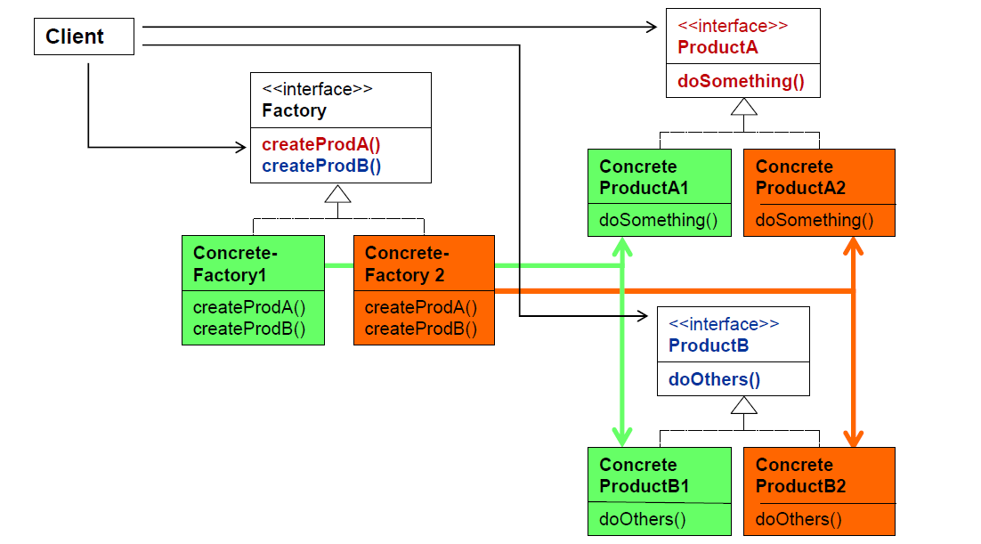

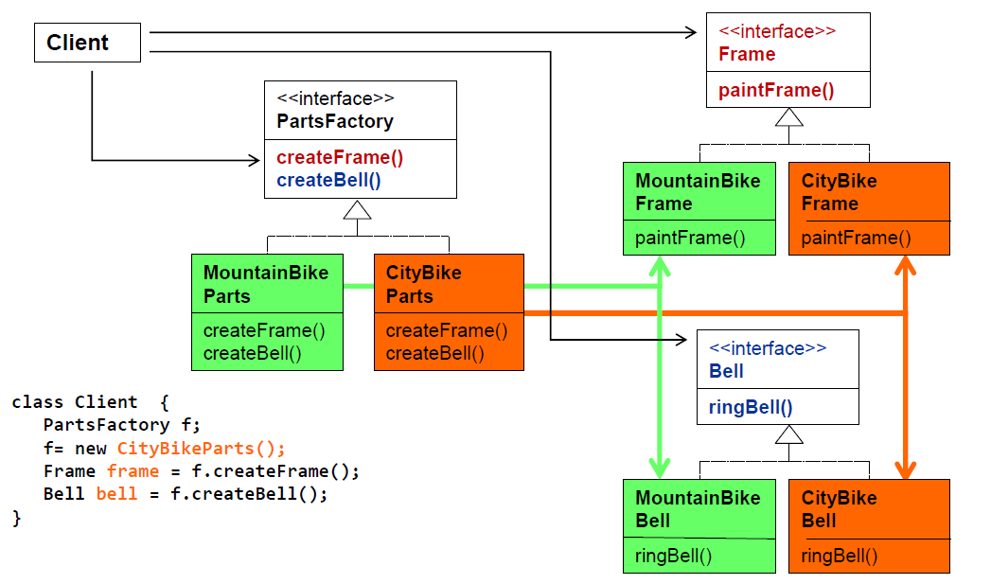

### Implementation

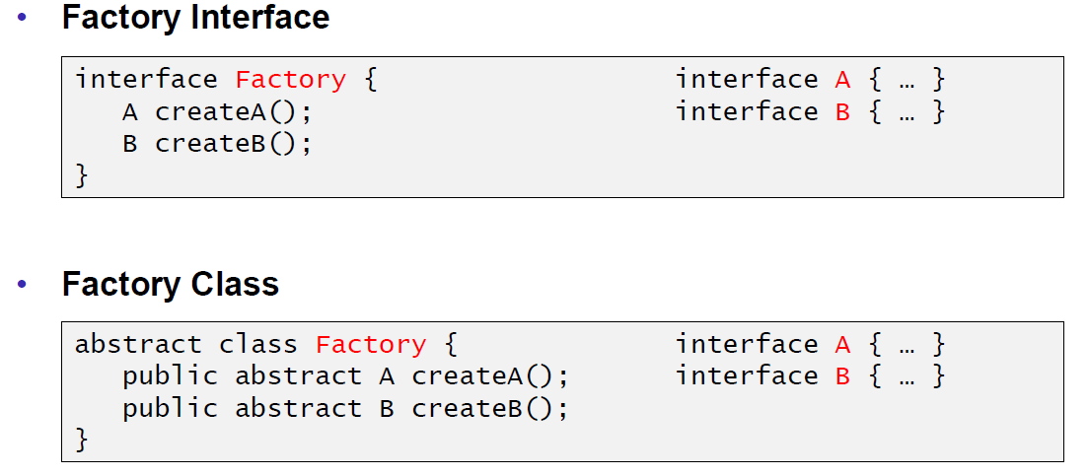

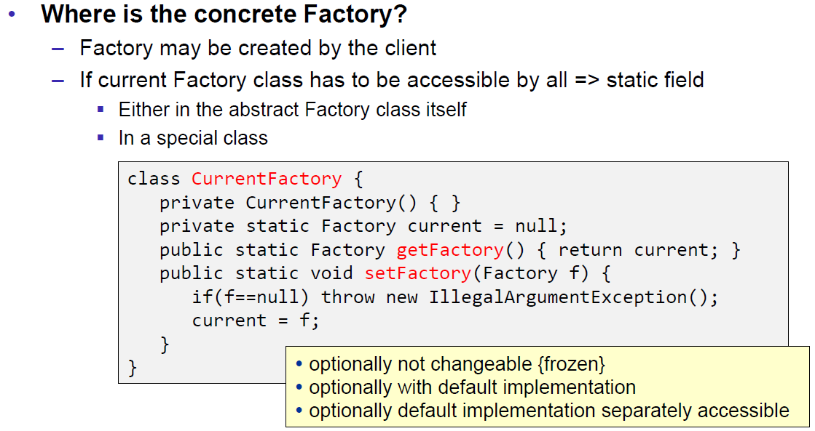

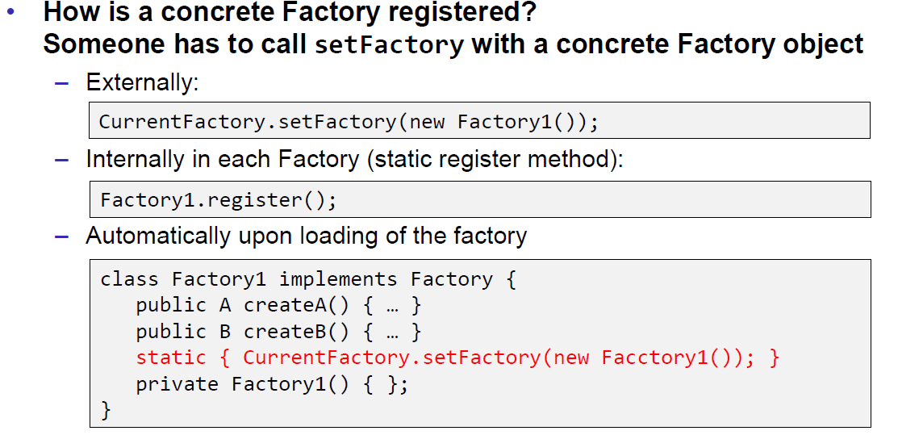

### Motivation and Examples

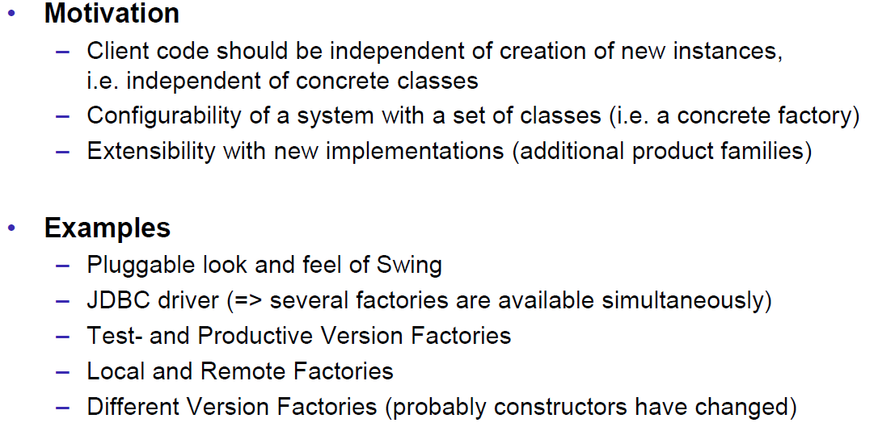

### Remarks

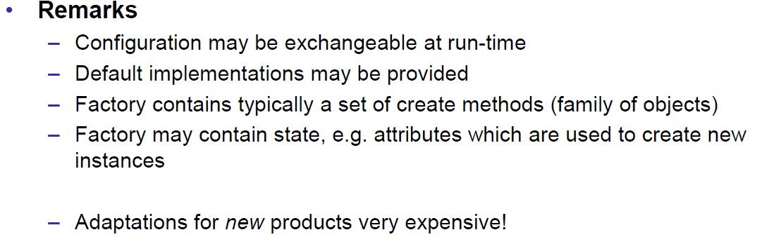

## Dependency Injection

### Problem of Coupling

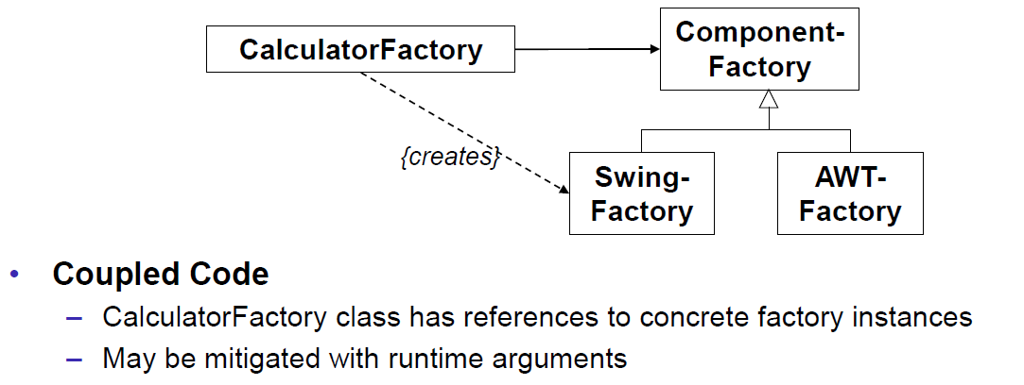

### Dependency Injection as Solution

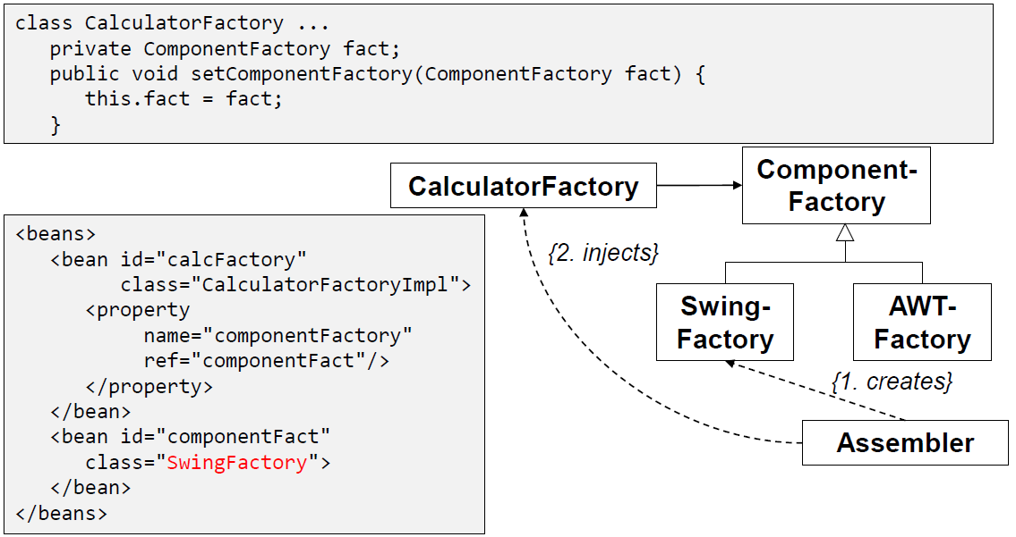

### Property Values

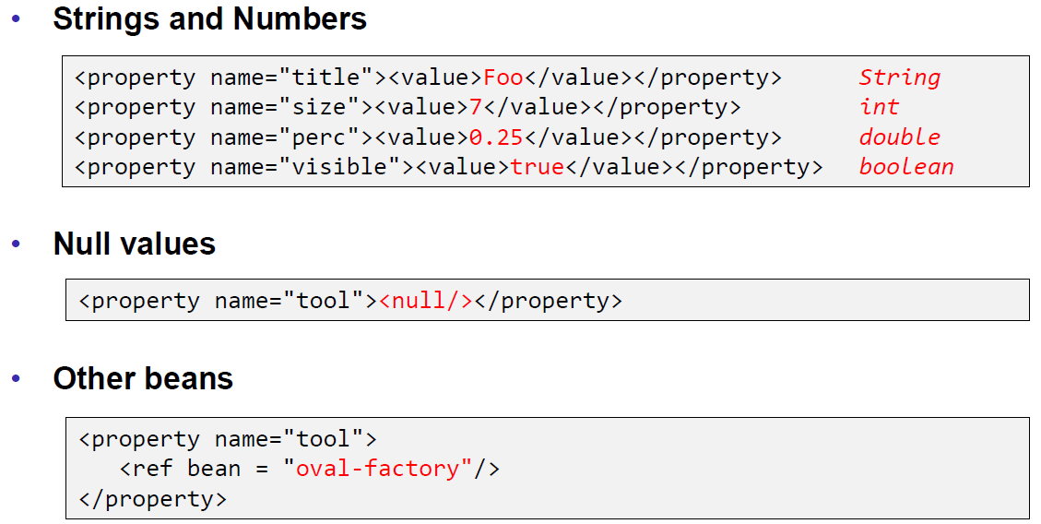

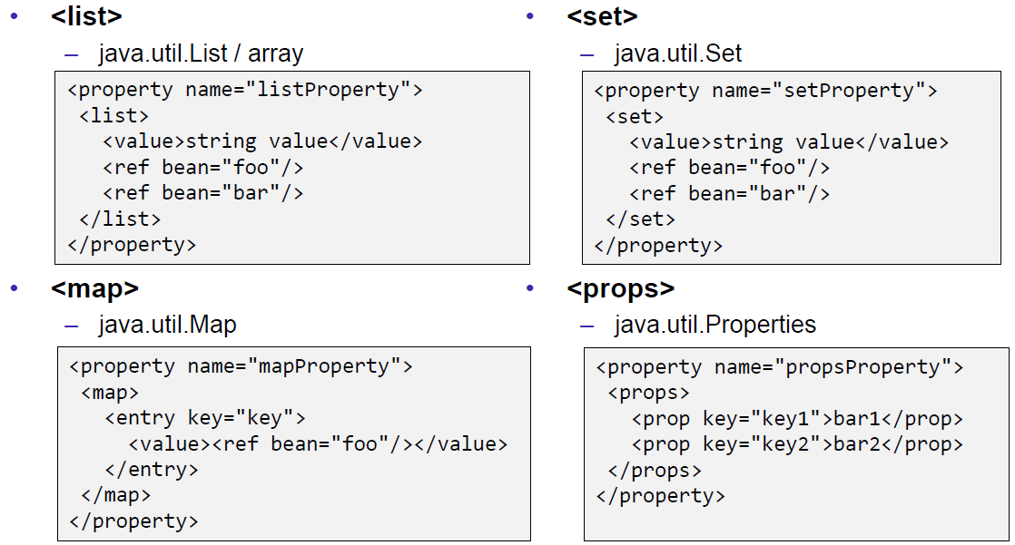

### Spring in Action

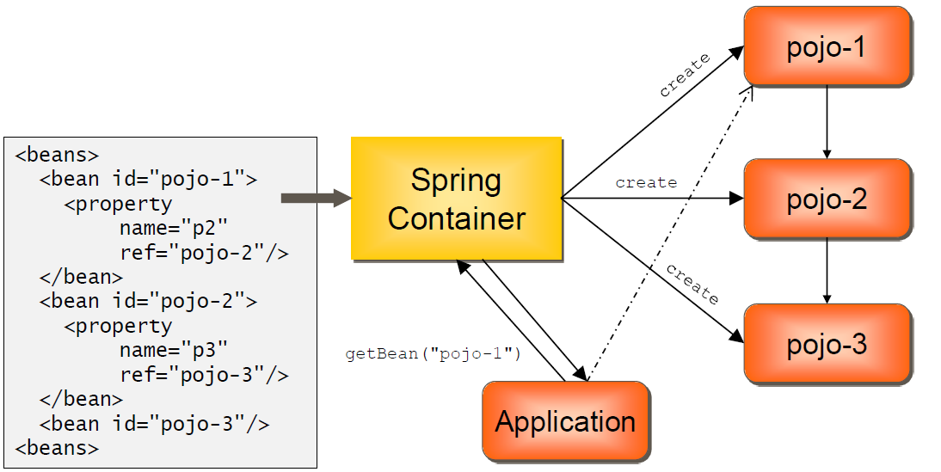

# Woche 14

## Singleton Pattern

### Introduction

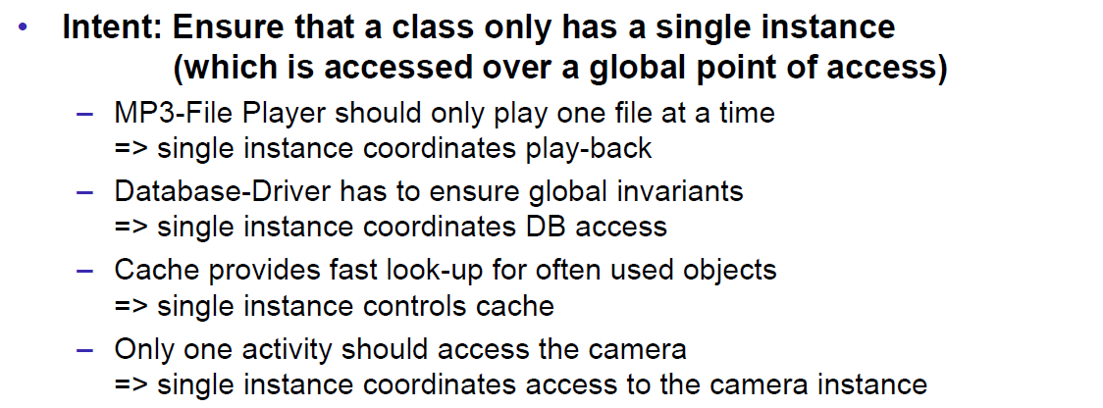

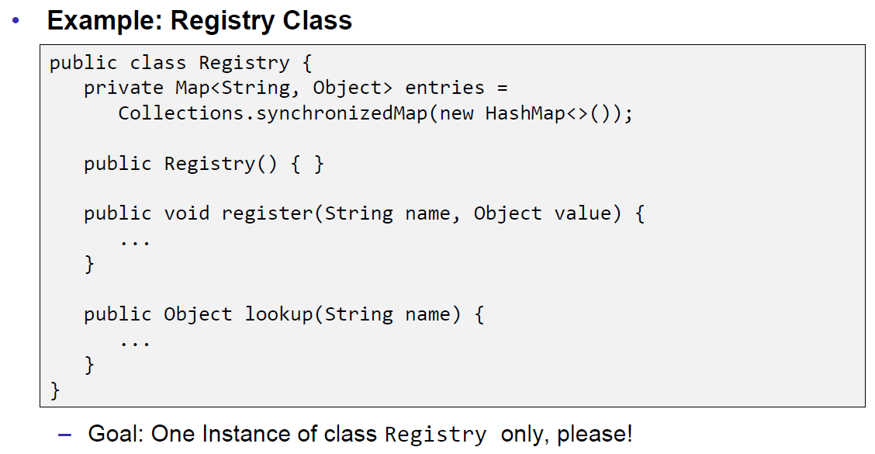

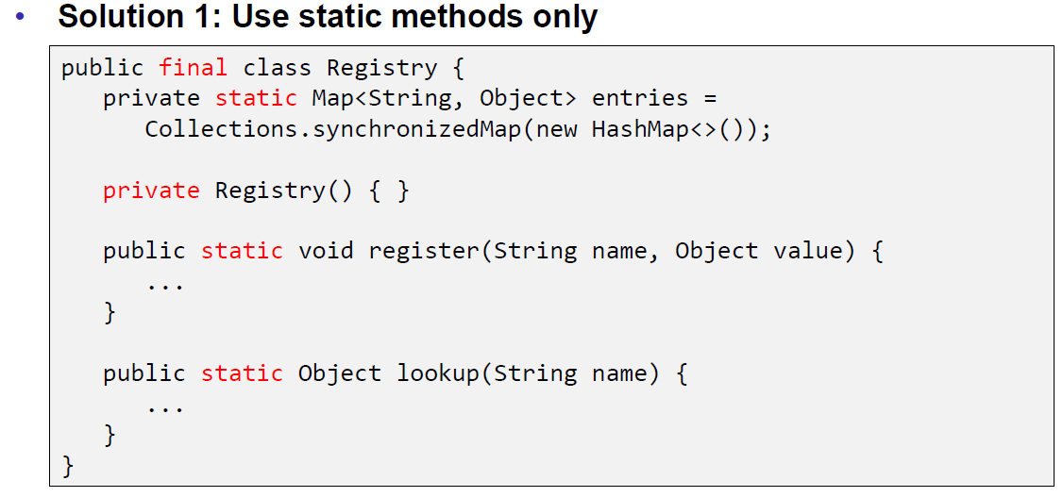

### Problems with the static Approach

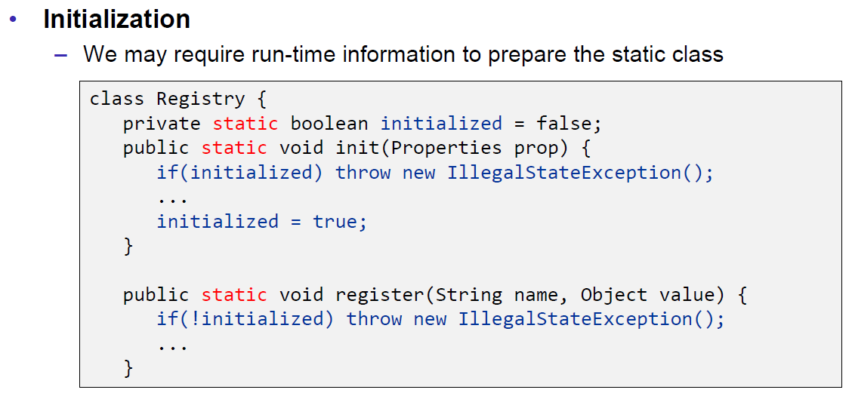

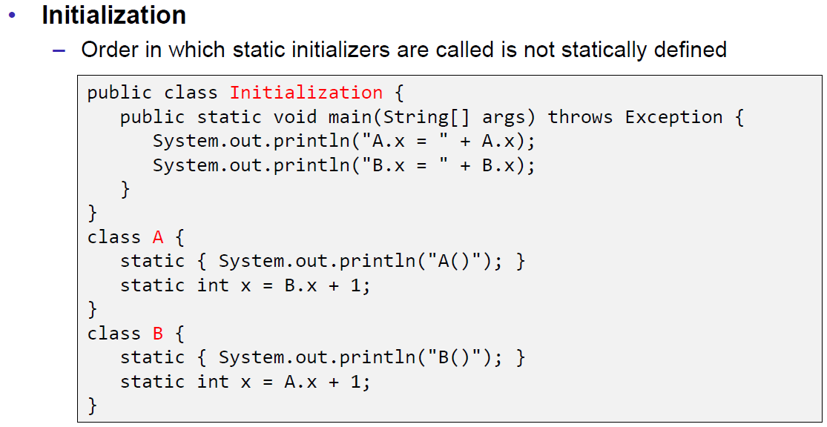

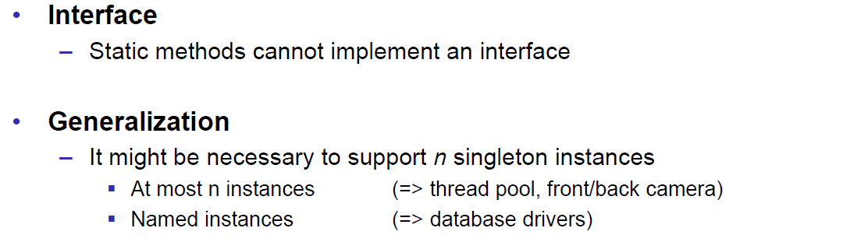

### Singleton Pattern

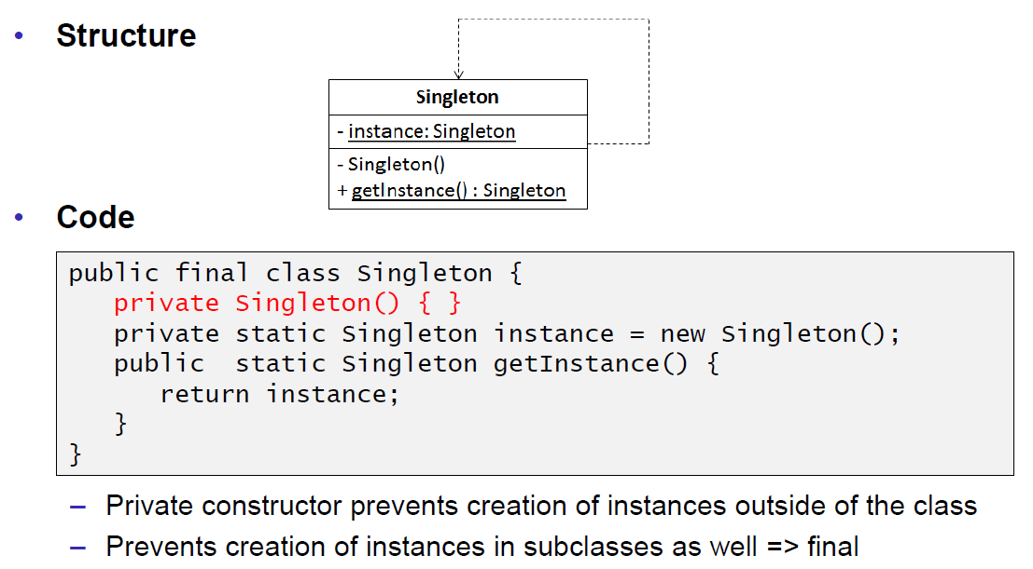

### Example

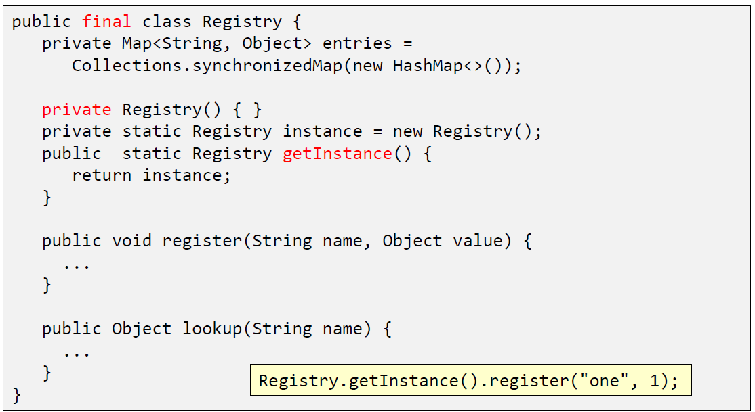

### Samples

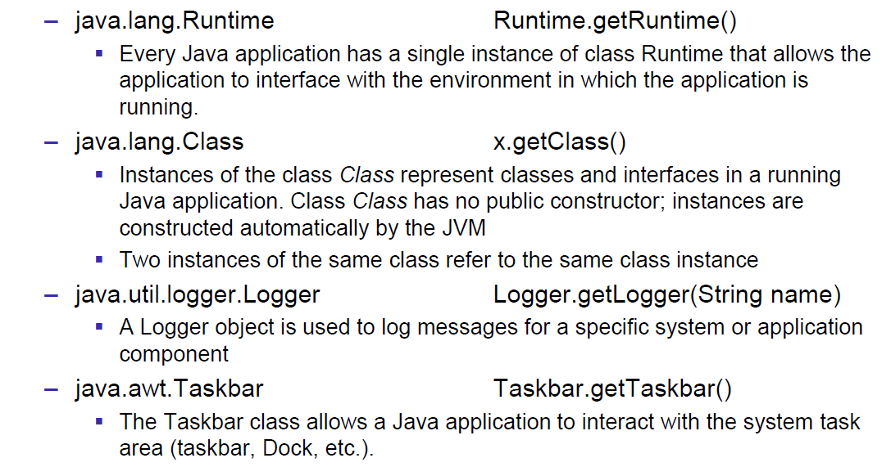

### Implementation Remarks

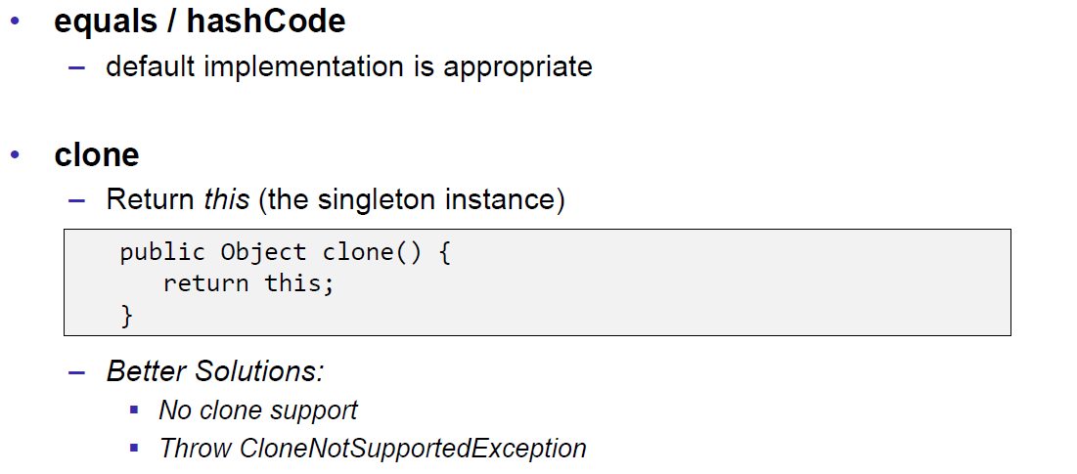

### Lazy Initialization

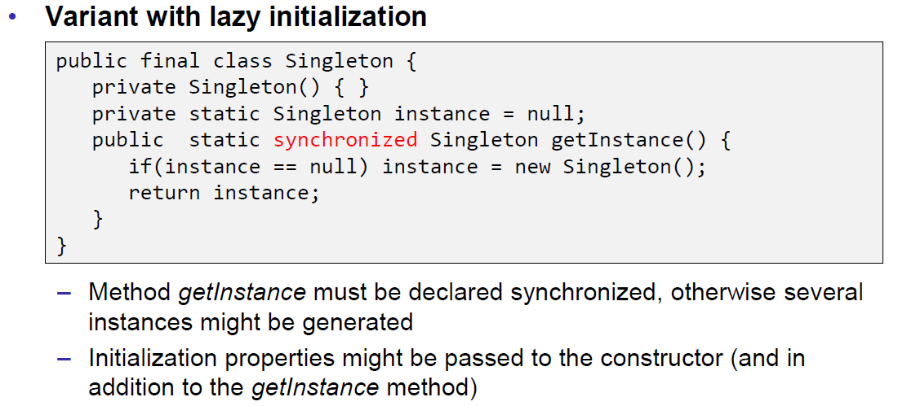

### Implementation Remarks

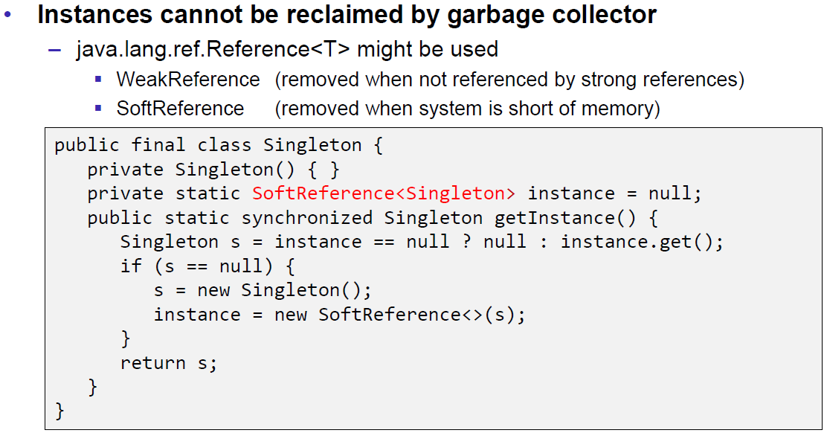

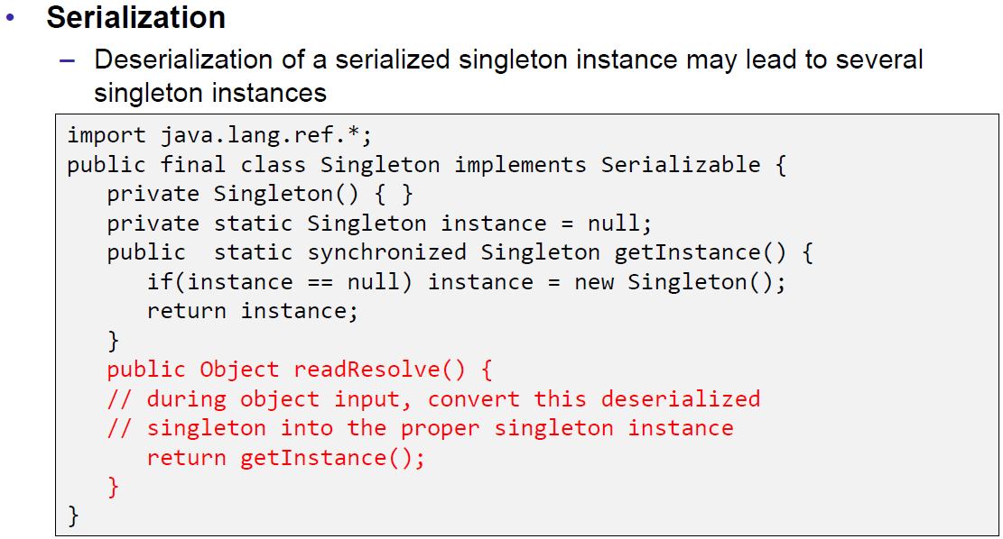

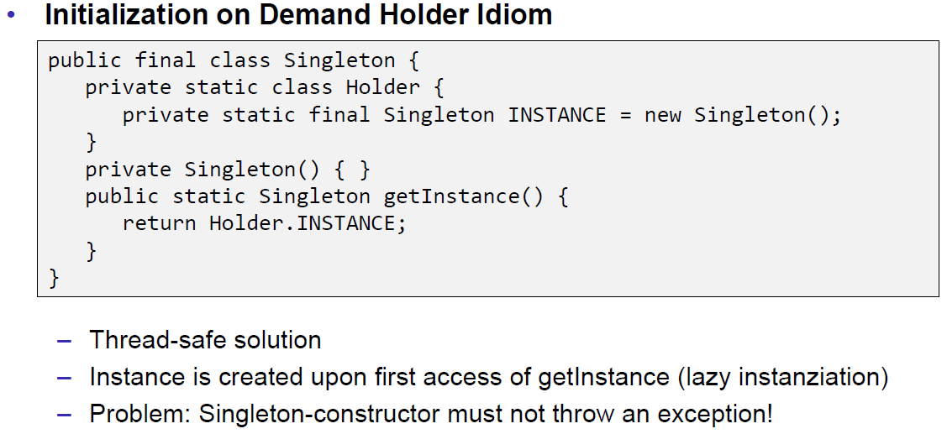

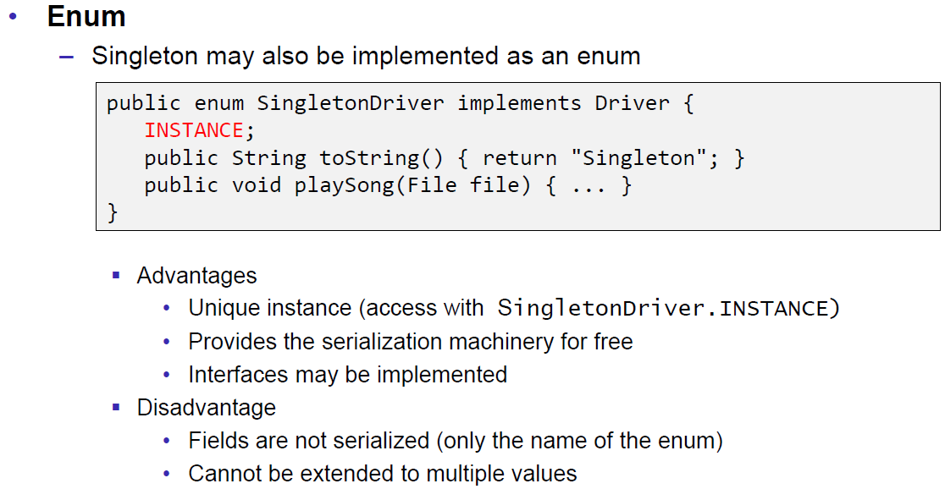

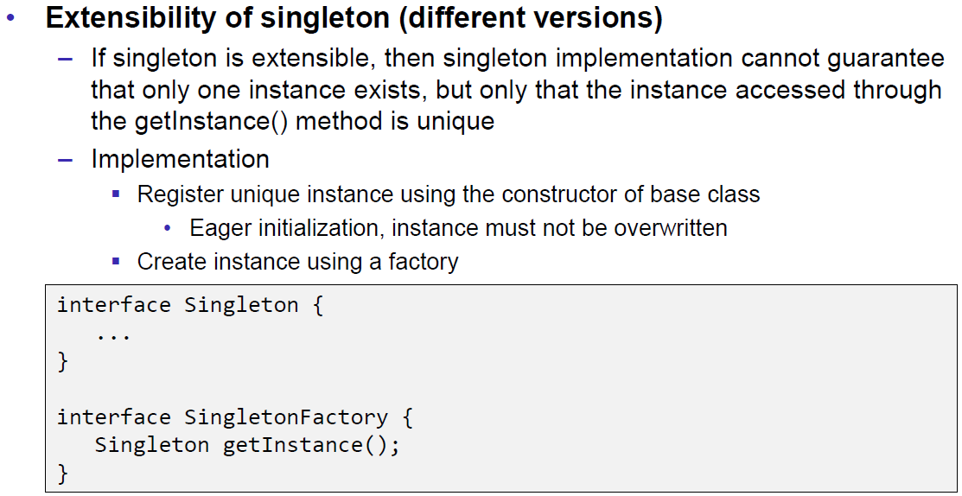

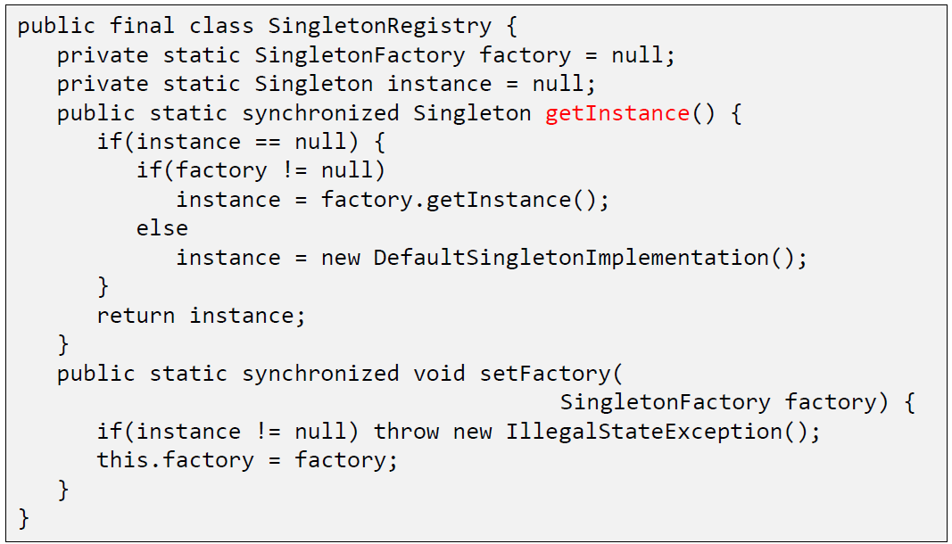

## Singleton and Spring

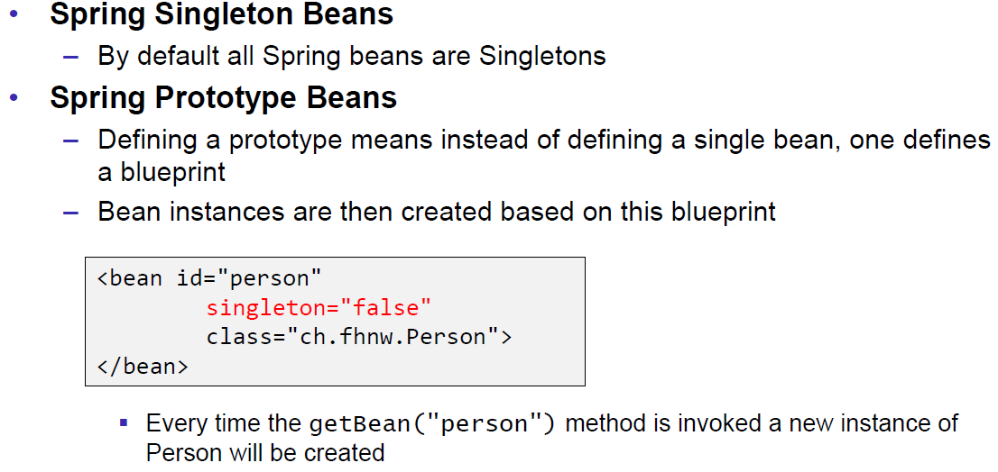

## Relation with other Patterns

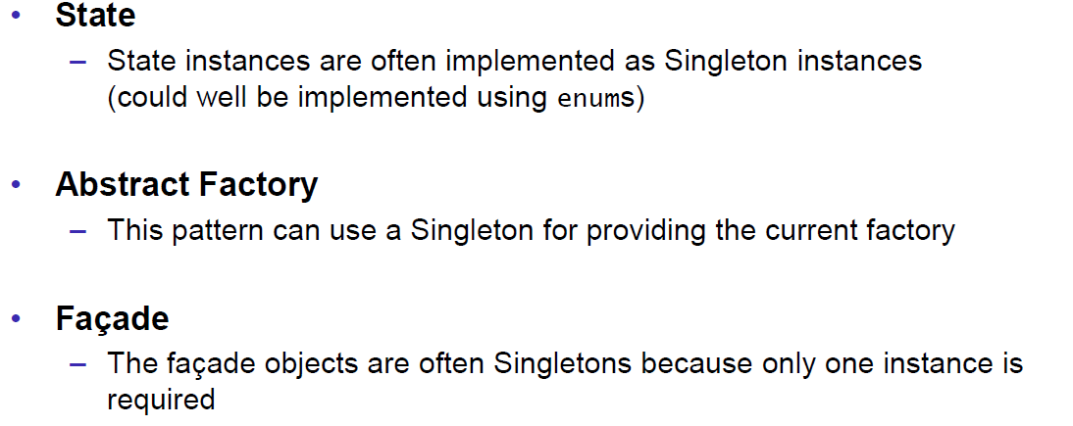

## Problems of Singleton

### The Pattern 15 Years later

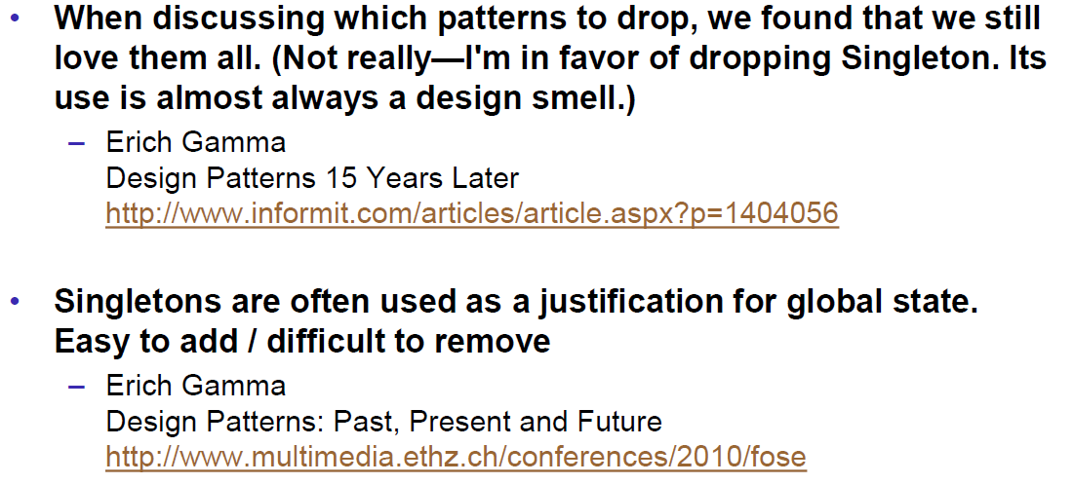

### Disadvantages

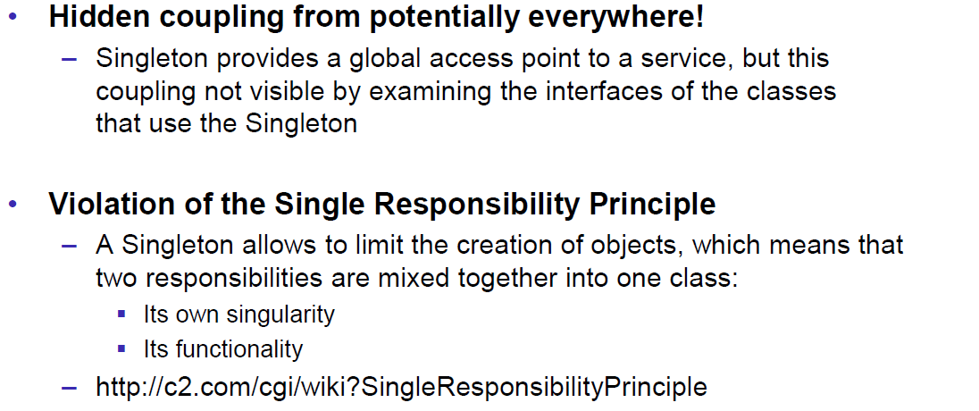

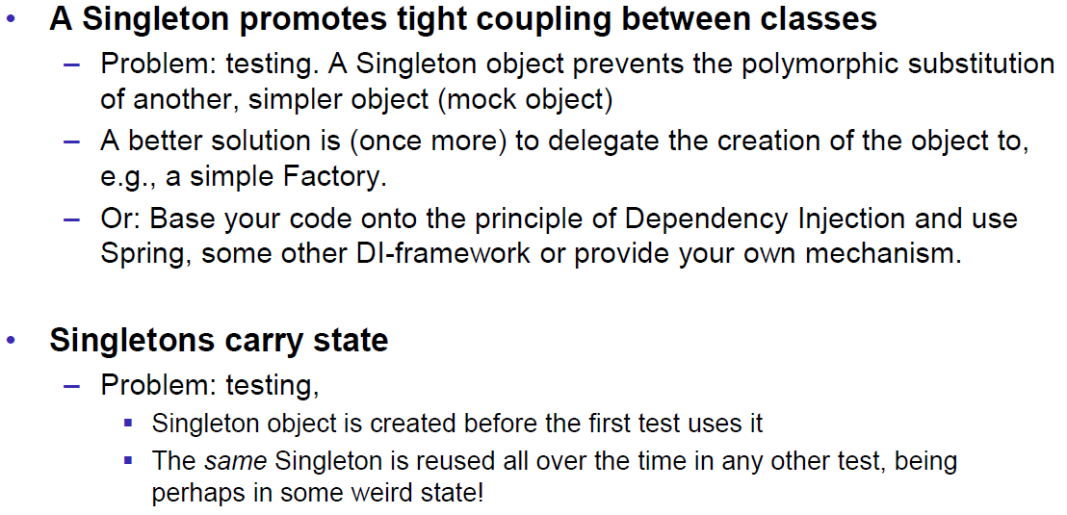

### Discussion and Comments

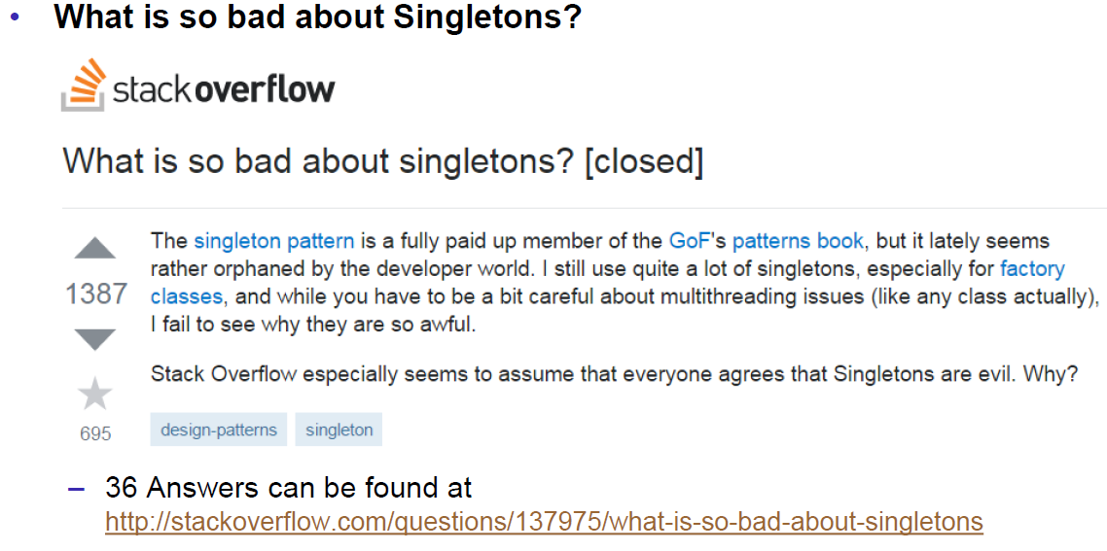

# Woche 15

## Inheritance

### Considered harmful

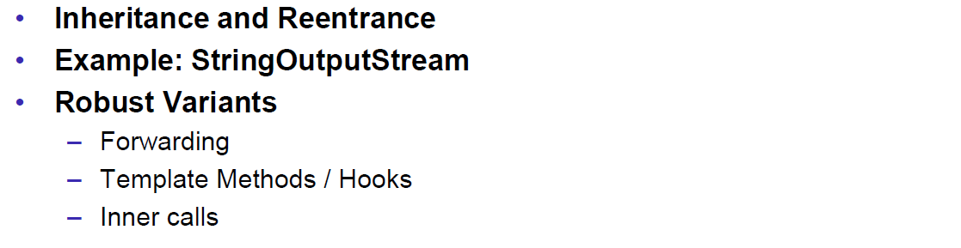

### Inheritance

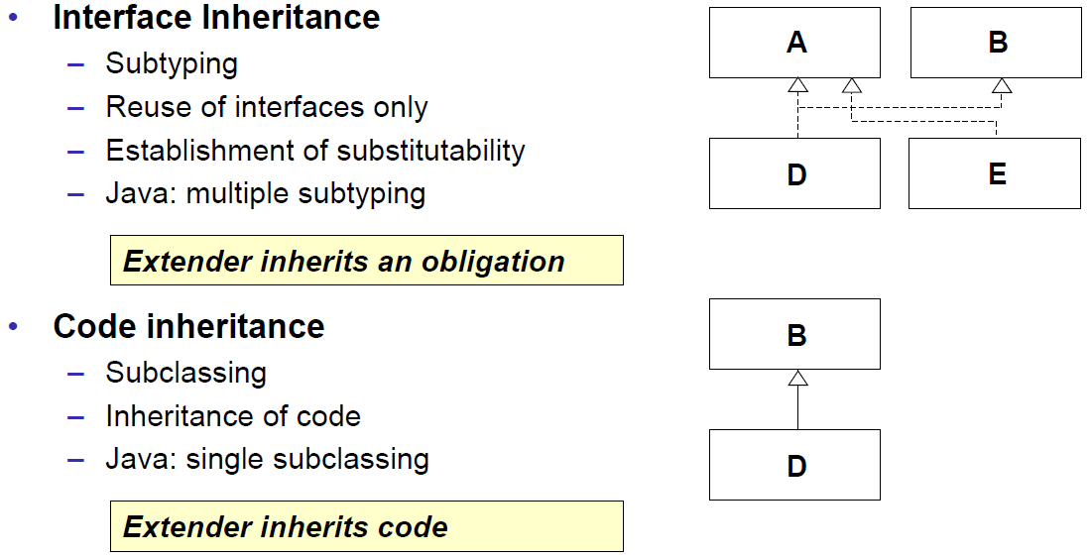

### Subclassing: Example

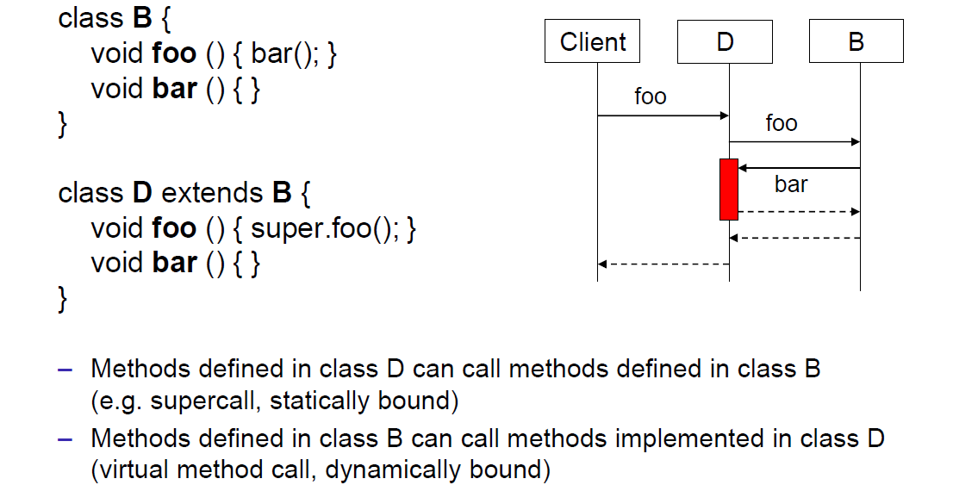

### Reentrance

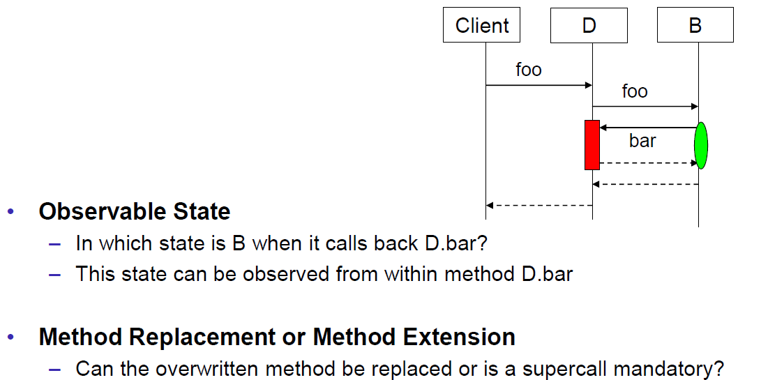

### Example of StringOutputStream

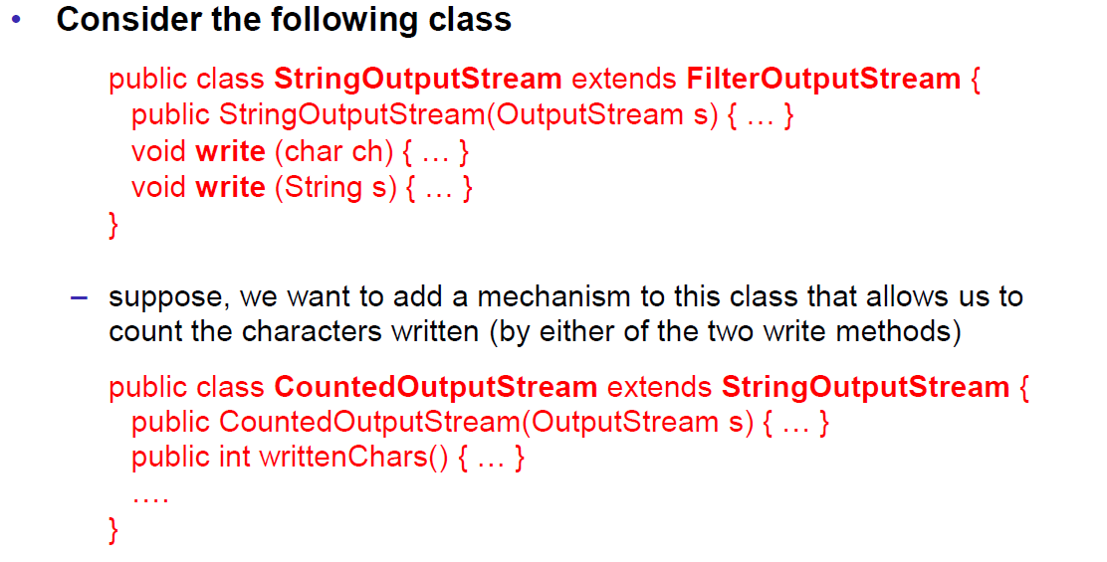

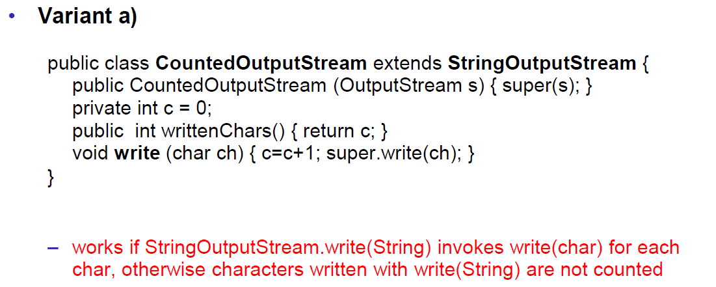

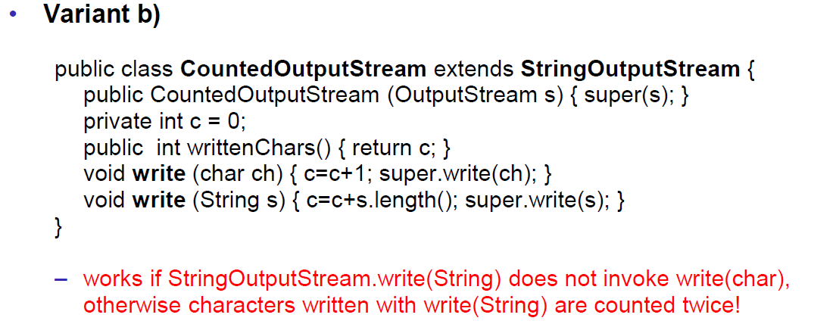

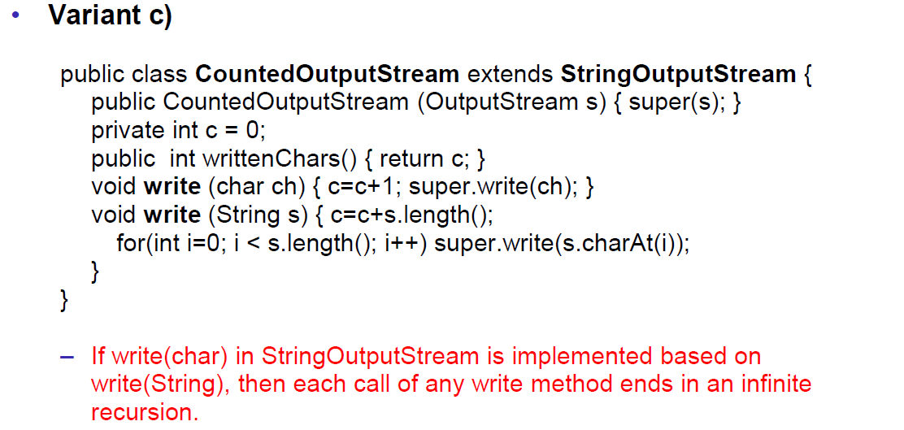

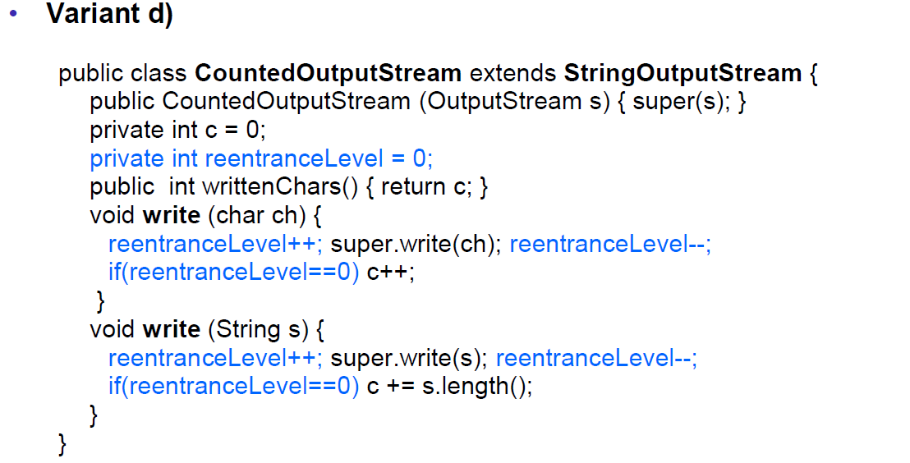

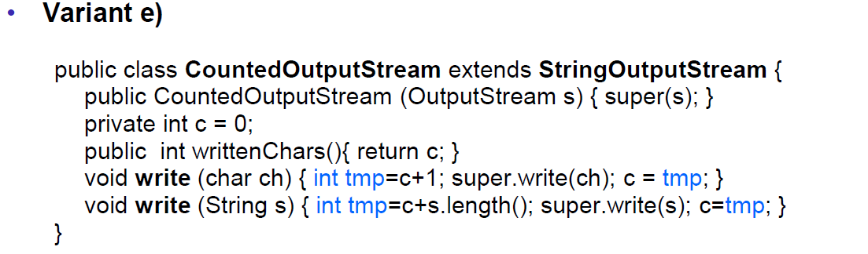

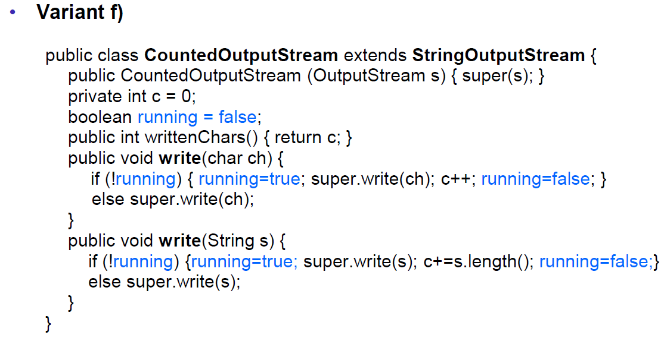

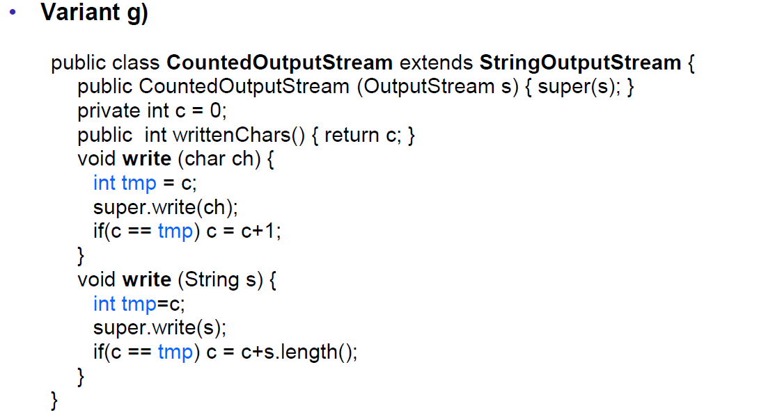

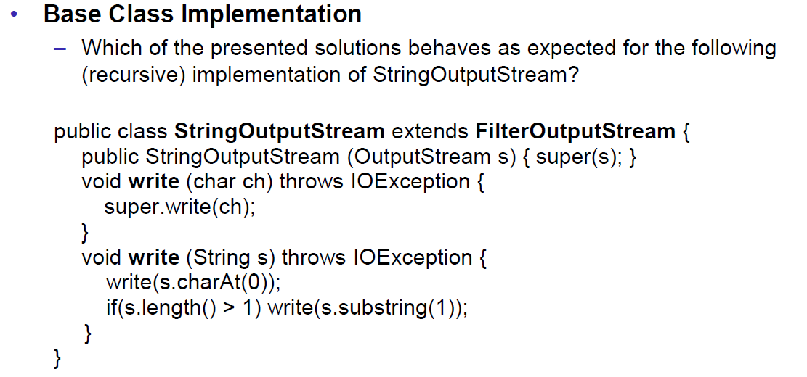

### Inheritance breaks Encapsulation

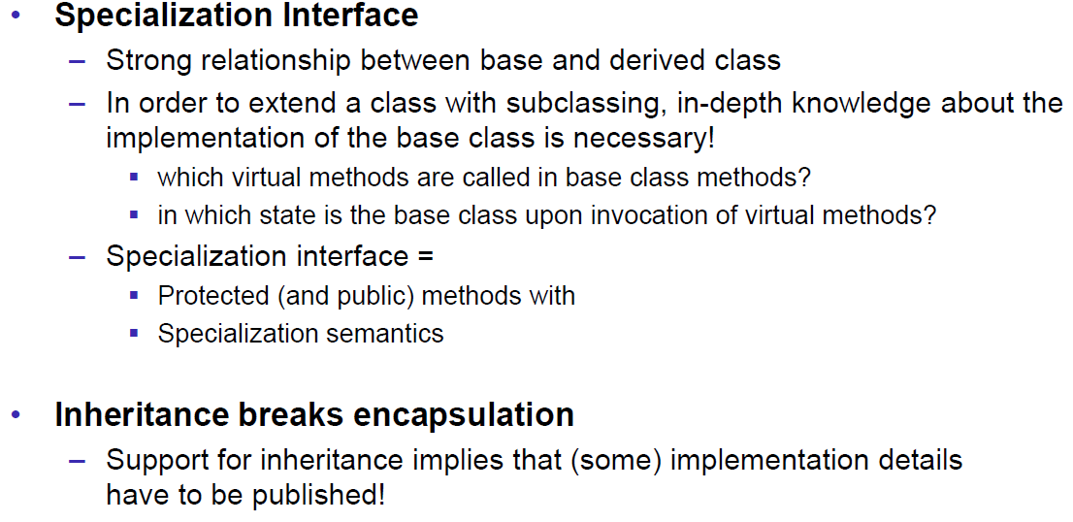

### Inheritance considered dangerous

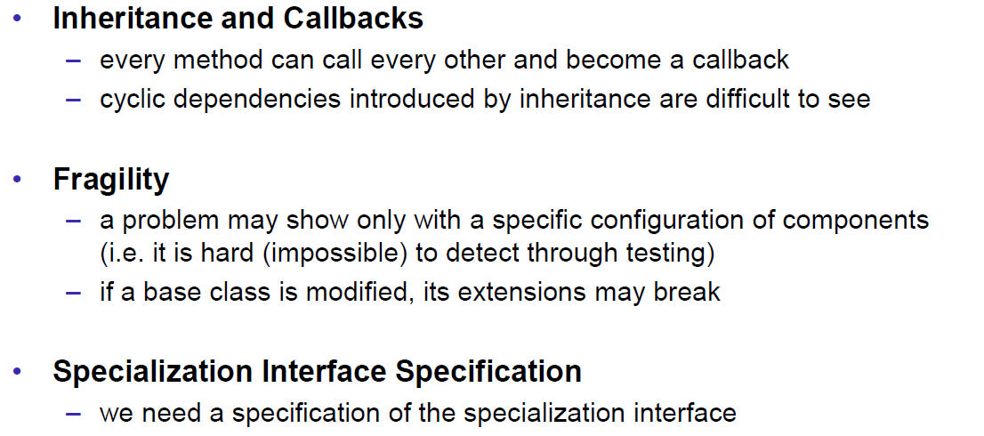

### Robust Variant of Forwarding

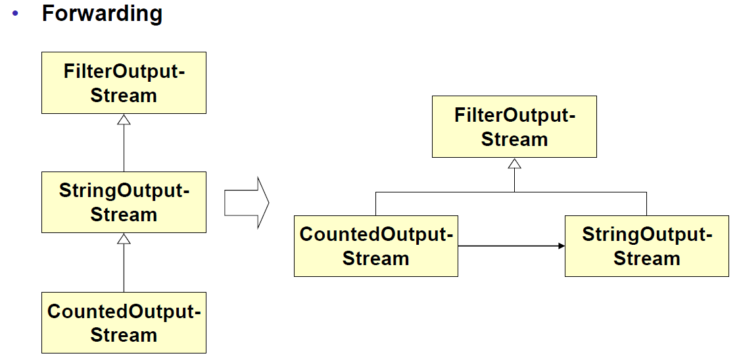

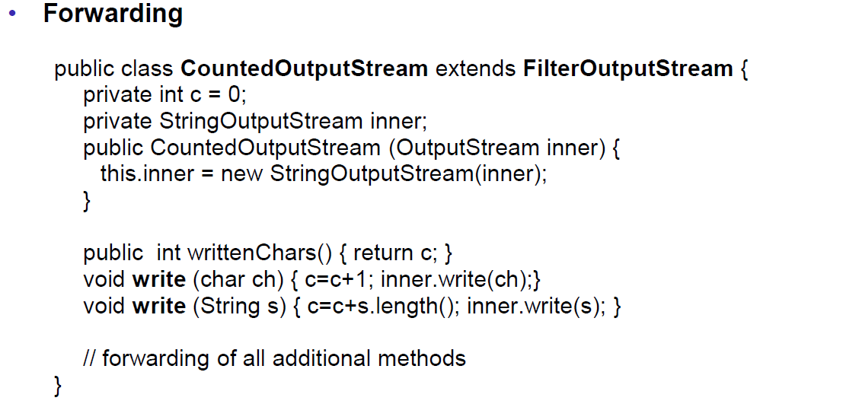

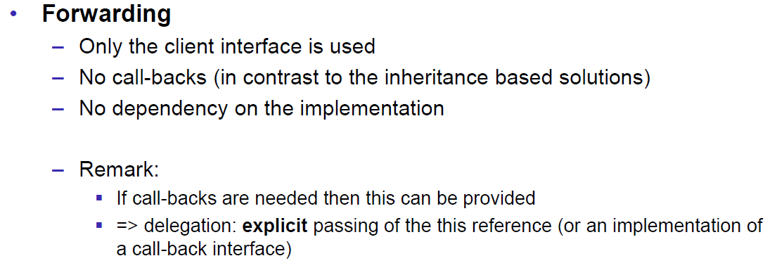

### Robust Variant of Template/Hooks

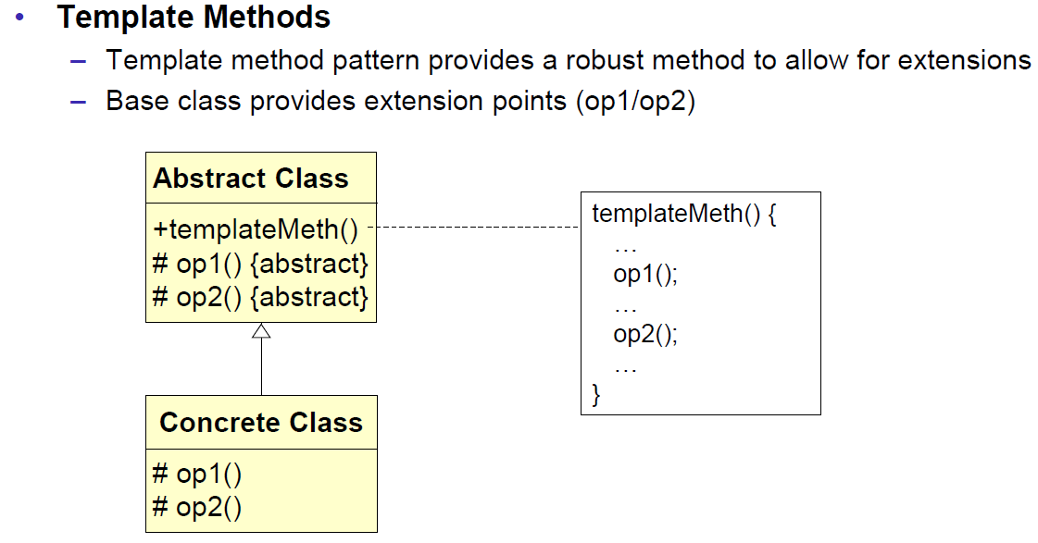

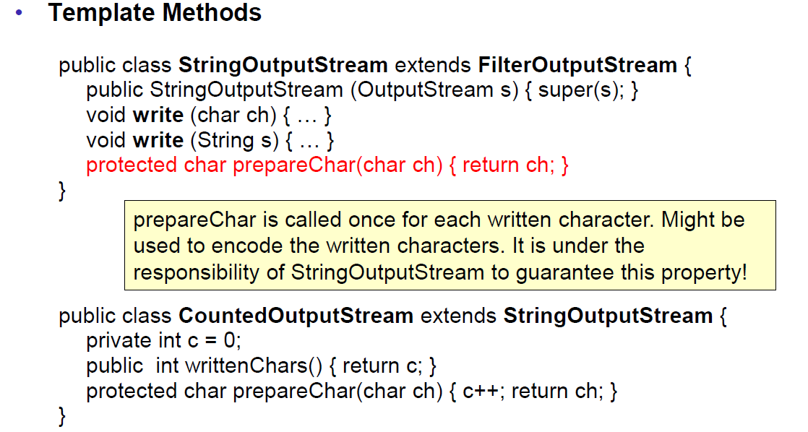

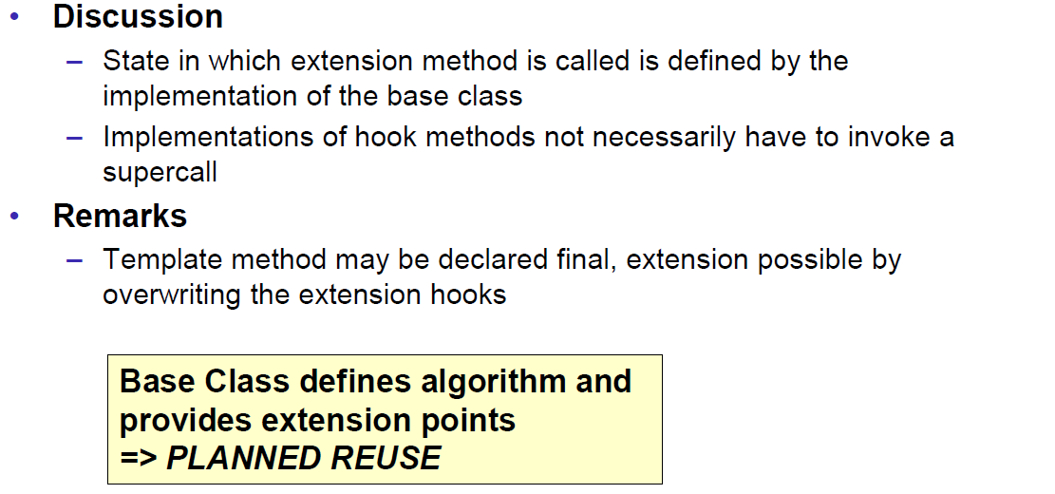

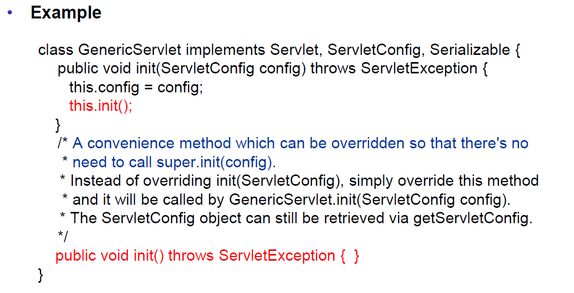

### Robust Variant of inner Calls

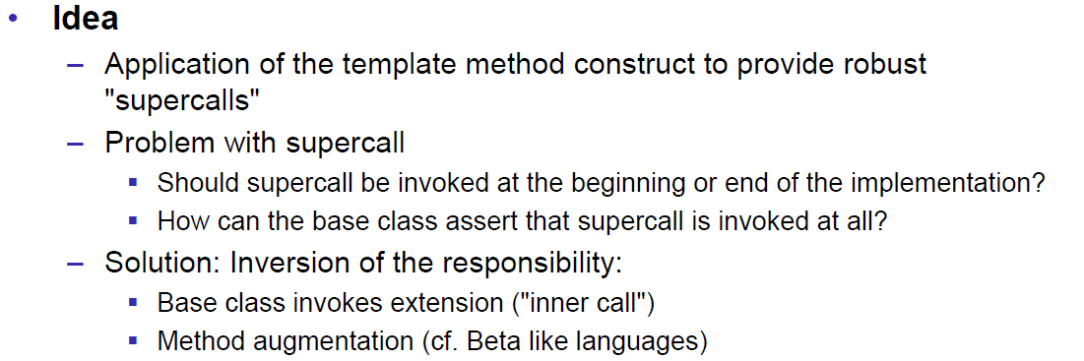

### Example of externalizable with Super Call

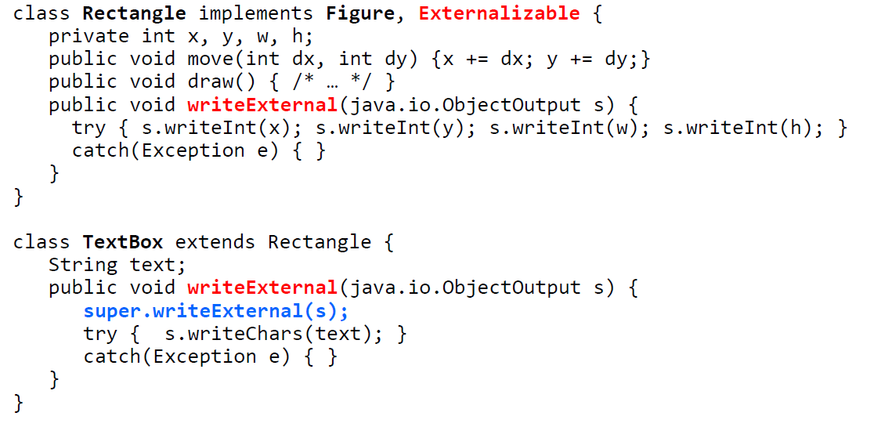

### Example of externalizable with inner Call

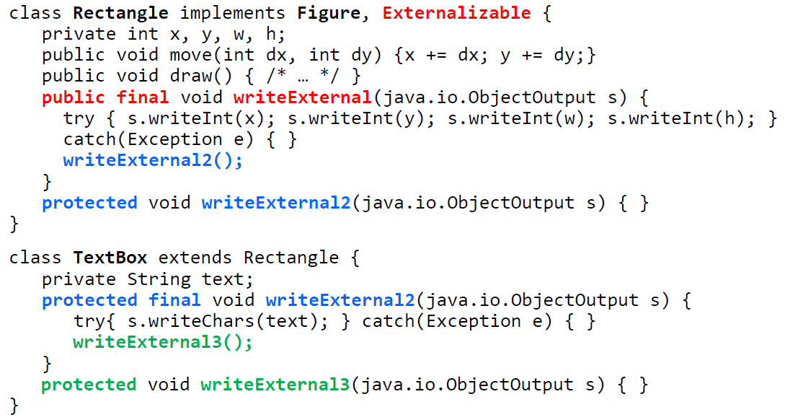

### CheckStyle Design for Extension

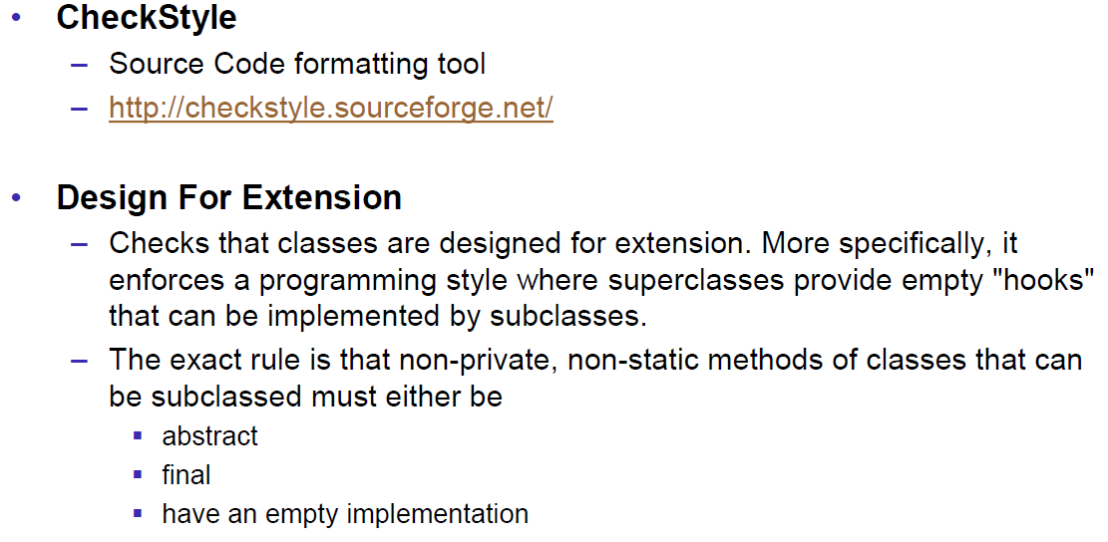

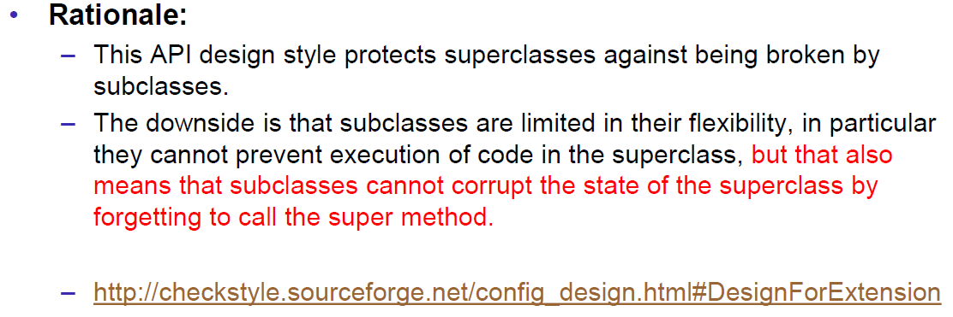

### Summary

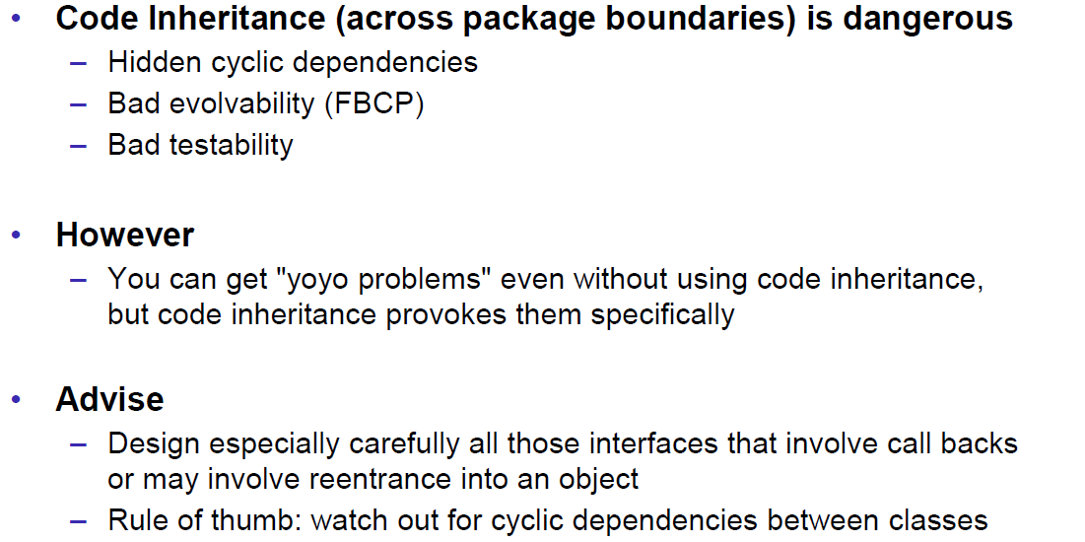

## Object Orientation

### Principles

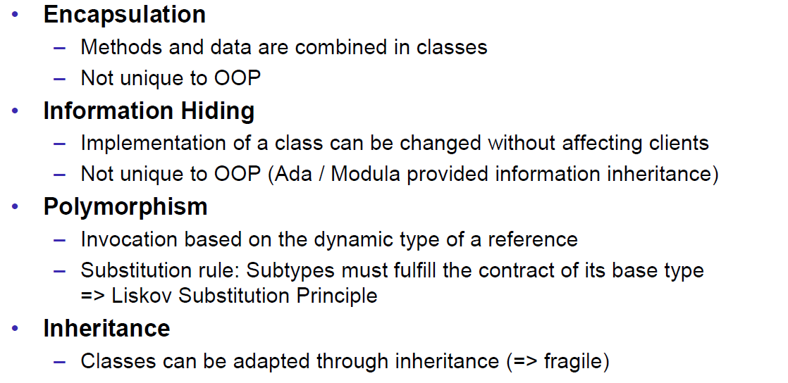

### Design Principles

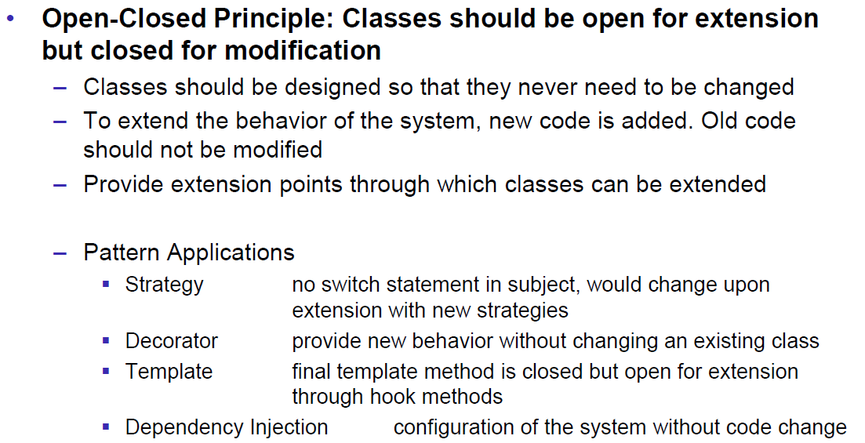

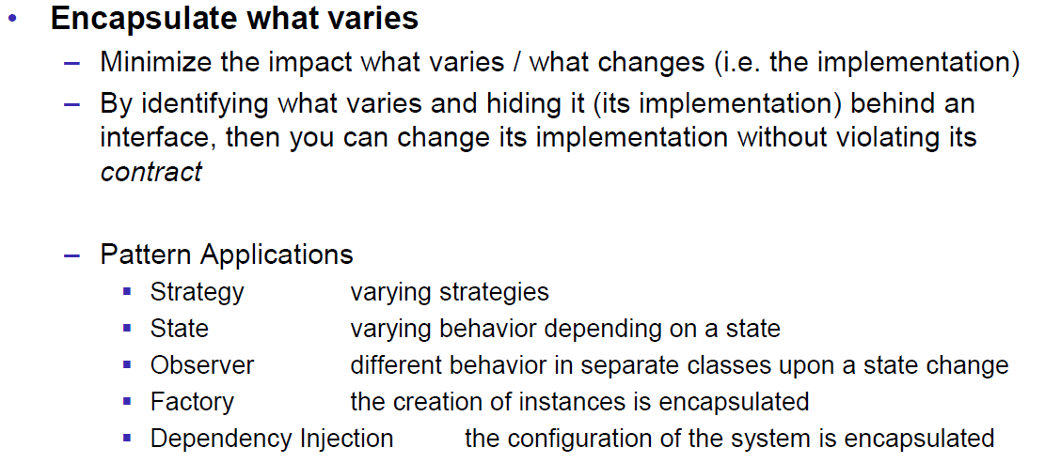

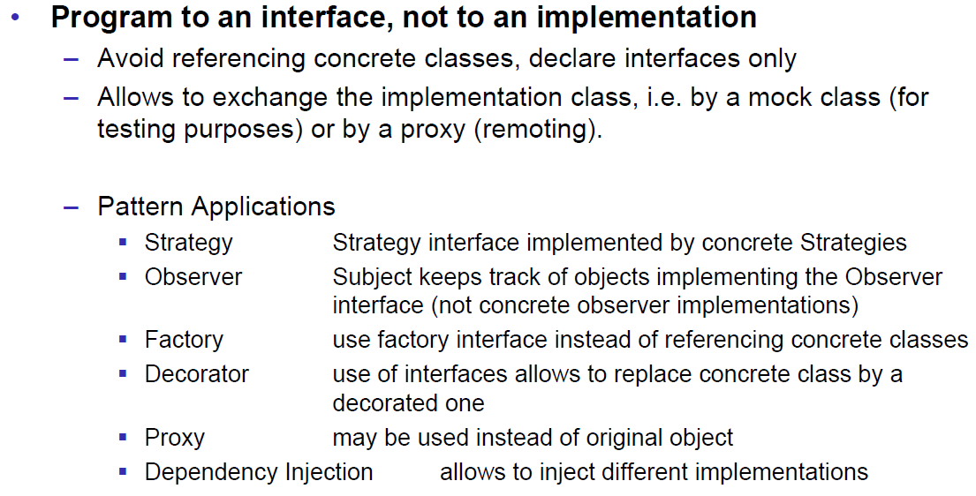

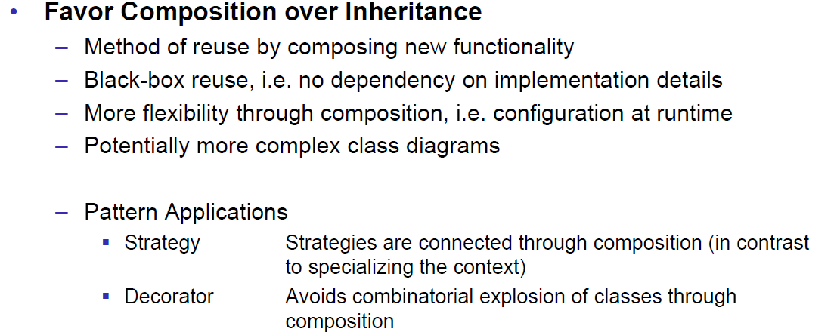

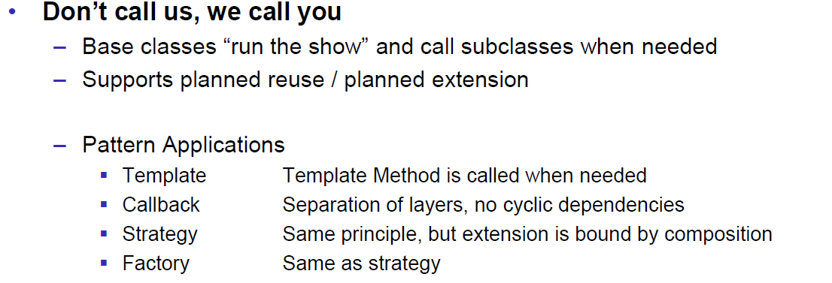

### SOLID Principle

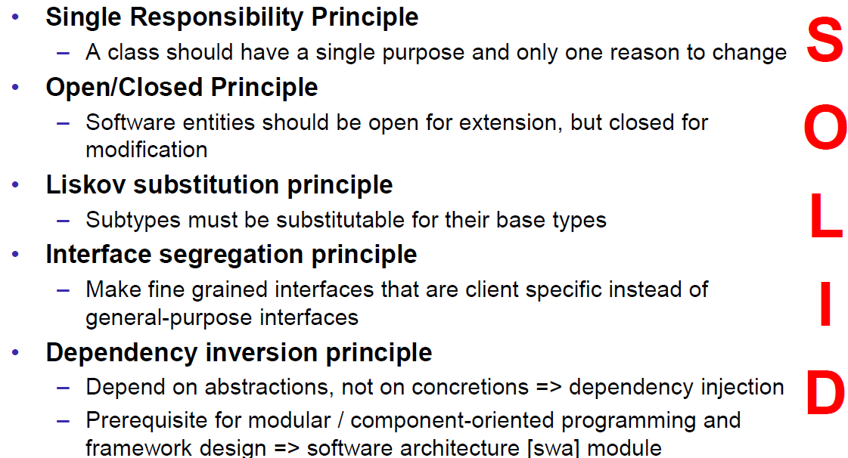

## Design Patterns: Past, Present and Future

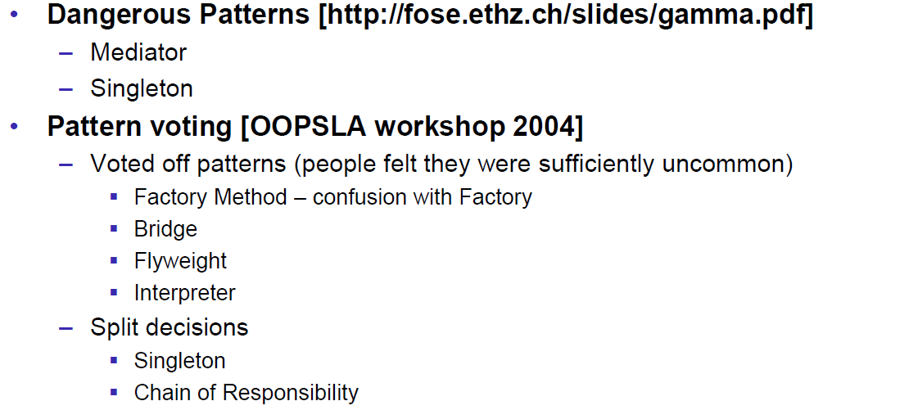

## Gamma

### A new Categorization

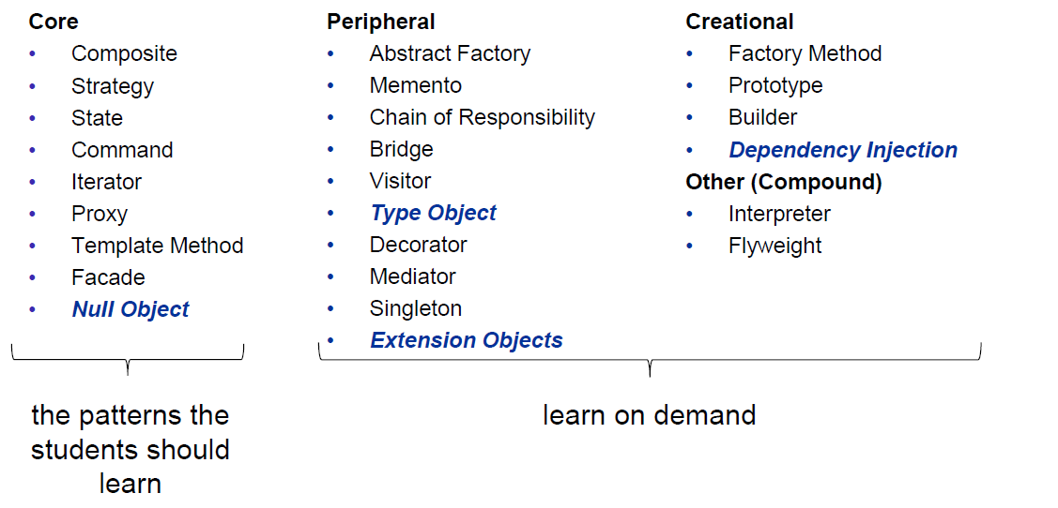

### What hasn’t changed

